Hepatic flukes (liver trematodes)

Phylum: Platyhelminthes
Class: Trematoda
Subclass: Digenea
Order: Prosostomata
1-Family: Fasciolidae
A)) Fasciola hepatica (sheep liver fluke)

Fasciola hepatica also commonly known as sheep liver fluke.

Geographical distribution: cosmopolitan.

Habitat: adult worm lives in the liver bile duct of definitive host.

Morphology:
1-Shape: broad and leaf like with head lobe (give it shouldered appearance).
2-Size: 2-3cm in len
gth by 0.8-1.3cm in breadth.
3-Oral and ventral suckers: oral sucker is smaller than the ventral sucker.
4-Intestinal caeca: the ceca are highly branched extend to the posterior end.
5-Ovary: branched ovary in front the anterior testis, on the right side of the mid line.
6-Vitelline glands: highly branched and occupy lateral fields from shoulder to
posterior end of worm.
7-Testis: the two testes are highly branched, in middle part of the body.

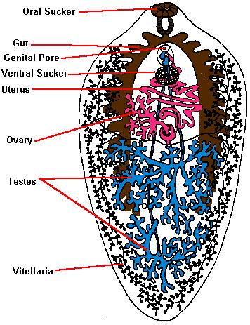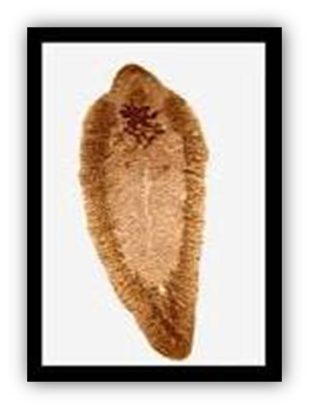

Adult worm of Fasciola hepatica
Life cycle
Intermediate host: Intermediate hosts of F. hepatica are freshwater snails from Family Lymnaeidae (Lymnaea Sp.)
Definitive host: sheep, goat, cattle and man.
Infective form : Metacercariae encysted on water plants that are ingested by human.

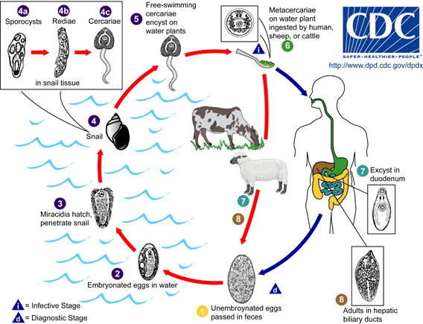
Life cycle of Fasciola hepatica

Disease:
It cause fascioliasis, liver rot, the most important symptoms are
1- Digestive disturbances
2- Abdominal pain.
3- Diarrhea
4- Anemia.
5- Loss of weight.
6- Enlarged liver.
7- Necrosis of liver tissues along pathway of worms
8- Irregular fever
9- Jaundice.

Diagnosis

1- Clinical information, and the source of infection may help to provide a diagnosis.

2- Diagnosis depends mainly on the recovery and identification of eggs in stool
specimens.
The eggs can be detected in the feces either by direct microscopy or by
concentration techniques. In heavy infections, adult worms can be detected
in the stool, especially during treatment

Treatment:

Bithinol is recommended for treatment of fascioliasis.

Prevention and control

1- Treatment and isolation of infected person.
2- Sterilization of night soil (human faeces) before being used as fertilizer (by using
10% ammonium sulfate to kill the eggs).
3- Steps should be taken to kill the molluscan hosts by using copper sulfate solution.
4- Avoidance of use of raw vegetables.
5- Washing of fruits and vegetables with water befor eating.
6- Avoidance of keeping food materials in open conditions.

