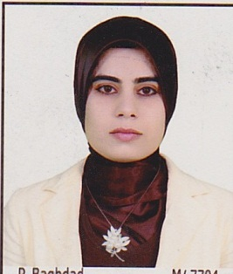
Curriculum Vitae
Personal Details
Name: Rezan Jalal Hassan
Date of birth: April 24/1986
Address: Hawler – Kurdistan
Mobile: 07504902073
Email: rezan.hassan@su.edu.krd
j.hassanrezz@Yahoo.com
Graduated Degree
2013-2014 Master in Physical chemistry , Department of chemistry, College of Science, Salahaddin University
2007-2008 Bachelor of chemistry, Department of chemistry, College of Science, Salahaddin University
Work experiences
2009-2011 chemical assistant, Department of chemistry, College of Science, Salahaddin University
Academic Appointment
2014-Present assist lecturer, Department of chemistry, College of Science, Salahaddin University
2017-Present started studding PhD
Skills
Language English, Arabic, Kurdish
Software Windows 7,8,10, Mac, Gaussian, linux.

