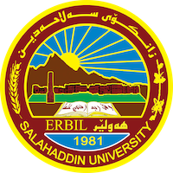
Academic Curriculum Vitae

Personal Information: 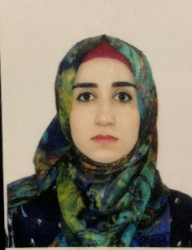
Full Name: Rezan Sabah Ahmed
Academic Title: Assistant Lecturer

Email: (rezan.s.ahmed@su.edu.krd)
Mobile: 07503883358

Education:
- Bachelor’s degree in Environmental health and science, College of Science at Salahaddin University, Erbil, Kurdistan/Iraq: (2012-2013)
- Master’s degree in Biology, College of Science at Salahaddin University, Erbil, Kurdistan/Iraq: (2010-211)

Employment:
- First employed at Salahaddin University on 10/8/2003 as a teaching assistant.
- Second, employed at Salahaddin University as an assistant lecturer on 16/10/2018

Qualifications
- Teaching methods training course for 6 weeks (2017) .
- Moodle Training Workshop, 2 hours, Salahaddin University Research Center.
- English Language qualifications are equivalent at the language center (2017).
- First aid, 2 hours, Salahaddin University, College of Science. Held on 25/11/2019.

Teaching experience:
- Water microbiology(Practical)
- Soil microbiology (Practical0
- Pollution (Practical)
- Environmental Toxicity and Pesticide (Practical)
- Meteorology (Practical)
- Principles of environment (Practical)

Research and publications
- Ahmed.R.S.(2023) Chemical and biological properties of compost produced from house hold solid waste. Zanco Journal of pure and Applied Sciences

- Yasin, S.A.; Ahmed, A. Q.; Tahir, L.O and Ahmed, R. S. (2023). Spring Water Quality Assessment Using Water Quality Index in Shawre Valley- Sulaymaniyah-Iraqi Kurdistan Region. Zanco Journal of pure and Applied Sciences, 35(2); 118-130. DOI: http://dx.doi.org/10.21271/ZJPAS.35.2.13

Conferences and courses attended
- 1st Scientific Conference of College of Health Sciences/Virtual Conference
Sponsored by Hawler Medical University on 6-7 September 2021
- 1st National Tishk Pharmaceutical Conference “Paradigm shift in Drug Discovery and Development” Erbil, Iraq, on 26-27 June 2021
- 4th international conference of Cihan University for Biological Science.

Funding and academic awards
- None of them.

Professional memberships
- Kurdistan Biology Syndicate (ID No.: 1630)
- Kurdistan Teachers Union (ID No.: 15204)

Professional Social Network Accounts:
- https://www.linkedin.com/feed/?trk=onboarding-landing
- https://orcid.org/0009-0006-9391-1058

