MICROBIOLOGY QUESTION BANK
Q1 / Write the name of this tool?

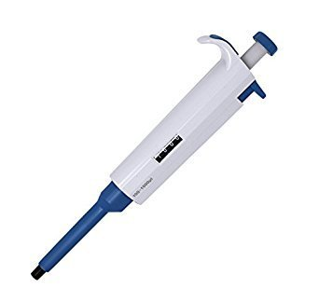
Q2// Write the name of this tool?

Q3 / Write the name of this instrument?
Q4/ Write the function of it?
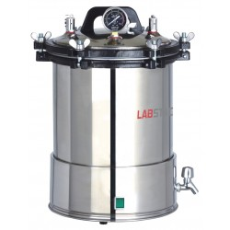

Q5/ A-Write the name of this bacteria?
Q6/ Write the name of stain used?
Q7/ Write the name of this bacteria?
Q8/ Write the name of stain used?
Q9/ Write the name of media uses of these microorganisms?
1-Bacteria
2- Fungi
3- Actinomycetes
4- Algae
Q10/ what is the name of this microorganism?
Q11/ what is incubation period and temperature for it?

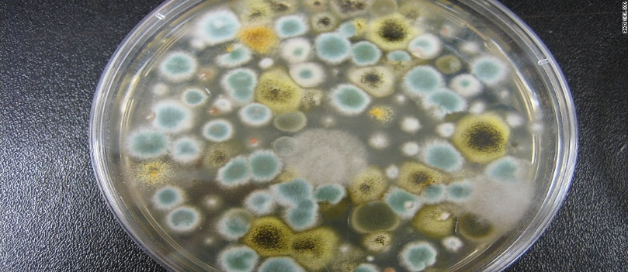

Q12/ what are the microbiology lab precautions?
13/ what are the advantages of fungi?
Q14/ can we use fungi in medicine?
Q15/ how can you prepare 200ml of nutrient agar?
Q16/ What are the difference between yeast and bacterial colony?
Q17/ why we use crystal violate stain?
Q18/ how are gram negative bacteria appear under microscope?
Q19/ Write the steps of bacterial staining?
Q20/write the steps of fungi staining?
Q21/ write the name of the media uses for yeast growth?
Q22/ What is the incubation period for bacterial growth?
Q23/What is the incubation period for fungi growth?
Q24/ What is the optimum temperature for bacterial growth?
Q25/ what is the optimum temperature for fungi growth?

