Question bank Principle of Environmental Science

Practical Examination (Principle of Environmental Science)

Q1/ Fill the blanks: (50 marks)
- Ecology is the ……………………………………………………………………………………..
- Ecosystems consist of…………………..and ……..……………..
- …………………….. is a group of individuals of same species that live together.
- Biosphere is part of ……………… in which all of the places were ………….……… can live.
- All the abiotic factors that affect the organisms called ……………………….
- A sample is ………………………………………………….…………………
- Hazardous substances includes: 1……………………… and 2……………………….
- Inlet is the branch of the water which is come …………….the river.
- Metrology gives information about ………………………….
- Thermometer is used to measure the air temperature in …………...or ………………………
- Evaporation usually measured by …………………………..
- The simple form of hygrometer called ……………………………….
- ………………….usually measured by (Barometer) the unit of Barometer is ……………………..or …..………………
- Hygrograph is an instrument that used to ……………………for ……………. or more
- Electrical conductivity (EC) is a measurement of the ………………………..or in an aqueous solution, which relates to the ability of the material to …………………………through it.

Q2 / Write the importance of atmosphere. (25 marks)

Q3/ Name the followings and for what purpose they used: (25 marks)

- 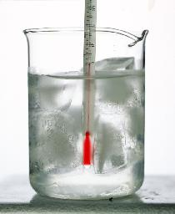

- 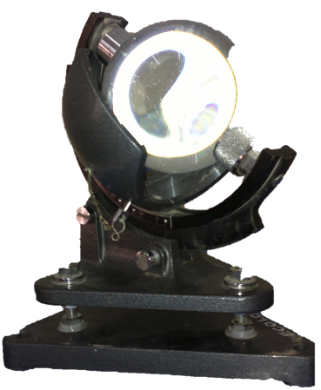

- 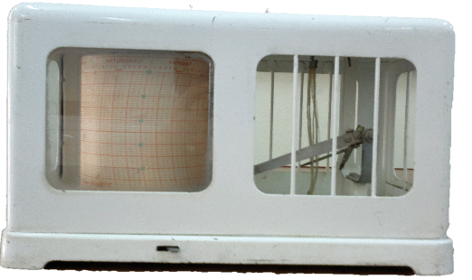
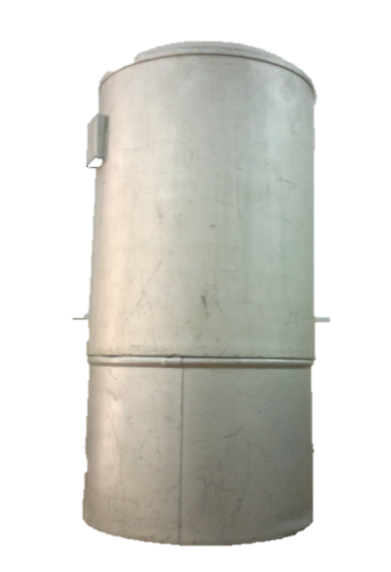

Q1/ Define the following words: (only 5) (10 mark)
- Environment:

- Wind speed:

- Omnivorous:

- Base:

- Metrology:

- Sampling:

- Out let:

Q2 / choose the best answer: (15 mark)

- A sequence of organisms, each of which uses the next lower member of the sequence as a food source called:
      - Food chain. C. Consumer.
      - Food web. D. Community.
- …………………the organism that produce their own food:
      - Heterotrophs. C. Autotrophs.
      - Decomposers. D. Non-of them.
- Acid condition increase as pH value --------------------.
      - Increase. C. Decrease.
      - Not change. D. Become neutral.
- Pure water dissociated to give a concentration of hydrogen ion equal to
      - 10⁻⁷ mole/ l C. 10⁻⁴ mole/ l
      - 10⁻¹⁴ mole/ l D. 10⁻⁹ mole/ l
- The instrument which are used to measure temperature is :
      - Thermometer C. Hygrometer
      - Barometer D. Capnometer

Q3/ Fill the blanks: (25 mark)

- Environmental physical factors such as ---------------, --------------, ---------------; that found in atmosphere.
- EC in tap water = ----------------------------.
- The commonly used units for measuring electrical conductivity of water are -------------- or ----------------.
- The sample can be classified according to source natural and types of analysis into 1---------------- and 2------------.
- When taking samples from the lake, we must take following points as consider -----------, ------------, ----------& -----------------------.
- This instrument (tool) is named as ----------------------------.
- Heterotrophs include both----------------- and -------------------.
- The consumer that eat herbs example---------------.
- Cavendish (1766) the scientist discovered -----------------------
- Ecology is -------------------.
- Ecosystems consist of two components 1----------------------- and 2-----------------------.
- --------------- is the process by which the producer take ---------------from the air & water from the soil by the help of light and chlorophyll to produce -------------- and ---------------.

Q4 / Put (T) for true, (F) for false sentences: (20 mark)
- As the water temperature goes up, pH goes up.
- Consumers are the organisms that able to produce its own food.
- Ecology is the science that studies the relationship between the organisms.
- The range in which the ecology study includes biosphere, ecosystem, community, population, organism, tissues, cells and molecules.
- Decomposer: are organisms like: bacteria and fungi.
- Abiotic factors of ecosystem includes light, temperature, water.
- pH value of HCl equal to one.
- We have only one type of liquid which is used in thermometer.
- Distilled water has a good electrical conductivity.
- We can estimate the sunshine by sunshine recorder.

Q5/ write the reason for the followings: (15 mark)

- The electrical conductivity of the water depends on the water temperature, explain.

- We must take sample from cross section of river within three points.

3. The sampling methods may challenges.

Q6 / Answer the followings: (15 mark)
- Write the name of instrument that we used in EC measurment? and we take EC we cannot immerse the EC meter totally, why?

- Write the principle of action of thermograph or thermometer.

- Write the relationship between EC & TDS.

- Write two Effect of the Electrical Conductivity on Plants.

- Write the methods we used to measure pH of water? When you measured the pH, the result was acidic or alkaline? and then mention the importance of pH in streams and lakes

Q1/ Sampling media (source) includes the following:
- 2-
3- 4-
Q2/ Write the definition of the following:
- Inlet:
- Out let:
Q3/ A- Identify the device?
B- Write the function of it?

Q4/ A- Identify the device?
B- Write the function of it?
Q5/ In a water sample which measured Ec as 255μS.cm-1, how you can find out TDS of the water sample?

Q6/ What is the relation between electrical conductivity and temperature?

Q7/ A- Identify the device?
B- Write the function?
C- write its unit?
Q8/ Is the Ec of tap water higher or ground water? Why?

Q9/ Write the Sources of turbidity?
1-
2-
3-
Q10/ What are the factors that pH of natural water depends on?

Q11/ A- Identify the device?
B- Write the function?
C- write its unit?
Q12/ what is the relation between Turbidity and Dissolved oxygen?

Q1/ A- How can you remove Chloride in drinking Water?
B- Determine the amount of soil moisture in soil sample when the initial weight of soil is 50g and the weight of dried soil is 40g?

Q2/ A- Calculate the total suspended solid for the water sample, when the weight of dry filter is 1.1798g and weight of filter and dried solid is 1.194g and the volume of sample is 500ml?
B- What are the sources of water color with example?

Q3/ A- How can you differentiate between TDS and TSS with figure?
B- What is the difference between apparent color and true color with example?

Q4/ A- What are the factors which effect on formation of soil?
B- What are the sources of chloride in water?

