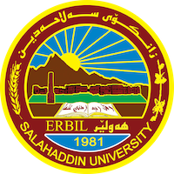
Academic Curriculum Vitae
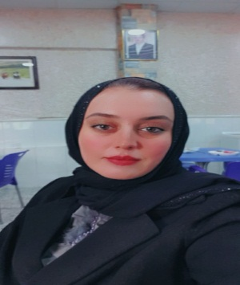
Personal Information:
Full Name:REZHEN AKRAM QADER
Academic Title:Lecturer
Email: (rezhen.qader@su.edu.krd)
Mobile:07504925702

Education:
- BScs: Salahaddin University./ College of Arts/ Geography Department/2005-2006
- M.A.: Got a Master degree in Physical (Natural) Geography-Climate & Water Resource/ College of Arts – Geography department - Salahaddin University/ Erbil./ 2019-2012
- Lecturer / 2020-2021

Employment:
- Employed as a researcher in Faculty of Arts/ Salahaddin university- Morning Study.
(2007 - 2013)

Qualifications
- Teaching qualifications / Assistance lecturer in 2013-2020
Lecturer in 2020-2021
- IT qualifications / Word , Excel , power point , spss
- Language qualifications such as TOEFL, IELTS or any equivalent/ Nothing
- Any professional qualification / Nothing
- You could put any professional courses you have attended / The session of the Iraqi High Commission for Elections in 2018

Teaching experience:
- State all teaching courses you delivered, stating undergraduate or post graduate/ Nothing
- Courses, trainings, lab supervision, etc.,/ Supervision of summer training for undergraduate students since the beginning of the academic year 2014-2022

Research and publications
- State all researches, publication you made;-
- Using GIS Technologies for Analyzing the Relationship between Spatial Variability and Development of Restaurants: Erbil City as a Model / Published in Journal of Tikrit University for Humanities 2022 / available online at: http://www.jtuh.tu.edu.iq
- The Tourism Climate & his Obstacles in Erbil City (A study IN Applied Climate) / Published in Journal of Arts Magazine/ Issue 137 (June) 2021 / / https://doi.org/10.31973/aj.v1i137.939
- Dust Storms And Their Health Causes In Erbil City, has published in Qalaai Zanist Journal latest issue -Volume 5, No 1, 2020. DOI: https://doi.org/10.25212/lfu.qzj.5.1.17 , URL: http://journal.lfu.edu.krd/ojs/index.php/QZJ/article/view/441

Conferences and courses attended
- Give details of any conferences you have attended, and those at which you have presented delivered poster presentations./ Nothing

Funding and academic awards
- List any bursaries, scholarships, travel grants or other sources of funding that you were awarded for research projects or to attend meetings or conferences./ Nothing

Professional memberships
- List any membership you hold of any professional body or learned society relevant to your research or other life activities. ./ Nothing

Professional Social Network Accounts:

- List your profile links of ReserchGate, LinkedIn, etc.
- https://www.researchgate.net/profile/Rezhen-Akram
- https://www.linkedin.com/in/rezhen-kaser-082103133/
- https://scholar.google.com/citations?hl=en&user=XPR5A-
- https://myaccount.google.com/?hl=ar&utm_source=OGB&utm_medium=act

It is also recommended to create an academic cover letter for your CV, for further information about the cover letter, please visit below link:
https://career-advice.jobs.ac.uk/cv-and-cover-letter-advice/academic-cover-letter/

