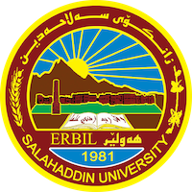
Academic Curriculum Vitae
Personal Information:
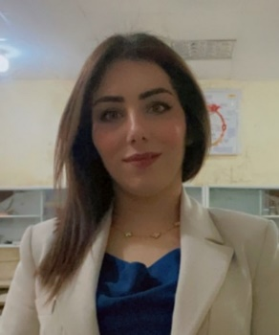
Full Name: Rezhin Ali Mohammed
Academic Title: Assist lecturer

Email: (rezhin.mohammed@su.edu.krd)
Mobile: 07504730010

Education:
1. Ph.D student
2. M.Sc. Degree in mycology College of Education / Salahaddin University 2016.
Title of thesis “Conventional and Molecular Identification of Pathogenic and Keratinophilic Fungi Isolated from Birds in Erbil city.
- Date of attainment January 16, 2016.
3. B.Sc. Degree in Biology, College of Education / Salahaddin University 2009-2010.
Employment:
- December 21, 2010 Demonstrator. At Biology Dept., Education College, Salahaddin University – Erbil, Iraq.
- November , 2018 Assist. Lecturer.

Qualifications
- Teaching qualifications
- An excellent user of office programs and and emailing.
- Latest exam of IELTS I scored 5
- Any professional qualification
- You could put any professional courses you have attended

Teaching experience:
- I taught the following courses so far in public and private universities:
  - General Mycology (practical + theory)
  - Zoology (practical)
  - Plant Anatomy (Practical)
  - General Botany (Practical)

- State all teaching courses you delivered, stating undergraduate or post graduate
- Courses, trainings, lab supervision, etc.,

Research and publications
- State all researches, publication you made.

Conferences and courses attended
- Give details of any conferences you have attended, and those at which you have presented delivered poster presentations.

Funding and academic awards
- List any bursaries, scholarships, travel grants or other sources of funding that you were awarded for research projects or to attend meetings or conferences.

Professional memberships
- Member of Kurdistan Biologists Syndicate
- Member of

Professional Social Network Accounts:
- ORCID Link: https://orcid.org/0000-0002-4907-6837
- Google Scholar Citation (GSC) Link :
- https://scholar.google.com/citations?hl=en&user=6LCzBfsAAAAJ&sortby=pubdate&viewh.
- ttps://www.researchgate.net/profile/Rezhin-Mohammed

