Questions of Practical Mycology
Q1/ Fill the blanks:
1. The mass of branched hyphae is called ........................... .
2. According to physical state, media can be divided into ………………., ……………….., ………………..
3 Cell walls of fungi, usually present .................... and ................ rarely on ................. and ................... in Oomycota.
4.The spore produce asexually are either borne in....................then called ...........................or produce at the tip or sides of hyphae called ......................
5. Non pigmented fungi is .........................and pigmented: pink is ..........................
6. Asexual stage of fungal life cycle termed as the .................................while sexual stage termed as the.......................
7. There are four types of spores 1(a)......................... (b)..........................2............................ 3....................... 4..................
8. ………………………………………….. is media for pathogenic fungi.
9. The most common asexual fruting body are…………………, …………………, ………………., ………………..
10 ………………………… Mass of spores formed inside peridium.
11. The wall of Oospore consist of ………………., ………….……..., ………………...
12. Cell walls of Oomycota composed of .................... and .........................
13.Plasmodium consist of 3 types ………………………………………., ……………………………...…………..,
14. The main order of zygomecetes are ……………………………………………., ………………………………..
15. Entomophthora muscae, a pathogen of ………………., while Entomophaga maimaiga, a biocontrol agent of …………………..
16 Sexual reproduction of zygomycetes occurs through …………………………….
17. Common genera of order ……………………….. are Rhizopus and Mucor.
18. The phylum of non-truly fungi are phylum ………………………………and phylum ……………………………………..
19. Stages in life cycle of slime mold are ……………………………………, ……………………………………,………………………………….

Q2/. Write the difference between primary and secondary zoospore of Saprolegnia?

Q3/ Count the basic requirements of culture media?

Q5/Identify this slide?
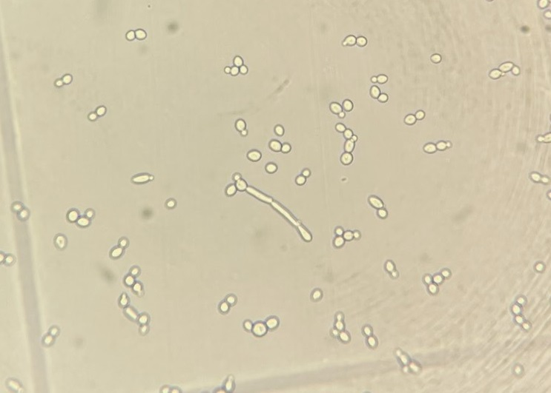
Q6/Count (4) fungal stains and fixative?
Q7/ Identify these slides, with type of reproduction?
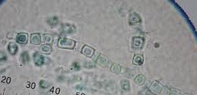
Q9/ Why we preserving cultures?

Q10/ Identify this slide, With reproduction type?
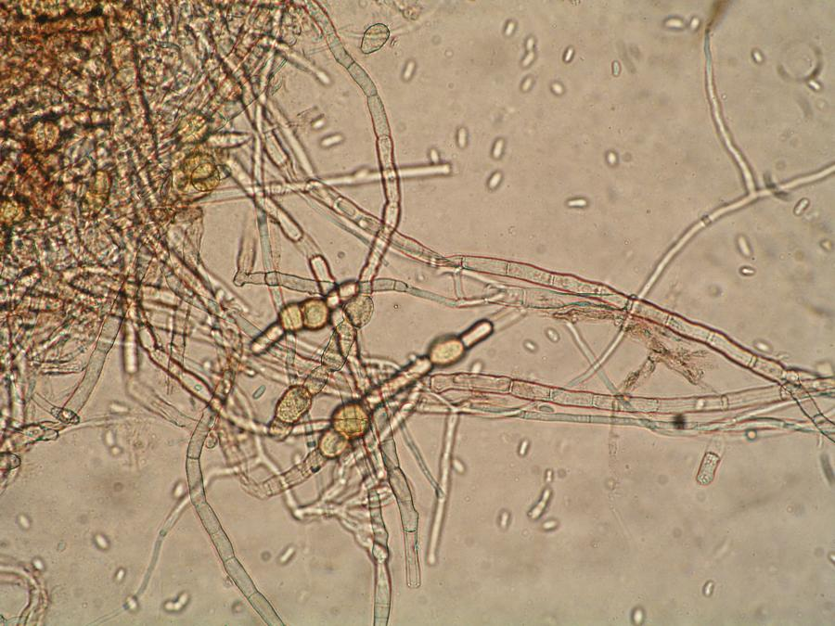
Q11/ Why we use dimethyl sulfoxide (DMSO) before preservation of broth culture medium?

Q12/ Write about feeding in fungi (briefly)?

Q13/Identify these slides, with reproduction type?
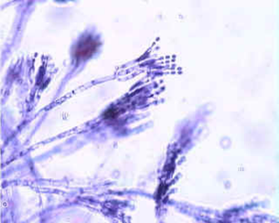
Q14/Draw and label sexual stage of fungal life cycle?

Q15/ Identify this slide, classify it?
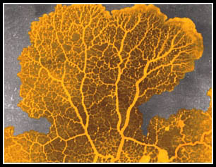
Q16/Mention the role of sex hormone in sexual reproduction?

Q17/ Identify these slides?
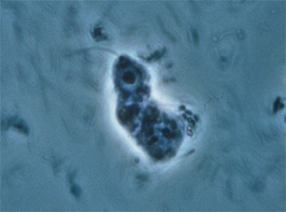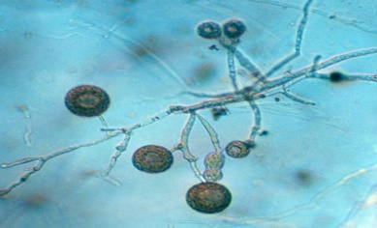
Q18/ write the difference between Rhizopus and Mucor?

Q19/ Identify these slides?
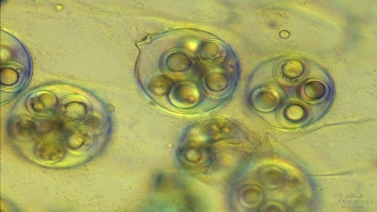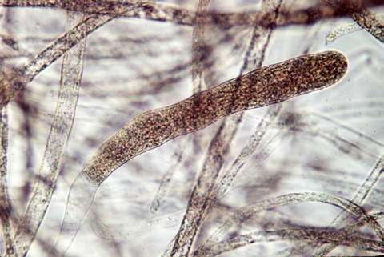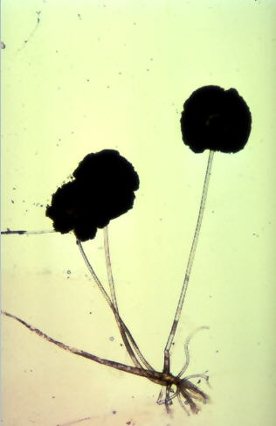
- 2. 3.
Q20/ Describe sexual reproduction of zygomycetes (briefly)?

Q21/ Identify these slides?
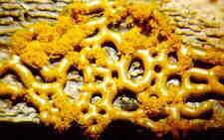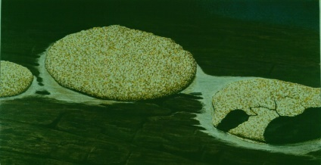
- 2.

Q22/ Identify these slides?
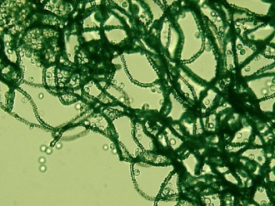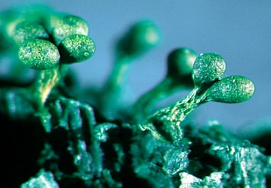
1. 2.
Q30/ Write the function of:
1. Swarm cell:
2. Sclerotium:
3.cell wall
4. Oogonuim
5. Oospore
Q31/ Illustrate the classifications of true fungi?
Q32/ Classify non truly fungi?
Q33/ What is cup fungi?
Q34/ Mention the step of fungal stain?
Q35/ Write the disease of Saprolegnia parasitica?
Q36/ Write the difference between monomorphic and delomorphic spore?

