Kurdistan Regional Government-Iraq
Ministry of Higher Education & Scientific Research
Salahaddin University
College of Science
Physics Department

General Physics Lab.
1st Stage Chemistry

Prepared by Lab. Staff
Academic Year: 2022-2023

Experiment No. (1)

The acceleration of free fall by means of simple pendulum

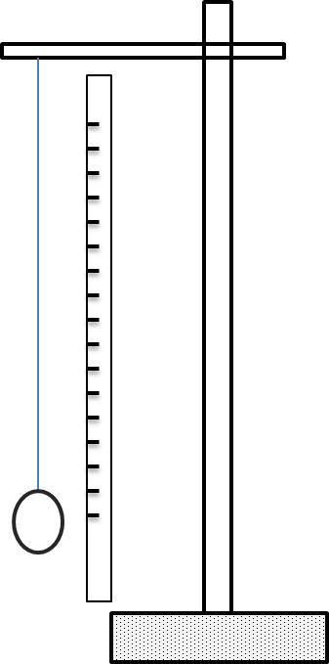
Apparatus
- Pendulum bob.
- Cotton.
- Stop watch.
- Meter scale.
- Stand and clamp
- Small improvised vice (e.g two small metal plates)
s
Purpose
To calculate the acceleration of free fall.

Method
Tie a meter length of the cotton to the pendulum bob and suspend the cotton from the jaws of an improvised vice, such as two small metal plates held in clamp. Alternatively, two coins, two halves of cork split lengthwise, or the jaws of pair of pliers serve equally well for the point of suspension when gripped in a clamp. Place a piece of paper with a vertical mark on it behind the pendulum so that when the latter is at rest in hides the vertical mark from an observer standing the pendulum. Set the pendulum bob swinging through a small angle of about (10$°$ ).
with a stop-watch measure the time for (20) complete oscillations, setting the watch going when the pendulum passes the vertical mark and stopping it (20) complete oscillations later when it passes the mark the in the same direction.
Repeat the timing and record both times. Measure the length ( $l$ ) of the cotton from the point of suspension to the middle of the bob.
Shorten the length of pendulum by successive amount of (5 or 6 cm) by pulling the cotton through the vice and for each new length take two observation of the time for (20) oscillations.

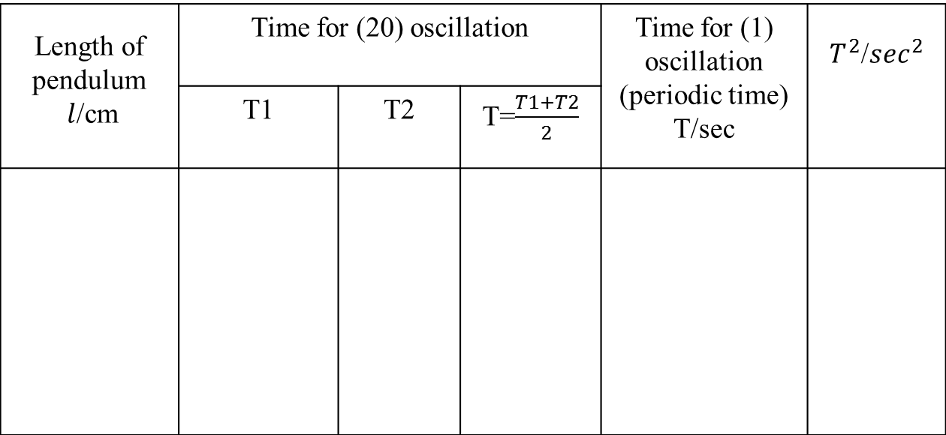
Data Tabulate:

Plot the value of ($T^{2}/\sec^{2}$) as ordinates (y-axis) against the corresponding values of ($l$/$cm$) as abscissas (x-axis)

Theory and calculation

The periodic time (T) of a simple pendulum ($l$) is given by:

$$T=2π\sqrt{\frac{l}{ g }}$$
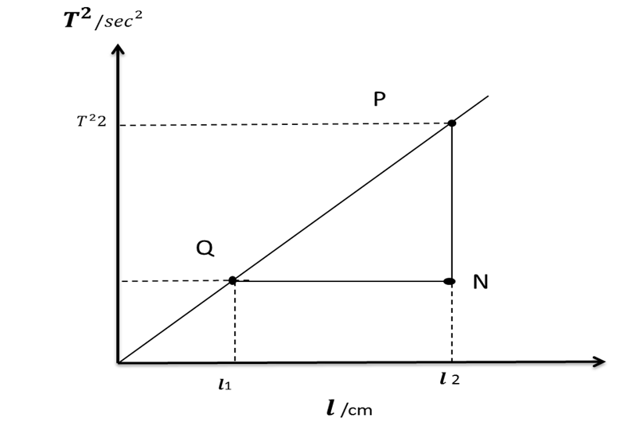
Where $g$ is the acceleration of free fall , by square above equation we get:
$$∴T^{2} =\frac{ 4π^{2}l }{g}$$
Graph
From the table take the data and then plot a graph between the ($l/cm$ ) in x-axis, and ($T^{2}/\sec^{2}$) in y-axis. The graph with values is a straight line as shown in figure. Draw the best strength line through the points and from two points (P) and (Q) on the line obtain the value of the slope:-
$$slope= \frac{ T^{2}}{ l }=\frac{\left(T^{2}2-T^{2}1\right)}{\left(l2-l1\right)}=\frac{4 π^{2}}{g }$$
Experiment No. (2)
To test validity of Ohm’s law using an Ammeter and Voltmeter
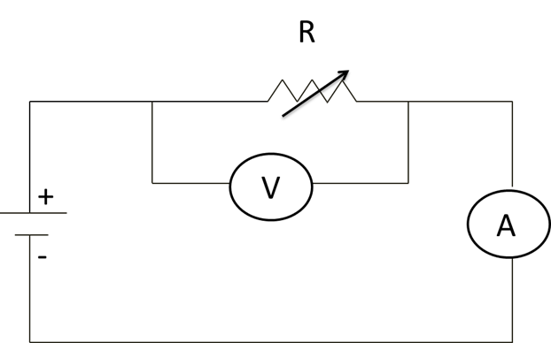
Apparatus
- DC ammeter.
- Voltmeter.
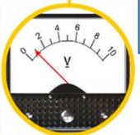
- DC power supply (battery).
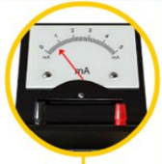
- Rheostat, Resistance box.
s
Purpose
To test validity of Ohms law.

Method
- Connect up the circuit as shown in the diagram.
- Set the value of resistance (o) then record both the voltage and current through the conductor using DC voltmeter and ammeter as shown in the figure.
- Change the value of the resistance in the box (R1, R2,R3) exp.(999Ω).
- Change the value of the voltage across the resistance and read the current.
- Plot the value of ($V/volt$) as ordinates against the corresponding values of ($I$/$Amp$) as abscissas.

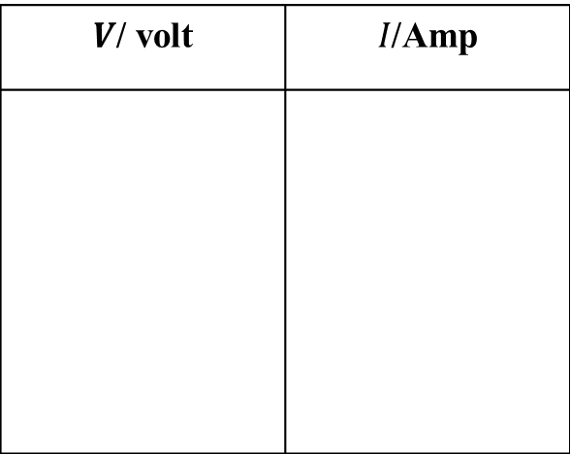
Data Tabulate:

Theory and calculation

The resistance (R) of the conductor depends only upon the nature of its composition and upon the size and shape of the conductor, but also depends upon also temperature it can be expressed by the following equation:

$$R=\frac{ρ L}{A} …1$$
Where, $ρ$ is the resistetivety of the material.
$L$ is the length of the material
$A$ is the cross – section area of the conductor.
A material is said to obey Ohm’s law when the current through a material (held at constant temperature) is strictly proportional to the applied potential difference across the material. Most metallic conductors obey this law, but there are material that do not the former are called Ohmic, and later nonohmic.
In this experiment we are concerned with Ohmic materials. The resistance of material at fixed temperature is defined by equation:
$V=IR ……………..…$2
Where, $I$ is the current through the conductor.
$V$ is the potential difference across the conductor.
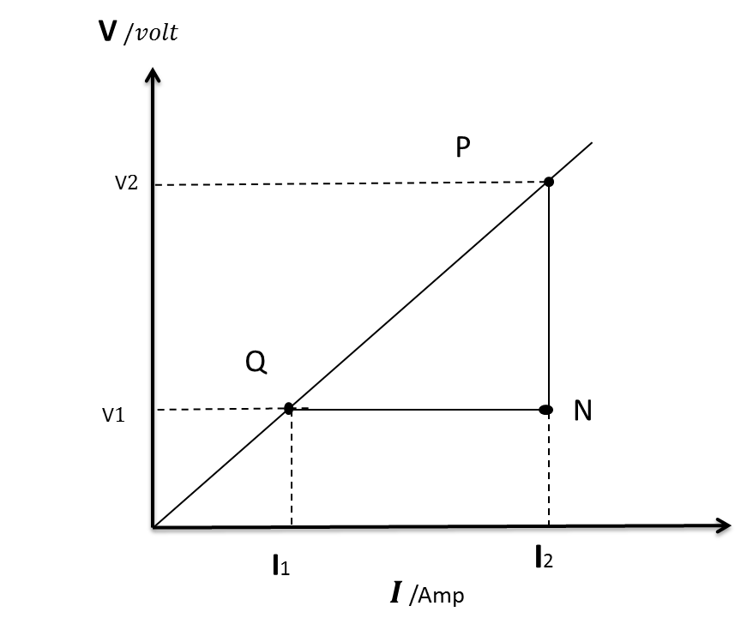
If (V) in volt and (I) in amperes then (R) is in Ohms. The above equation is frequently called Ohm’s law for the convenient but the condition on which is based should be loop in mind.
Graph
From the table take the data and then plot a graph between the (I /Amp) in x-axis, and ($V$/$volt$) in y-axis. The graph with values of is a straight line show in figure. Draw the best strength line through the points and from two points (P) and (Q) on the line obtain the value of the slope:-
$$slope=\frac{V}{I}=\frac{(V2-V1)}{(I2-I1)}=RΩ$$
Experiment No. (3)

The fall of a body through a viscous medium to deduce the Coefficient of Viscosity of the medium
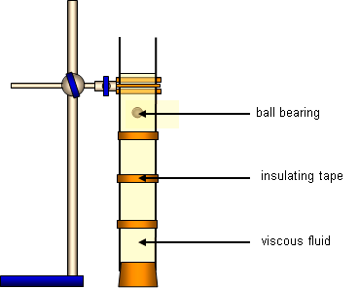
Apparatus
- A long glass tube or Perspex tube about (1m) closed at one end.
- Glycerine (fluid).
- Micrometer screw gauge.
- Meter scale.
- Steel ball bearings about a dozen of each of (5-6) different diameter.
- Clamp the tube vertically and fill it with glycerine.
- Rubber band put (2) paper collars round the tube, one near the bottom and the other about(8-10 cm) from the surface of the glycerine.

Purpose
To determine the Coefficient of Viscosity of the medium

Theory
Select ten or a dozen balls of the same diameter. Adjust the distance between the paper collars so that their upper edges are a convenient distance (h) about (60 cm) apart and record this distance. Now drop a sphere centrally down the tube and with the stop –watch find the time it takes to traverse the distance between the upper edges of the paper collars. Obtain a confirmatory reading with a second sphere.
Keeping the lower collar fixed, lower the upper one by (5cm) at time and obtain two values of the time of fall for each new distance apart.

Data Tabulate:

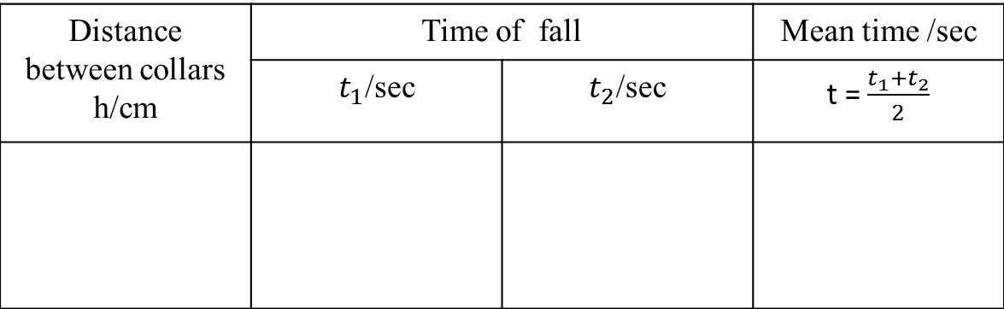
Plot a graph with values of (h/cm) as ordinates against the corresponding values of (t/sec) as abscissas, and from the graph calculate the terminal velocity ( $v$ ).

Theory and calculation
By Stocke’s law, the viscous force (F) acting on a sphere of radius (r) falling with constant terminal velocity ( $v$ ) through a medium of viscosity ( Ƞ ) is given by :-

$$F=6π Ƞ r v …(1)$$
Since the sphere is falling steadily this viscous force is exactly balanced by the net downward, force on the sphere due to its weight, allowance being made for the up thrust due to displacement. Let ($ρ$) and ($σ$) be the densities of the sphere and the glycerine respectively:-
$$F=6π Ƞ r v =\frac{4}{3} π r^{3}g\left(ρ-σ\right) …(2)$$

Hence from equation (2):- $Ƞ =\frac{2 r^{2}g \left( ρ - σ \right)}{9 v} …(3)$

From which rearranging the value of (r) is equal to :- $r=\frac{d}{2} …(4)$
Putting eq(4) in eq(3) we get :-
$$Ƞ =\frac{g \left(ρ-σ\right)d^{2}}{18 v} …(5)$$
Where equation (5) is used in the calculation of this experiment .
Where the parameters in the equation (5) all of them are constant except one, which is the velocity, the values of these parameters are:-
1.$g=980 cm/\sec^{2}$
2.$ρ_{sphere}=7.878 g/{cm}^{3}$
3.$σ_{glycrine}=0.72 g/{cm}^{3}$
4.$d=0.2cm$

And the value of the velocity ( $v$ ) we get from plotting graph between (h/cm) with time (t/sec).

Graph
From table (1) take the data and then plot a graph between the mean time (t /cm ) in x-axis , and high of the sphere ball in the liquid (h/cm) in y-axis .
The graph with values of is a straight line show in figure . Draw the best strength line through the points and from two points ( P) and (Q)on the line obtain the value of the slope :-
$$∴ Slope=\frac{PN}{QN}=\frac{h2-h1}{t2-t1}=velocity (v)$$

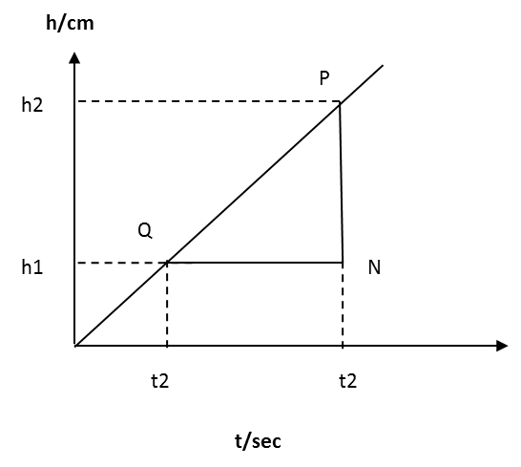
Substitute this in equation (5) above and also insert the values of ($ρ$ )and ($σ$) both in ($g/{cm}^{3}$ ) obtain the coefficient of viscosity of the medium.

Experiment No. (4)
The Velocity of Sound by Means of Resonance tube closed at one end

Apparatus
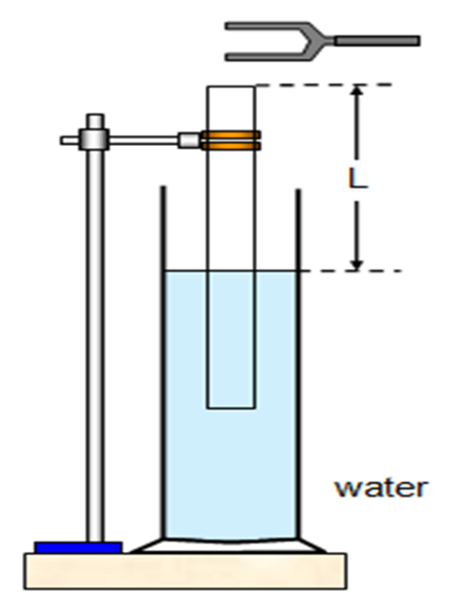
- Resonance tube (0.8-1m long , 3-4cm diameter, see diagram) .
- Set of tuning forks (512-288 Hz).
- Meter scale.
s
Purpose
To calculate the velocity of sound by means of resonance tube.

Method
Begin the experiment with the length of air column in the resonance tube of a few cm in length. Select the fork of highest frequency, strike it smartly on rubber pad and hold it over the mouth tube. While the fork is vibrating adjust the length of the resonance column until the tube responds to the vibrations of the fork, i.e. until resonance occurs. By further small adjustment obtain the position of maximum loudness as exactly as you can. Measure the length of the air in the tube, repeat measurement two or three time and take the mean ( $l$ ). Obtain different values of ( $l$ ) using the other forks, and record the room temperature ( $T ℃$ ).

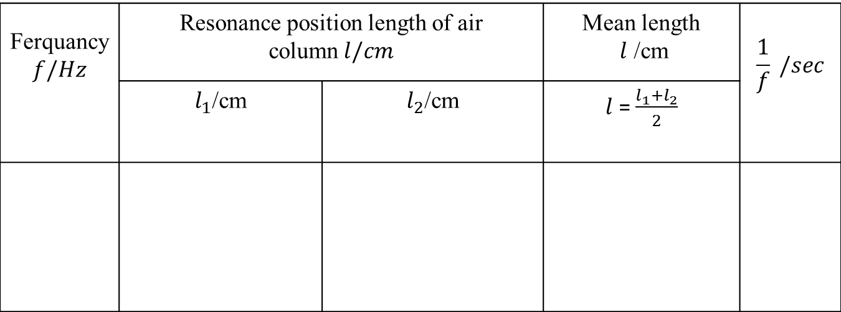
Data Tabulate:
Plot the value of ($l/cm$) as ordinates against the corresponding values of ($\frac{ 1 }{ f }$ /$sec$) as abscissas.
Theory and calculation

From the following relation:
$$l+ε=\frac{1}{4}λ=\frac{c}{4 f}$$
Where 𝝀 is the wavelength and$c$ is the velocity, $f$ is the frequency, and $ε$ is the end correction. We obtain: $l=(\frac{ c }{4 }*\frac{1 }{ f })-ε$
Thus the graph of Plot the value of ($l/cm$) as ordinates (y-axis) against the corresponding values of ($\frac{ 1}{ f }$ /$sec$) as abscissas (x-axis) is a straight line whose slope is numerical value of ($c/{4 }$), while the negative intercept on the ($l/cm$ ) axis is the numerical value of ( $ε$).
[
Graph
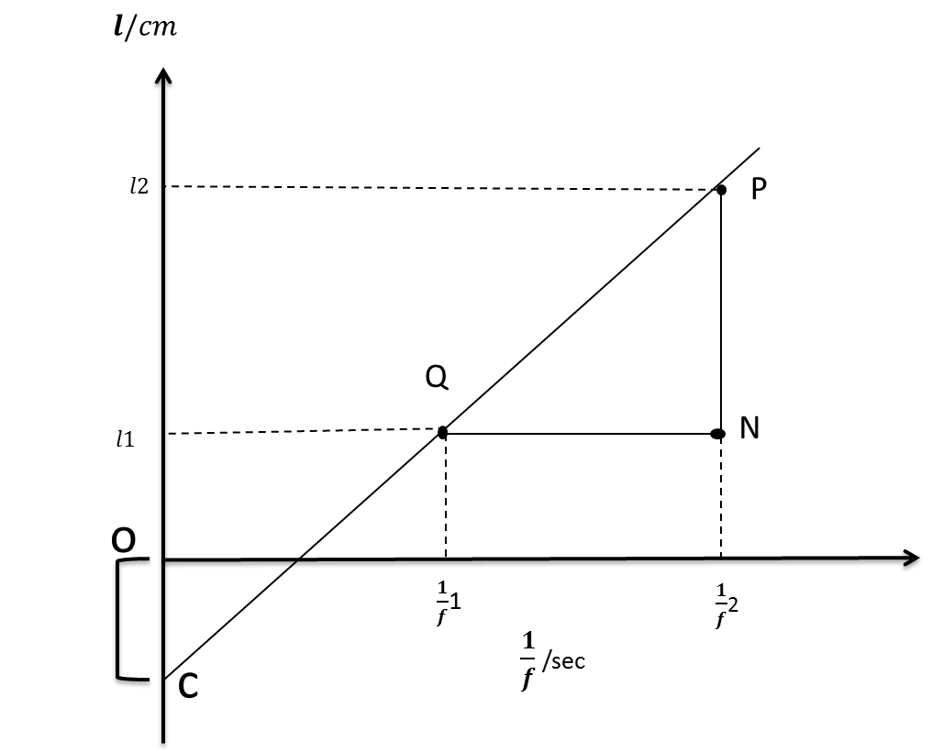
From the table take the data and then plot a graph between the ($l/cm$ ) in y-axis, and ($\frac{ 1 }{f }/sec$) in x-axis. The graph with values of is a straight line show in figure. Draw the best strength line through the points and from two points (P) and (Q) on the line obtain the value of the slope:-
$$slope= \frac{ PN}{ QN }=\frac{\left(l2-l1\right)}{\left(\frac{1}{f}2-\frac{1}{f}1\right)}=numerical value=\frac{ c }{ 4 }$$
Hence the velocity of sound is:-
$∴c= 4×\frac{PN}{QN}=4×slope$
And the end correction of tube
$ε= intercepte \left(OC\right)cm$
And finally, compare the values obtain for the velocity of sound ($c$) with their theoretical values: -
here $K°$ is tempertare in kelven (i.e. $T /K°$=273+$T ℃$).
$$c= 331\sqrt{\frac{ T/K ° }{ 273 }}$$

Experiment No. ( 5 )
The refraction index of Glass and a Liquid by real and apparent depth using traveling microscope.
Apparatus/ tools
➢ Traveling microscope.
➢ One slab of glass.
➢ Lycopodium powder (wood powder).
➢ Liquid (water).
➢ Vessel with a plan base to hold the liquid.

Purpose
To determine the refraction index of Glass and a Liquid by real and apparent depth.
(Part A) * Measuring the refractive index of glass // Method:
1. Place one of the glass slabs on the bench to serve as a base and sprinkle some lycopodium (wood powder) on its upper surface. Adjust the cross-hairs of the microscope so that they can be clearly seen without strain.
2. Place the microscope vertically above the lycopodium Adjust the height of the instrument until the grains are in shape focus with no parallax between their image and the cross-hairs. read the vertical Vernier scale of the microscope (d₁).
3. Place the second of the glass slabs on the top of the first one without removing the powder and raise the microscope slowly until the grains are again in focus. Read the Vernier (d₂).
4. Sprinkle some lycopodium (wood powder) on the upper surface of the second glass slab and raise the microscope again until these grains are clearly in focus. Read the Vernier (d₃).
5. Tabulate the readings as shown in table (1).

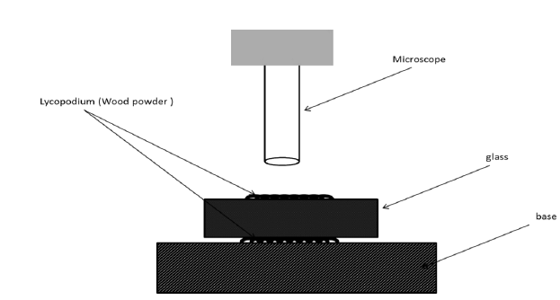
(Part B )* Measuring the refractive index of water // Method:
1. Sprinkle some grains of sand on bottom of the flat-bottomed vessel and focus the microscope on them. Read Vernier (d₁)
2. Pour some water to a depth of about (1 cm) in to vessel. raise the microscope until the grains of the maker on the bottom of vessel is in focus. Read Vernier (d₂).
3. Sprinkle some lycopodium (wood powder) on the water surface. raise the microscope further until the lycopodium (wood powder) on surface is in focus. Read Vernier (d₃).
4. Tabulate the readings as shown in table (1).
