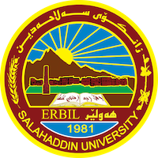
Academic Curriculum Vitae
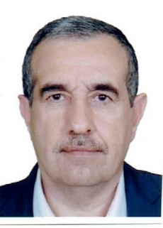
Personal Information:
Full Name: Dr. Rizgar Ali Hummadi
Academic Title: Assistant professor / Civil Engineering Department/
College of Engineering/ University of Salahaddin
Email: rizgar.hummadi@su.krd.edu
Mobile: 00964750 4452548

Education:
2001 Ph.D Civil Engineering ( Soil Mechanics and Foundation Eng. ), University of Baghdad , College of Engineering – Baghdad , Iraq
1990 M.Sc. Civil Engineering (Soil Mechanics and Foundation Eng.),University of Salahaddin , College of Engineering , Erbil - Iraq
1985 B.Sc. Civil Engineering , University of Salahaddin Erbil, Iraq
Employment:
Member of Teaching Staff Civil Engineering Department/ College of Engineering/ University of Salahaddin Erbil, Iraq since 1992
Teaching experience:
-1st year stage mathematic, Statistics.
– 3rd year students: soil Mechanics, Engineering Analysis
-4th year students : Foundation Engineering, Engineering Project
-M.Sc, Ph.D Students: Advanced soil mechanics, Soil Improvement, Rock Mechanics. Advanced Foundation Engineering. - Supervising the completion of six MSc students thesis.
Currently I am working with the following postgraduate students.
- Supervise Ph.D. student. The thesis is under the title " Evaluation of field swelling potential with standard and different sample size tests"
Research and publications
- A study of some engineering properties of undisturbed and remolded desiccated soils in Dohuk governorate.
- 2- Performance of stone columns in Erbil soils.
3-Engineering characteristics of compacted oil contaminated Erbil soils.
4-Engineering characteristics of Erbil municipal solid waste materials. 5-Treatment of swelling and collapsible characteristics of soils by waste building materials

Professional Social Network Accounts:

Rizgar Hummadi - University Lecturer - university of salahaddin | LinkedIn
(19) Rizgar Hummadi (researchgate.net)
Rizgar Ali Hummadi‬ - Google Scholar‬‬‬‬‬
Rizgar Hummadi (0000-0002-0277-0960) (orcid.org)

