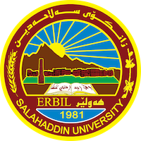

Academic Curriculum Vitae
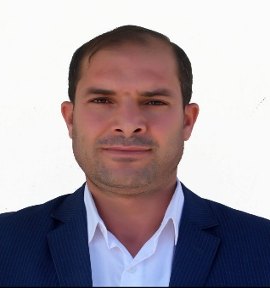
Personal Information:
Full Name: Mr. Rizgar Ismaeeh Kareem
Academic Title: Assistant lecturer
Email: (rizgar.kareem@su.edu.krd)
Mobile: +9647504144088

Education:
- I started work at 24/10/2012
- I have a bachelor’s degree at university of Salaheddin – college of language.
- I have a master degree at university of Salaheddin – college of language from 2017.
Qualifications
- pedagogy and the way of teaching .
- It at university of Salaheddin.
- I have certifications placement test at language center from university of Salaheddin.
Teaching experience:
- I am teaching courses third stage in bachelor’s degree.
- And I am teaching Courses and supervised research student forth stage bachloreouse.

Research and publications
- When I started I have 2 researches published.

Conferences and courses attended
- I attended confrans title was grant give for the best project and idea for student university .

Funding and academic awards
- I attend conferences graduation research student forth stage and got certificate for it.

Professional Social Network Accounts:

- I have ResearchGate, google scholar .

It is also recommended to create an academic cover letter for your CV, for further information about the cover letter, please visit below link:
https://career-advice.jobs.ac.uk/cv-and-cover-letter-advice/academic-cover-letter/

