Date: | Examination No.: | Version:11/9/2022 | Start: 11/9/2022
Module Name - Code | Fundamentals of Turbomachinery
Module Language: | English
Responsible: | Assistant Professor Dr. Rizgar Bakr Weli
Lecture (s):
College: | College of Engineering – Salahaddin University
Duration: | 15 weeks – 1 semester
Course outcomes: | At the end of the semester, students would be able to understand the fundamentals of turbomachinery which include rotary pumps, water turbines, and wind turbines—learning the basic calculations of these turbomachinery machines and electing the best device o suit the application completely.
Course Content: | types of turbomachinery machines, types of pumps, types of water turbines, main components of the hydroelectric power plant, and water turbine types including Pelton, Francis, and Kaplan Turbines. centrifugal and axial flow compressors. axial flow gas turbines. impulse and reaction steam turbines design and calculations. blade design of axial wind turbines, and the effect of blade profile on Horizontal axial wind turbine characteristics.
Literature: | H. Cohen, G.F.C. Rogers, H.I.H. Saravanamuttoo, "Gas turbine theory", second edition, 1979.  T.D. Eastop, A. McConkey, "Applied Thermodynamics for Engineering Technology", Fourth edition, 1991, Longman.  J.F. Manwell, J.G. McGowan, A.L. Rogers, "Wind Energy EXPLAINED Theory, Design and Applications", 2002, Wiley.  John F. Douglas, Janusz M. Gasiorek, John A. Swaffield, Lynne B. Jack," Fluid Mechanics", Fifth Edition 2005 PEARSON Practice-all.
Type of Teaching: | 4 hrs in lectures
Pre-requisites:
Frequency: | Yearly in the fall semester
Requirements for credit points: | To award credit points, it is necessary to pass the module exam.  The module exam (practical and theoretical) contains:  [Written 120 min for academic]  Student attendance is required in all classes.  The students should be excluded from the final examination if their absence exceeds 10%.  The student should be excluded from the final examination if his annual effort of less than 15 out of 40.
Credit point: | 5
Grade Distribution: | The Grade is generated from the examination result(s) with the following  Annual effort 40%  Final examination 60%  Annual Effort [25% seasonal exam+5% quizes+5% homeworks+5% Assignmets]
Workload: | The workload is 135 hours. It results from 60 hours of attendance and 75 hours of self-studies.

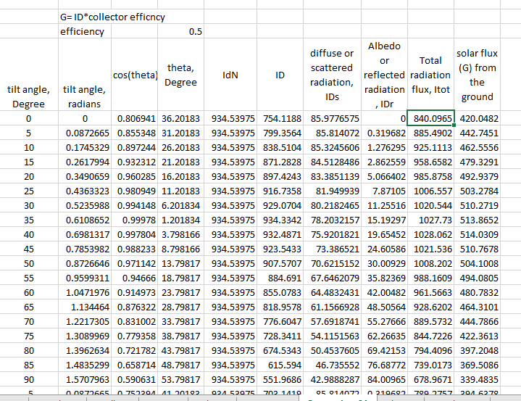
clc
clear all
lamda=5;
r_tip=5;
r_r=[0.1 0.2 0.3 0.4 0.5 0.6 0.7 0.8 0.9 1];
for k=1:1:10;
lamda_r(k)=r_r(k)*lamda;
% fprintf(' lamda_r = %6.2f\n',lamda_r(k));
end

r=[0.5 1 1.5 2 2.5 3 3.5 4 4.5 5];
cl=1.2;
cd=0.0084;
alfa=[7 7 7 7 7 7 7 7 7 7];
alfa_rad=0.122173;
B=3;
%j=1;
for i=1:1:10;
phi(i)=atan(2/(3*lamda_r(i)));
r_R(i)=r(i)/5;

c(i)=(8*pi*r(i)*sin(phi(i))/(3*B*cl*lamda_r(i)));
section_pitch(i)=phi(i)-alfa_rad;
end
fprintf(' r/R phi chord twist angle pitch angle\n');
for j=1:1:10;
twist_angle(j)=phi(j)-phi(10);

fprintf(' %8.2f %8.1f %8.4f %8.1f %8.1f\n',r_R(j),phi(j)*180/pi,c(j),twist_angle(j)*180/pi,section_pitch(j)*180/pi);
end

\Chapter 1

Introduction

1.1emergy

1.2 yue

Chapter 2

2. Literatur review
Kgjffff
Kjkjkkj

2.1 literature
Wind turbines generate electricity through the interaction of the rotor and the wind. Horizontal wind turbines with practical designs utilize airfoils to convert the kinetic energy in the wind to useful energy. It is critical for designers to understand and learn how to calculate the optimal blade shape prior to beginning blade design, as well as how to analyze the aerodynamic performance of a rotor with known blade shape and airfoil characteristics. Different methods combine momentum theory and blade element theory to form a strip theory that enables the calculation of the characteristics of the rotor's annular section. After integration or summing, the characteristics of the entire rotor are obtained.

Chapter 3

3. theory
sslslkgs
aslllk

3.1 solar 1

