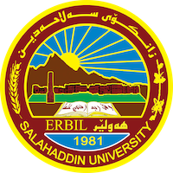
Academic Curriculum Vitae

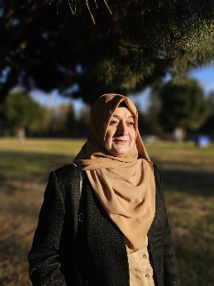
Personal Information:
Full Name: Dr. Ropak Ahmad Sheakh Mohamad
Academic Title: Lecturer
Email: ropak.shekhmohamad@su.edu.krd
Mobile: +964750 000 0000

Education:
From- To | Degree | College-University | Country
2021 to date | PhD in Physical Organic Chemistry, Department of Chemistry | College of Science- University of Salahaddin | Iraq
1996-1997 | M. Sc. in physical Chemistry, Department of Chemistry | College of Science- University of Salahaddin | Iraq
1989-1993 | B.Sc. Chemistry, Department of Chemistry, | College of Science- University of Salahaddin | Iraq

Employment:
Assignments and Posts:
From- To | Post | Department -College | University
2021 to date | Lecturer | Chemistry Department-College of Science | Salahaddin University
1997-2015 | Assistant Lecturer | Chemistry Department-College of Science | Salahaddin University
1993-1995 | Assistant Chemist | Chemistry Department-College of Science | Salahaddin University
For Two years | Member of Examination Committee | Chemistry Department-College of Science | Salahaddin University

Teaching experience:
- Teaching Activities
From- To  1997-2023 | Subject | Stage-College | University
For One year | Physical Chemistry- Theoretical Part  Kinetics of Chemical Reactions  -Electro Chemistry | 3rd - year students / Chemistry Department-College of Science | Salahaddin University-Erbil
For One year | Physical Chemistry- Theoretical Part  Chemical Equilibria and Solution | 2nd year students / Chemistry Department-College of Science | Salahaddin University-Erbil
For many years | Physical Chemistry- Practical Part  -Electro Chemistry  -Kinetics of Chemical Reactions | 3rd - year students / Chemistry Department-College of Science | Salahaddin University-Erbil
For many years | Physical Chemistry- Practical Part  -Thermodynamics  -Chemical Equilibria and pace rule | 2nd year students / Chemistry Department-College of Science | Salahaddin University-Erbil
For many years | General Chemistry- Practical Part | 1st- year students / Biology Department, Geology Department-/College of Science | Salahaddin University-Erbil
For many years | Physical Chemistry- Practical Part | 2nd- year students / Pharmacy College | Salahaddin University-Erbil

Research and publications
Published articles, papers and researches:
- Crystal structure and Hirshfeld surface analysis of 4-{[(E)-4-(heptyloxy) benzylidene] amino}-N-(naphthalen-2-yl)-1, 3-thiazol-2-amine Acta Crystallographica Section E: Crystallographic Communications Vol. (76) No. (7) 2020
- Crystal structure and Hirshfeld surface analysis of 4-(naphthalen-2-yl)-N-[(Z)-4-propoxybenzylidene]-1, 3-thiazol-2-amine Acta Crystallographica Section E: Crystallographic Communications Vol. (76) No. (6) 2020
- Crystal structure and Hirshfeld surface analysis of (E)-N-(4-propyloxybenzylidene) benzo [d] thiazol-2-amine Acta Crystallographica Section E: Crystallographic Communications Vol. (76) No. (10) 2020

Conferences and courses attended
- Training course in Teaching methods, College of Education Univ. of Salahaddin (1996).
- Training course in English language related to UNOSKO, Arts college Univ. of Salahaddin (2001).
- Training course in computer, Science College Univ. of Salahaddin (2009).
- Training course in English language,Basic Education Univ. of Salahaddin (2009).
- Training course in computer, Science College Univ. of Salahaddin (2011).
- Training course in e-Learning, Salahaddin Univ. e-learning center (2011).
- - English language proficiency course / Intermediate in 2018 (Six-week)
- - English language proficiency course / Upper Intermediate in 2019 (Six-week)
- - English language proficiency course / Advanced in 2019 (Six-week)

Professional memberships
- From 2000 to date member in Kurdistan Chemist’s Syndicate
- From 2007 to date member in Kurdistan Teachers Union
Professional Social Network Accounts:
ORCID ID: https://orcid.org/0009-0009-1998-3901
Academic Profile: https://academics.su.edu.krd/ropak.shekhmohamad
LinkedIn:https://www.linkedin.com/in/ropak-sheakhmohamad-b85591122/
Scholar Account: https://scholar.google.com/citations?user=YOd0rr8AAAAJ&hl=en
Research gate: https://www.researchgate.net/

