





Calculate the max λ for the following compounds :

**Problem 1 :**



Homo diene 253 nm

**Problem 2 :**



Homo diene 253 nm

Problem 3 :



Homo diene 253 nm

Problem 4 :



**Hetero diene 214 nm**

**Problem 5 :**



**Homo diene 253 nm**

**Conjugated enones problems :**

**Problem 1 )**



**Six memberede ring ketone 215 nm**

**Problem 2)**



**Six membered ring ketone 215 nm**

**Problem 3)**



**Five membered ring 202 nm**

**Problem 4)**



Six membered ring ketone 215 nm

5) **C**hoose the structure that best fits the infrared spectrum shown

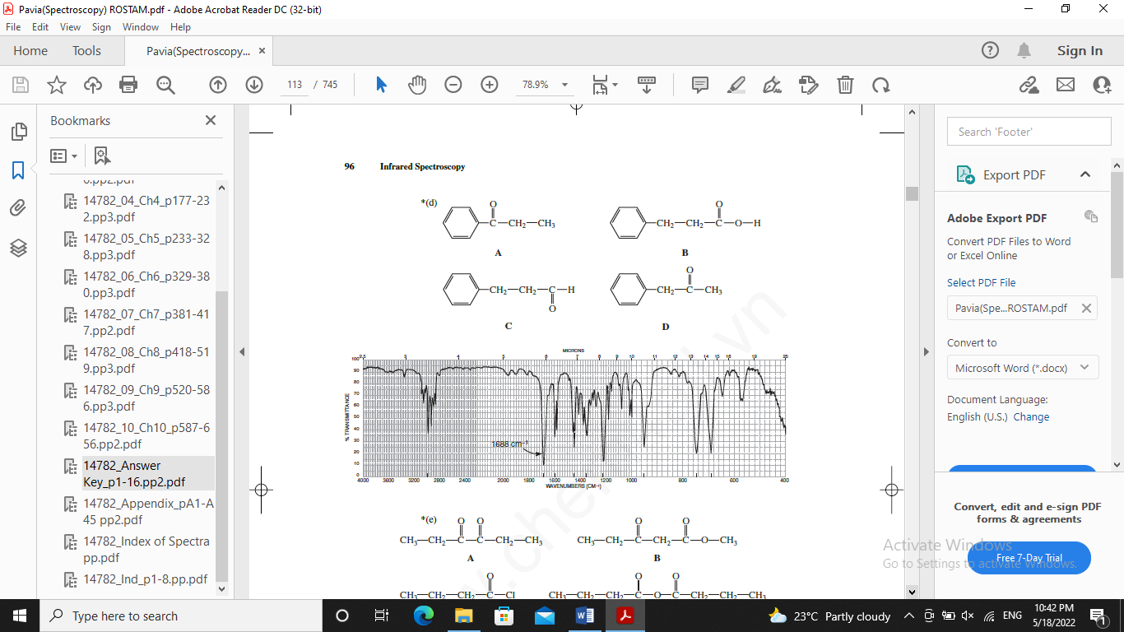



Predict the appearance of the NMR spectrum of *n*-propyl bromide.

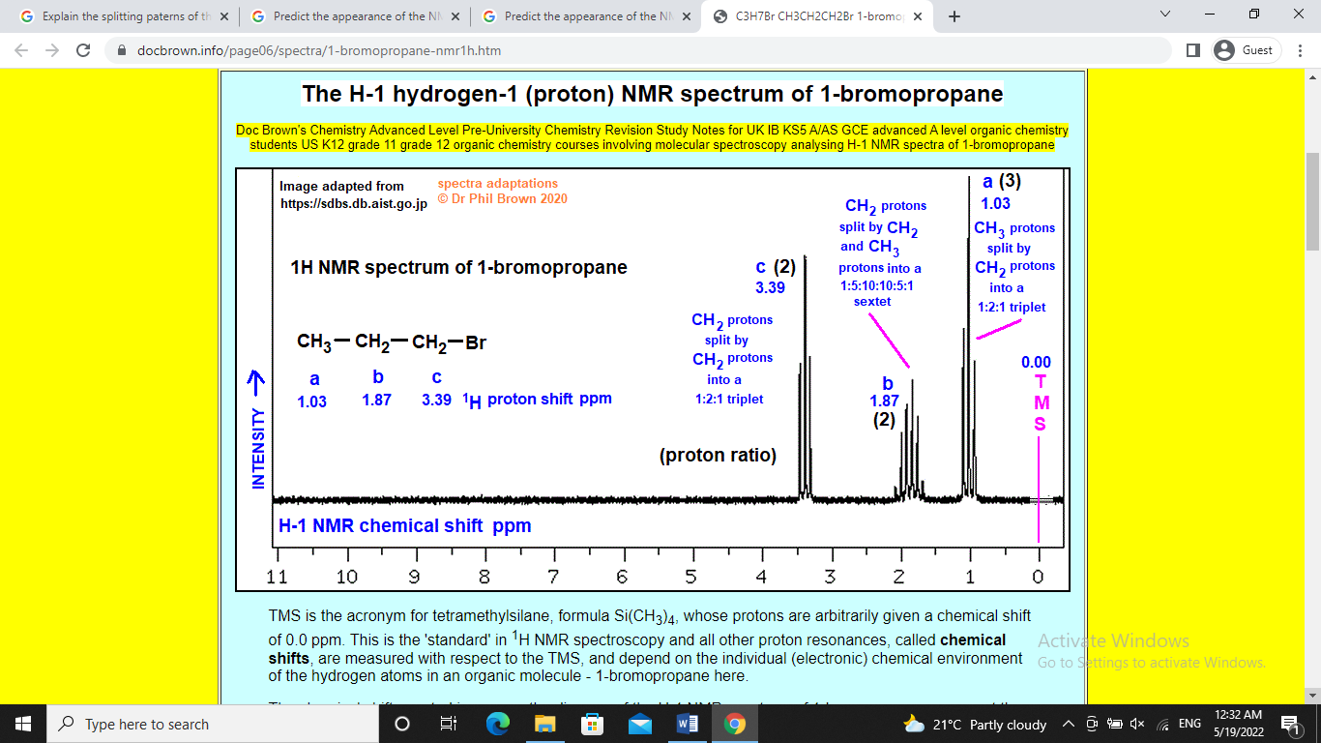

Q)

For molecules, however, the UV absorption usually occurs over a wide range of wavelengths ?

Q)

What is the effects of polar and nonpolar solvents on an uv-absorption band ?

7- A substance has the molecular formula C4H9N. Is there any likelihood that this material contains a triple bond? Explain your reasoning.

The main constituent of cinnamon oil has the formula C9H8O. From the following infrared spectrum, deduce the structure of this component.

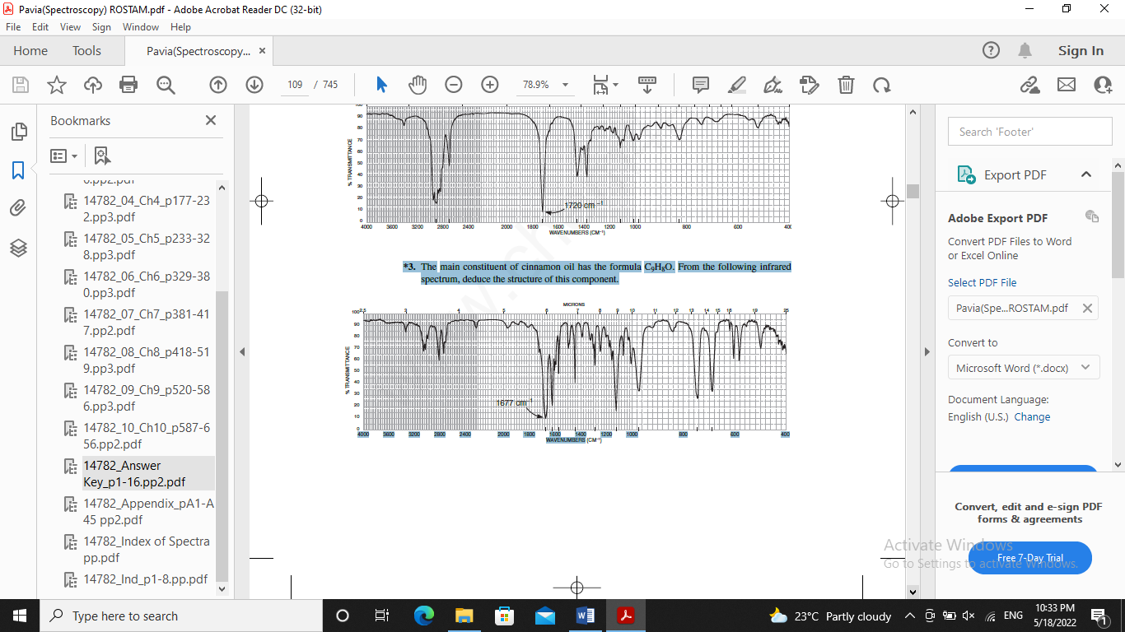

Along with the following NMR spectrum, this compound, with formula C5H10O2, shows bands at 3450 cm–1 (broad) and 1713 cm–1 (strong) in the infrared spectrum. Draw its structure.

