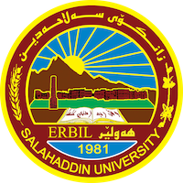
Academic Curriculum Vitae
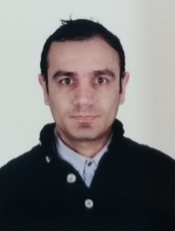
Personal Information:
Full Name: Rozgar Yousif Omar
Academic Title: Lecturer
Email: rozgar.omar@su.edu.krd
Mobile: +9647504510668

Education:
- University of Salahaddin-Erbil PhD student in Linguistics, 2020-present
- University of Newcastle (UK) MA in Linguistics, 2012-2013
- University of Salahaddin-Erbil BA in Translation, 2005-2009
Employment:
- Lecturer at University of Salahaddin-Erbil 2013 - Present
- Consultant at HIWAYFIRDOWS Ltd. (ACP & Glasses) 2015 - 2017

Qualifications
- Teaching Methods Salahaddin University-Erbil, License MT15 March 2014

Teaching experience:
- GEfUS at College of Science, SUE
- Cutting-Edge at SUE Language Center

Research and publications
- Omar, R. and Jawzal, N. (2021). English lexical enrichment: methods and their frequency/productivity in 1785, 1885, and 1985. Academic Journal of Nawroz University, 10 (1) 28-35. https://journals.nawroz.edu.krd/index.php/ajnu/article/view/706/523
- Jawzal N. and Omar, R. (2020). The Loss of English Directional Adverbs: An Empirical Study. ZANCO Journal of Humanity Sciences (JAHS), Volume 24 (3) 315-324. http://zancojournals.su.edu.krd/index.php/JAHS/article/view/3410/2289
- Kareem, M., Omar, R. and Ghazi, A. (2018). Narratology: Applying Simpson’s Modality in Kafka’s The Judgement. Scientific Journal of Cihan University-Erbil, 2 (1) 91-99.
- Omar, R., (2017). Problems and strategies of translating Gogol’s Шинель (Shinel) from Russian and English versions into Kurdish. Journal of Raparin University, 4 (11) 25-32. http://ojournal.uor.edu.krd/ArchivedIssues/English/02.pdf

Conferences and courses attended
- Open Speaker at West Asia Mathematical School WAMS-CIMPA Conference, December 2015
- Open Speaker at West Asia Mathematical School WAMS-CIMPA Conference, December 2016
- Organizing committee member at 6th International Conference and Workshops on Basic and Applied Sciences (6th ICOWOBAS), March 2017
- Organizing committee member at Second International Conference of Mathematics in Erbil (SICME), February 2019
- Conference Secretary at Second International Conference of Mathematics in Erbil (SICME), February 2019
- Organizing committee member at Gathering Mathematics Researchers: Meeting with Caucher Birkar, April 2019
- Conference Secretary at Third International Conference of Mathematics & Its Applications in Erbil (TICME), August 2022
- Training, Garnet Education, October 2013
- Course, Teaching Methods MT15, March 2014

Funding and academic awards
HCDP Scholarship/MA
Ministry of Higher Education and Scientific Research, KRG
September 2011

Professional memberships

Professional Social Network Accounts:
- https://www.researchgate.net/profile/Rozgar-Omar

