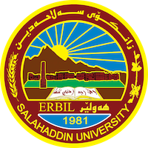
Academic Curriculum Vitae
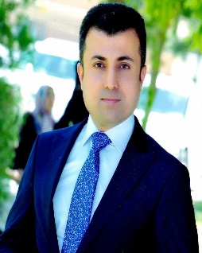
Personal Information:
Full Name: Rozhgar Muhamadamin Ali
Academic Title: Assistant Lecturer
Email: ( rozhgar.ali@su.edu.krd )
Mobile: 0750 446 2550

Education:
I am PhD student at College of Arts-Salahaddin University-Sociology Department. Also, I am an instructor at Philosophy Department. I have two Bachelor Degrees; one of them is in Sociology at Salahaddin University and the other is in Law at the same university. Moreover, I have Master's Degree in Sociology at Alexanderia University in Egypt. I have more than seven years of professional experience in teaching various subjects at university. I have worked and experienced in Civil Community Organizations. I am also vice president of Kurdistan Organization for Transparency. Similarly, I have worked as a trainer about election subjects.

Employment:
- I have been teaching sociology and philosophy for over (10) years.

Qualifications
- Scientific Title
- Language qualification at Salahaddin University-Language Center

Teaching experience:
- I have taught (Political Philosophy, Educational Philosophy, Philosophical Contexts in Arabic Language, Academic Debate). Courses, trainings, lab supervision, etc.,

Research and publications
- The role of the Kurdish community in protecting the heritage and its holdings in promoting the Kurdish identity in Erbil Governorate.
- The role of the multi-party system in social stability after the 1991 uprising in the city of Erbil.
Conferences and courses attended
- Give details of any conferences you have attended, and those at which you have presented delivered poster presentations.

Funding and academic awards
- List any bursaries, scholarships, travel grants or other sources of funding that you were awarded for research projects or to attend meetings or conferences.

Professional memberships
- List any membership you hold of any professional body or learned society relevant to your research or other life activities.

Professional Social Network Accounts:

- List your profile links of ReserchGate, LinkedIn, etc.

It is also recommended to create an academic cover letter for your CV, for further information about the cover letter, please visit below link:
https://career-advice.jobs.ac.uk/cv-and-cover-letter-advice/academic-cover-letter/

