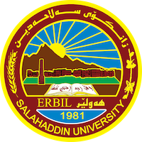
Academic Curriculum Vitae
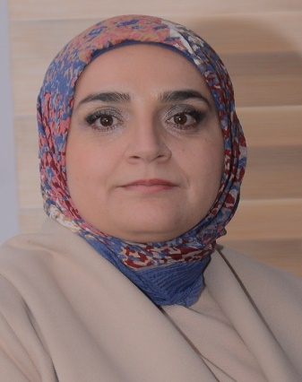
Personal Information:
Full Name: Runak Hussein Mustafa
Academic Title: Assistant Lecture
Email: runak.mustafa@su.edu.krd
Mobile:

Education:
1) B. Sc. in Mathematics, Mathematics Department - College of Basic Education - Salahaddin University -Erbil in 2005.
2) M. Sc. in Mathematics. Mathematics Department - College of Basic Education – University of Sulaimani – Sulaimani in 2010.

Employment:
- State employment starting from first employment
- 24/11/2005 College of Basic Education\ Department of Mathematics.

Qualifications
- Certificate of computer training course (ICDL) started from 3/2/2013 to 13/3/2013 College of Education, Salahaddin University-ERBIL.
- Certificate of teaching methods course started from 15/1 2011 to 2/3/2011 College of Law, Salahaddin University-ERBIL
- Online course of development started from 4th to 8th November Avicenna center of learning-Salahaddin University-ERBIL.
- Certificate of completion (Child Friendly School Training , College of Basic Education, Salahaddin University-ERBIL, for the period 26-31 December 2013.
- IELTS

- Teaching qualifications
- IT qualifications
- Language qualifications such as TOEFL, IELTS or any equivalent
- Any professional qualification
- You could put any professional courses you have attended

Teaching experience:
- State all teaching courses you delivered, stating undergraduate or post graduate
- Courses, trainings, lab supervision, etc.,
(B. Sc.) students
- Abstract Algebra. (3rd Math. )
- Linear Algebra. (2nd Math.)
- Finite Mathematics. (1st Math.)
- Calculus (1st Math.)
- Advanced Calculus
- Linear Mathematics (Optional) (4th Math.)
- Information Technology ( 1st Math.

Research and publications
- State all researches, publication you made.

Conferences and courses attended
- Give details of any conferences you have attended, and those at which you have presented delivered poster presentations.

Funding and academic awards
- List any bursaries, scholarships, travel grants or other sources of funding that you were awarded for research projects or to attend meetings or conferences.

Professional memberships
- List any membership you hold of any professional body or learned society relevant to your research or other life activities.
- Research Assistant, Dept. of Mathematics, College of Basic Education, University of Salahaddin-Erbil, 2005-2008.
- Assistant Lecturer, Dept. of Mathematics College of Basic Education, University of Salahaddin-Erbil, 2010-2018.
- Vice head of Mathematics Dept. 23/6/2011 to 23/4/2014.
- Member of Examination Committee in College.
- Member of Scientific Committee in Mathematics dept.
- Member of Quality Assurance committee in Math. Dept. 2018.

Professional Social Network Accounts:

Google Site: https://sites.google.com/a/su.edu.krd/runak-hussein-mustafa
Research gate: https://www.researchgate.net/profile/Runak_Hussein2
LinkedIn: https://www.linkedin.com/in/runak-hussein-5a9968122/

It is also recommended to create an academic cover letter for your CV, for further information about the cover letter, please visit below link:
https://career-advice.jobs.ac.uk/cv-and-cover-letter-advice/academic-cover-letter/

