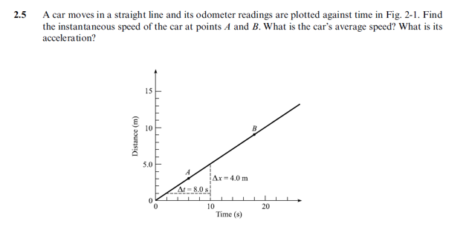
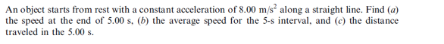
Q1;
----------------------------------------------------------------------------
Q2;
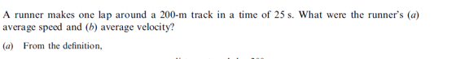
----------------------------------------------------------------------------
Q3;

-------------------------------------------------------------------------------
Q4;

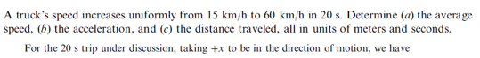
Q5;

Q6;
Q7;
Q8;

Q9;

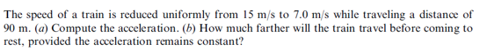
Q10;

