Water Resources Department
College of Engineering
University of Salahaddin
Subject: Reinforced concrete
Stage: 3rd Year
Lecturer's name: Rushdi Khalis Esa
Academic Year: 2020/2021

Design of Concrete Structure
References:
1-Nilson A.H and et.al. ''Design of concrete structure '' Thirteen edition 2013
2- Wang C.K and Salman C.G ''Reinforced concrete Design 4th edition 1985
3- Ferguson P.M ''Reinforced Concrete Fundamental 4th edition 1981
4- Syal I.C and Goel A.k '' Reinforced Concrete Structure '' 2nd edition 1987

Codes:
- ACI 318-02 ''Building Code Requirements For Structure concrete''

Syllabuses:
- Introduction: Material properties, Loads
- Flexural behavior of beams
- Working stresses
- Design of rectangular reinforced concrete beams by working stresses method
- Ultimate strength method
- Singly reinforced rectangular beams
- Doubly reinforced rectangular beams
- T-beams
- Irregular beams
- Shear and diagonal tension
- Continuous beams
- One way slabs
- Two way slabs
- Short columns
- Long columns
- Band, anchorage and development length
- Serviceability

Reinforced Concrete:
Reinforced concrete is a strong durable building material that can be formed into many varied shapes and sizes .it utility and veracity are achieved by combining the best features of concrete (Plain Concrete) and steel. Where the properties of these two materials are as follow:

Properties Concrete Steel
Strength in tension Poor Good
Strength in compression Good Good
Strength in shear fair Good
Durability Good corrodes if unprotected
Fire resistance Good Poor-suffers rapid loss of strength at high temperature

From above, when they are combined the steel is able to provide the tension strength and probably some of the shear strength while the concrete strong in compression protects the steel to give durability and fire resistance.

Composite action:
The tensile strength of concrete is only about 10-15 % of the compressive strength so reinforcement is designed to carry these tensile forces. Which are transferred by bond is not adequate the reinforcing bars will just slip within the concrete and there will not be composite action.

- The coefficient of thermal expansion for steel and for concrete are of the order 10 ×10⁻⁶ per ºC and 7-12 ×10⁻⁶ per ºC respectively. These value are sufficiently close that problems with bond seldom arise from differential expansion between the two material over normal temperature range.

- Where tension occurs it is likely that cracking of the concrete will take place. This cracking however does not detract from the safety of the structure provided there is good reinforcement bond to ensure that the cracks are restrained from opening so that embedded steel continues to be protected from corrosion

Concrete:
Plain concrete is made by mixing : cement, fine aggregate(sand), coarse aggregate (gravel), water and frequently admixtures

Compressive Strength:
The compressive strength of concrete is denoted in the us by fc̀, which is the compressive strength in Mpa of test cylinder diameter 150mm ×300mm high measured on the 28th day after they are made In UK, the standard unit is the cube (150 mm for each side) for normal strength concrete, the relationship of strength between two sides it is the strength of cylinder fc̀ equal 0.8 from strength of concrete for cube by side 200mm.
For normal using concrete of strength it 20 to 28 Mpa

Stress-Strain Curve:
For concrete
The stress-strain its important under compression because the concrete uses to resist the compression. The fig 1-1 explain the stress – strain concrete for fc̀ =30 Mpa
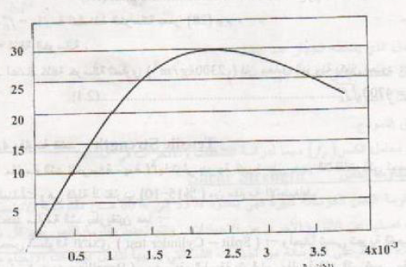

Fig 1-1 Strain-stress for concrete for fc̀ =30 Mpa
Noted the stress-strain be in straight line approximately from third to half max strain after that its be proportional non linear

For steel
The two properties decided the type of steel its yield point which it be equal in tension, compression and modules of elasticity Es its be equal in all type steel 200000 Mpa
The stress – strain curve for steel its be in strait line for beginning load until apoint after that the curve transfer going to a horizontal line this point called yield point at that point known by yield strength fy. After this stage the stress is increase by increasing strain again but in lower rates this process called strain hardening. The curve is a level when arrive to max strength after that a curve began to come down until failure happens.

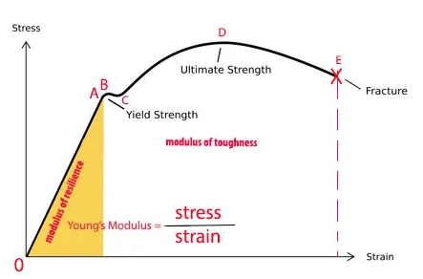

Modulus of elasticity:
That’s percentage between the variable of stress over the variable of strain its equal for tangent of stress-strain curve and its be change by strength of concrete and depended also on concrete age and property of sand,gravel,cement,shape and size a sample and it can be define:
1-initial tangent modulus: its represent the slope of tangent at being point
2-Secant modulus: its slope intersection connect between the original point and stress arranged 25% to 50% from strength compression Fc̀
E_{c} The symbol of modulus of elasticity
E_{c} =$w^{1.5}($0.043)$\sqrt{fc'}$
$f_{c`}$: Compression strength of concrete at 28 days
W: Concrete density
If we depend the concrete density its equal to 2300kg/m3 so the modulus of elasticity be
E_{c}=4700 $\sqrt{fc'}$

Tensile strength:
The strength of concrete in tension is also an important that greatly affects the extent and size of cracking in structure it is about 10-15% of $fc̀$ tensile strength is usually determined by using the split cylinder test in which same size cylinder used for compression test is placed in the test machine lying on its side so that the compression load p is applied uniformly along the length of cylinder in the direction of the diameter. The cylinder will split in half when tensile strength reached. Tensile strength $fct$ is computed
$fct$=$\frac{2p}{πdl}$
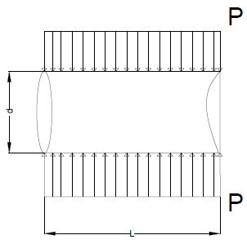
$fct$ Has been found to be proportional to$\sqrt{fc'}$
$fct$ =0.56$\sqrt{fc'}$ Mpa for normal weight concrete
Tensile strength in flexure known as modulus of rupture, it is also important when considering cracking and deflection of beams
The modulus rupture $fr$ computed
$fr$=$\frac{M.c}{I}$ =$\frac{6P}{h3}$
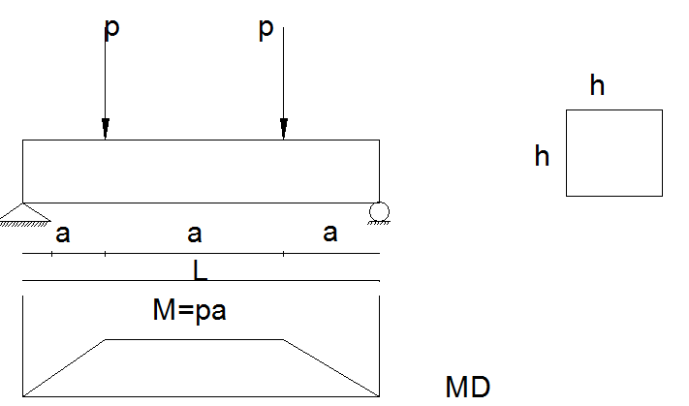
$fr$ give higher value for tensile strength than the split cylinder test
$fr$ =0.7$\sqrt{fc`}$ (Mpa) (for normal weight concrete)

Concrete weight ($γ_{c}$):
- Normal weight concrete =2320 kg/m³
- Normal weight reinforced concrete = 2400 kg/m³
- Light weight concrete=1120-1840 kg/m³
- Heavy weight concrete= 3200-5600 kg/m³

Steel reinforcement:
Steel reinforcement may consist of bars, welded wire, fabric or wire. For construction bars have deformation are used

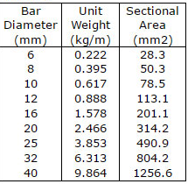

- Weight of steel W_{s} =7850 kg/m³
- Modulus of elasticity for all non prestressed steel may be taken Es=200000 Mpa
- 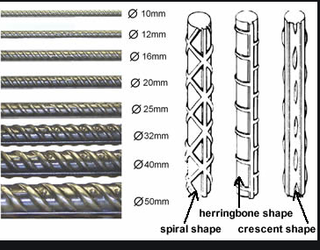
Types of deformed bars

Loads
Divided in to
Dead loads, live loads and environmental loads

-Dead loads: that are constant in magnitude and fixed in location throughout the life time of the structure (weight of the structure itself+ finishing + piping + and lighting fixtures)
Material Concrete steel Granit Brick Mortar Blaster Tile
Ten/m³ 2.4 7.85 2.8 2 2 2 2.4

-Live loads: there are magnitude and distribution at any given time are uncertain and even their maximum intensities throughout the life time of the structure are not known with precision.

-Environmental loads: like live loads, environmental loads at any given time are uncertain both in magnitude and distribution. These loads consist mainly of snow loads, wind pressure, earthquake loads, soil pressures, loads from rain water and forces caused by differential.
Design concept:
Must be satisfied
- Serviceability requirement : that deflections be adequate small, crack be limit, vibration be minimized, etc
- Strength requirement: must be safe against collapse and strength of structure be adequate for all loads that might act on it.

Strength requirement:
Assumption of design
- All internal stress must be in equilibrium with all external actions
∑Fx = ∑Fy = ∑M =0 at any section

2- Plan section before bending remain plan after bending (liner strain distribution)
- Strain in reinforcement shall be assumed to be equal to that of concrete at reinforcement level (we assume perfect bend between steel and concrete)
- In a cracked section all concrete in tension shall be neglected

Analysis and design of beam under flexural stress

Behavior:
There are three stages:
- Un-cracked stage
- Cracked stage
- Ultimate strength stage

- Elastic un-cracked section

f_{c}˂ 0.45f_{c}' concrete elastic
fs ˂ fy steel elastic
f_{ct} ˂ f_{r} Un-cracked

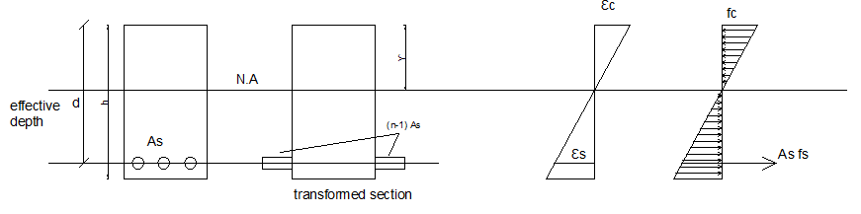
ε_{s}= ε_{c}
F_{s}=F_{c}
E_{s}=E_{c}
Fs=$\frac{Es}{Ec}$ Fc …………….Fs=nFc
n=$\frac{Es}{Ec}$=$\frac{200×{10}^{3}}{4700\sqrt{fc̀}}$ (Modular ratio)

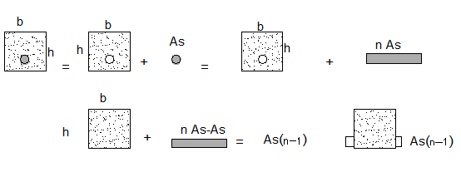

$ỳ=\frac{\sum{Ay}}{\sum{A}}$ = (bh) ($\frac{h}{2}$) + (n-1) A_{s} d
$I_{N.A}$=$\frac{bỳ^{3}}{3}$ + $\frac{b{\left(h-ỳ\right)}^{3}}{3}$ + $\left(n-1\right)As$ ${\left(d-ỳ\right)}^{2}$
$$f_{ct}=\frac{M.c}{I}$$
$f_{ct}=\frac{M_{max}\left(h-ỳ\right)}{I_{N.A}}$ $<$ $f_{r}$ $\left(f_{y}=0.7\sqrt{{fc}^{̀}}\right)$

$f_{c}=\frac{M_{max}\left(h-ỳ\right)}{I_{N.A}}$ $<$ 0.45${fc}^{̀}$
$f_{s}=\frac{M_{max}\left(d-ỳ\right)}{I_{N.A}}$ . n $<$ $f_{y}$

- Elastic – cracked section

$f_{ct}$ $>$ $f_{r}$

$f_{c}$ $<$ $045{fc}^{̀}$ concrete elastic

$f_{s}$ $<$ $f_{y}$ Steel elastic

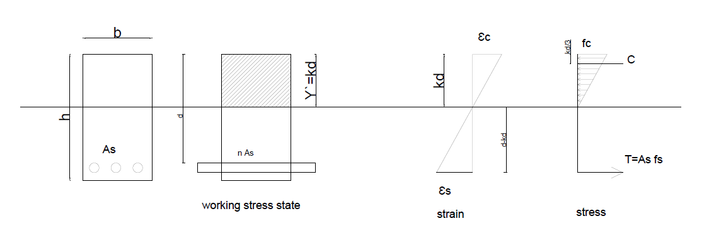

C=T C=$\frac{b kd fc}{2}$ T=$A_{S }F_{S}$

M= T j d = c j d j=1-k/3

N.A Location:
Moment of compression area about N.A=Moment of tension area about N.A
b.kd.(kd/2) = nA_{S} (d-kd)
Let $ρ=\frac{A_{S}}{bd}$ steel ratio
$$A_{s}=ρbd$$
b.k² d²/2 = n$ρbd^{2}$ (1-k)
$$\frac{k^{2}}{2}=nρ-nρk$$
$$k^{2}+2ρnk-2ρn=0$$
$$k=-\frac{2ρn}{2}+\sqrt{\frac{{(2ρn)}^{2}-4(-2ρn)}{4}}$$
$$k=-ρn+√{(ρn)}^{2}-2(ρn)$$
$$k=√{(ρn)}^{2}-2(ρn)-ρn$$
$$I_{N.A}=\frac{b{(kd)}^{3}}{3}+nA_{S}{(d-kd)}^{2}$$

$$f_{c}=\frac{M.C}{I}=\frac{M_{Max}kd}{I_{N.A}} <0.45 f_{\grave{c}}$$
$fs=\frac{M C}{I} . n= \frac{M_{max} (d-kd)}{I_{N.A}} . n < f_{S}$

EX: DETERMINE THE STRESS IN CONCRETE AND STEEL IF
- M=35 KN.M
- M= 95 KN.M
WHERE fc`=21 MPA , fy =414 and As =1847mm²

300 mm
y`
500 mm
80 mm

Assume uncracked section
SOLUTION:
Ec=4700$\sqrt{f_{c^{`}}}$ =21538 Mpa
Es = 200000 Mpa
$n=\frac{200000}{4700\sqrt{21} }$ = 9.29 use n=9
( fct < fr )
$y^{`}=\frac{300*500\left(\frac{500}{2}\right)+\left(9-1\right)*1847(500-80)}{300*500+\left(9-1\right)*1847}$= 265 mm
$I_{N.A}=\frac{300{(265)}^{3}}{3}+\frac{300{(265)}^{3}}{3}+\left(9-1\right)*1847{(420-265)}^{2}$
= 3.514 *10⁹ mm⁴
$f_{ct}=\frac{M C}{I}$ M_{C} =$\frac{fr .I}{C}$
fr=0.7$\sqrt{f_{c^{`}}}$ =3.2 Mpa

M_{cr} =$\frac{3.2*3.514*{10}^{9}}{(500-265)}=$ 47850212 N.mm *10⁻⁶
=47.85 Kn.m

- For M=35 Kn.m

؞ M < M_{cr}

$fct=\frac{35*{10}^{6}*235}{3.514*{10}^{9}}=2.34 N/{mm}^{2}$ $<fr$
$fc=\frac{35*{10}^{6}*265}{3.514*{10}^{9}}=2.64$ $N/{mm}^{2}$

$fs=\frac{35*{10}^{6}*(500-80-265)}{3.514*{10}^{9}}*9=13.89$ $N/{mm}^{2}$

- For M=95 Kn.m
M > M_{cr}
؞ crack section (y`-kd)

K=$\sqrt{{(ρn)}^{2}+2ρn}$ – $ρn$

d
nAS
b
kd

$$ρ=\frac{AS}{bd}=\frac{1847}{300(500-80)}=0.01466$$

$$ρn=9*0.01466=0.13194$$
K=$\sqrt{{0.13194}^{2}+2(0.13194)}$ – $0.13194$

=0.3984

$$I_{N.A}=\frac{300{(0.3984*420)}^{3}}{3} +9*1847* {(420-420*0.3984)}^{2}$$

= 1.53 * 10⁹ mm⁴

$f_{c}=\frac{M C}{I_{N.A}}$ = $\frac{95*(0.3984*420)}{1.53*{10}^{9}}*{10}^{6}$ N.mm/kN.m

= 10.39 N/mm²

Or $f_{c}= \frac{2M}{{kjbd}^{2}}=10.39 N/{mm}^{2}$

$$f_{s }=9* \frac{95*\left(420-420*0.3984\right)* {10}^{6}}{1.53* {10}^{9}}=141.2 \frac{N}{{mm}^{2}}$$

Or $f_{s}= \frac{M}{As j d}$=$\frac{95* {10}^{6}}{1847 \left(1-\frac{0.3984}{3}\right)420}$ = 141.2 $\frac{N}{{mm}^{2}}$

EX: Find the maximum applied stress in the following beam, take $f_{c^{`}}=210$, $f_{y}=414 Mpa$ (Neglect self-wight)

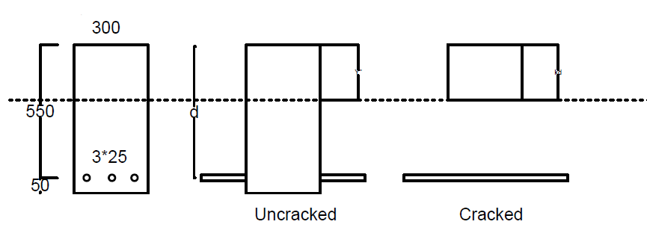
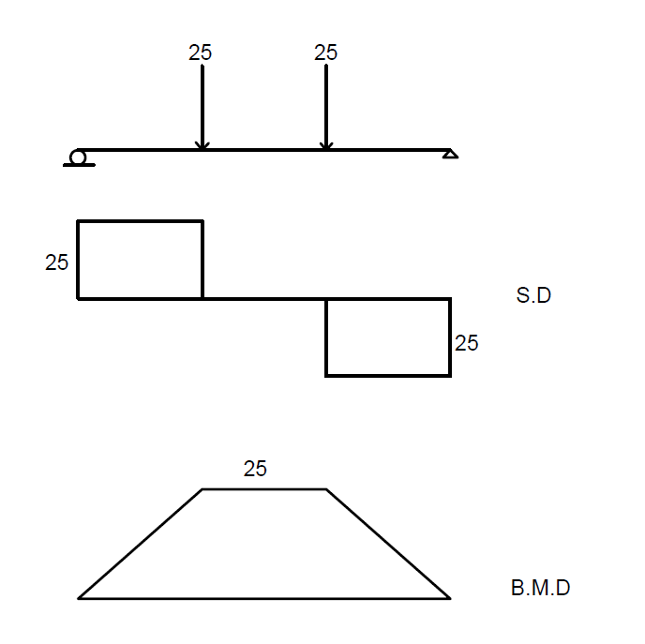

Sol:
As = 3*$\frac{{25}^{2}}{4}$ $π$ =1473 mm²
E_{C} =4700$\sqrt{f_{c^{`} }}$ =21538 Mpa
Es = 200000 Mpa
$f_{r}=0.7\sqrt{f_{c^{`}}}$ =3.2 Mpa
$$n=\frac{E_{S}}{E_{C}}=9.3 USE 9$$
$ρ=\frac{A_{s}}{bd}$ = $\frac{1473}{300*550}=0.00893$
$$ρn=0.0803$$
Assume uncracked section

$y^{`}=\frac{600*300*300+\left(9-1\right)*1473*550}{600*300+\left(9-1\right)*1473}$= 315.4 mm

$$I_{N.A}=\frac{300{\left(315.4\right)}^{3}}{3} +\frac{300{\left(284.6\right)}^{3}}{3}+9*1473* {\left(550-315.4\right)}^{2}$$

=6.09 *10⁹ mm⁴

M_{C} =$\frac{fr .I}{C}= \frac{3.2*6.09*{10}^{9}}{284.6* {10}^{6}}=68.5 kN.m$

Since $M>M_{cr}$ ؞ Cracked sec.

K=$\sqrt{{(ρn)}^{2}+2ρn}$ – $ρn$
K=0.3285 j=1-k/3= 0.891 kd=180.7

$f_{c}= \frac{2M}{{kjbd}^{2}}$ = $\frac{2*100*{10}^{6}}{0.3285*0.891*300* {550}^{2 }} =7.53 Mpa$
$$f_{s}= \frac{M}{Asjd}= \frac{100*{10}^{6}}{1473*0.891*550}$$

