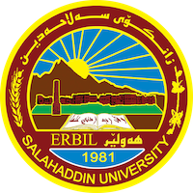
Academic Curriculum Vitae

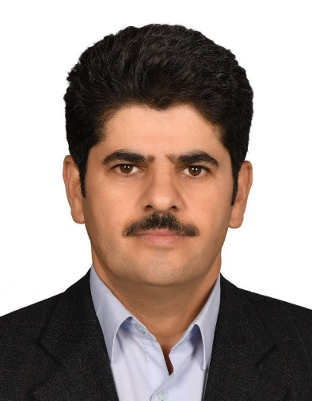
Dr.Saad Abdolrazzagh Ghazi
Email: saad.qazi@su.edu.krd phone: 07512255111
Address: Iraq / Erbil / Naz City apartment / Building A
Birth: Erbil 1/9/1966 Marital status: Married Academic Title: Lecturer Nationality: Kurd

About me
My main concern and focus is language. I believe language is a way to reach justice, freedom and human rights. I dedicated most of my life to these goals and I will continue to do so.

Education
- PHD at “language policy and planning in education system of the Kurdistan Region” From 2015 to 2019 in Carleton University and Salahaddin University-Erbil
- Master degree at Persian Language and Literature
From 2008 to 2010 in Urmia University
- Bachelor degree at Persian Language and Literature
from 1992 to 1996 in Islamic Azad University of Mahabad
Employment

- Lecturer in Urmia University from 2010 to 2012.
- Lecturer in Salahaddin University-Erbil from 2012 till current time.
- Member of the Board of Directors of “Khani Institute” in Urmia for eight years

Qualifications

- English language course from 2016 to 2017 and 2020 to 2021
- Microsoft office course intermediate level
- Expert in methodology
- Expert in Sociolinguistics

Languages

- Kurdish: (reading, writing, listening, speaking): Native.

- English: (reading, writing, listening, speaking): Advance.

- Arabic: (reading, writing, listening,speaking): Intermdiate.

- Persian/Farsi: (reading, writing, listening, speaking): Advance.

Key Skills

- Social Writer on policy, literature, critical literature, and satire
- Poet
- Computer skills (word, excel, PowerPoint, basic petrel, basic eclipse).
- Great leadership skills teamwork.
- High energetic and public motivator.
- Ability to work under pressure and adaptability.
- Highly social and good communicator.

Research and publication

- Language policys and planning in the education system of the Kurdistan Region / Salahaddin University-Erbil / 2020
- Poetry music / Urmia University / 2010

Media Activity

- Mother language / Rudaw
- Sociolinguistics / Rudaw
- Language rights / Rudaw
- Language policy / K24
- Language and education / K24
- Language and media / K24
- Language in the Barzani museum / K24
- Language planning in the Kurdish Academia / K24
- Relation of culture on language / Ava Tv
- Language planning and policy in education / Ava Tv
- Language and satire and comedy in Kurdish culture / Ava Tv
- Activities in social media

CEO and Founder of Athenaeum of Mahabad

Athenaeum of Mahabad is a cernter for gathering authures and poets of the area. In This center on the daily bases, gives people a great chanc to get in tuch with the art and it gives a chance to the artist to show their art. It’s a center for criticesm, art revew and discustion. Type of art that are shown in this center are: stry and novel, poem, speech, etc.

References

All references available upon request

