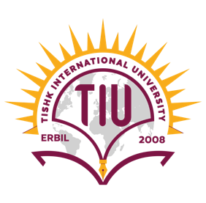

Kurdistan Region – Iraq
Tishk International University Faculty of Education
Biology Education Department

Biochemical properties of root and leaf extracts of Peruvian groundcherry on seed germination and growth of Wheat and Rapeseed

A Graduation Project Submitted to
Department of Biology, Faculty of Education
In Partial Fulfillment of the Requirements
For the Degree of
Bachelor of Science
In

Biology Education

By
Rawsht Abdulrahman Abdulsamad
Supervised by
Asst. Prof. Dr. Saber Wasman Hamad

2024
Erbil, Kurdistan Region-Iraq

