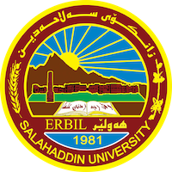
Academic Curriculum Vitae

Personal Information:
Full Name: Saber Mohammed Khudhur 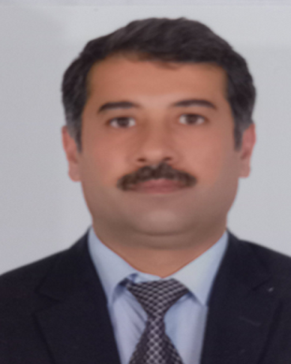
Academic Title: Lecture
Email: (saber.khudhur@su.edu.krd)
Mobile: 07504633385

Education:
- Bachelor’s degree – Salahaddin University, 1993-1994, College of science, department of biology.
- Bachelor’s degree – Salahaddin University, 2008-2009, College of Law
- Master’s degree – Salahaddin University, College of Law, 2014, Registering shares and writing them off in the stock market in Iraqi law.
- PHD- Salahaddin University, 2022, College of Law, Control over the stock market in Iraqi law.

Employment:
- Date of first appointment , 8/3/1994.
- Teacher at the Ministry of Education.
- Then I transferred my services from the Ministry of Education to the Ministry of Higher Education at 2009.
- Currently, a Lecture at College of Law / Salahaddin University.

Qualifications
- Teaching qualifications
- IT qualifications.
- Language qualifications IELTS , in 2017
- Any professional qualification
- You could put any professional courses you have attended

Teaching experience:
- State all teaching courses you delivered, stating undergraduate or post graduate
- Courses, trainings, lab supervision, etc.,

Research and publications
- State all researches, publication you made.

Conferences and courses attended
- Give details of any conferences you have attended, and those at which you have presented delivered poster presentations.

Funding and academic awards
- List any bursaries, scholarships, travel grants or other sources of funding that you were awarded for research projects or to attend meetings or conferences.

Professional memberships
- List any membership you hold of any professional body or learned society relevant to your research or other life activities.

Professional Social Network Accounts:

- Saber.khudhur@su.edu.krd.
- Saber.khudhur, facebook
- https://www.researchgate.net/profile/Saber-Khudhur.
- https://orcid.org/0009-0005-2882-8920.
- https://scholar.google.com/citations?hl=ar&user=AyJ-etUAAAAJ.

It is also recommended to create an academic cover letter for your CV, for further information about the cover letter, please visit below link:
https://career-advice.jobs.ac.uk/cv-and-cover-letter-advice/academic-cover-letter/

