Ichthyology2nd Year 2nd Lecture Theory part

Classification of Fish
Scientific classification;
Biological classification, or scientific classification in biology, is a method of scientific taxonomy used to group and categorize organisms into groups such as genus or species. Hierarchical grouping of organisms (used by Linnaeus, 1758).These groups are known as taxa (singular: taxon).
Taxonomy
Science of biological nomenclature (formal rules use according to binomial naming).
Systematics
The study of relationships between organisms; degree of similarity and variability.
Fish species are classified into two super classes;
1-Agnatha
2- Gnathostomata
The general taxonomy hierarchy of fish;
Kingdom: Animalia
Phylum: Chordata
Sub Phylum: Vertebrata
Super classes: Agnatha, Gnathostomata
Classes of Agnatha (Cephalaspidomorphi, Pteraspidomorphi)
Gnathostomata
Grade of Pisces (Fish); Chondrichthyes, Osteichthyes
Grade of Tetrapoda; Amphibia, Reptilia, Aves and Mammlia.
Characteristics of Chordates
- Presence of a notochord
This flexible skeletal rod that’s made of cartilage is what gives chordates their name. The notochord runs between an animal’s digestive tube and its nerve cord and provides support for the body. It is the precursor of a backbone, or spine, in vertebrates.
- Presence of dorsal hollow nerve cord
This is a tube made of nerve fibers that develop into the central nervous system, consisting of the brain and spinal cord, in vertebrates. This nerve cord is protected by the vertebrae, which are the bones that make up our backbone. What makes chordates different is that, in non-chordates, the nerve cords are solid and are either ventral or lateral within the body.
- Presence of gill (pharyngeal) slits
In invertebrates, this is used in feeding as a filter, while in vertebrate fish, it develops into gill arches, the function of which is to support gills. Human embryos have gillslits, but they disappear before we are born and the tissue develops into other structures in the head and neck. Generally, the tissue is modified for various purposes in terrestrial vertebrates, such as for the jaws and the Eustachian tube connecting the ear to the throat.

- Presence of post anal tail
This is a posterior elongation of the body that helps propel aquatic animals in water, provides balance, and is used by some terrestrial vertebrates to attract mates and signal when danger is near.

- Phylum Chordata is divided into four sub-phylum:

- Hemichordata.
- Urochordata.
- Cephalochordata.
- Vertebrata or Craniata

- Characteristics of Subphylum Vertebrata
- Habitat: Aquatic as well as terrestrial.
- Notochord is replaced by vertebrae or backbone.
- Symmetry: bilateral.
- Body divided into head, trunk and tail.
- Excretion: a pair of kidney.
- Circulation system: closed type.
- Fertilization; internal or external.

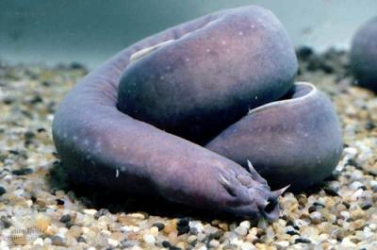
- Agnatha super class:
The general characteristics of Jawless fish are;
- Jaws are absent
- Lack paired fins
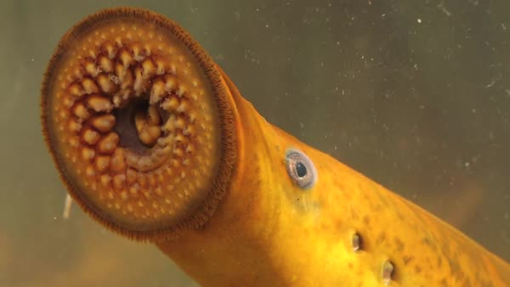
- Skeleton is made up of cartilage
- Possess round eel like body
- Absence of swim bladder and gill covers
- Soft skins , no scales
- Found in marine and fresh water
- Hagfish;
Common name is Pacific hagfishand scientific name is Eptatretusstoutii.
Kingdom: Animalia
Phylum: Chordata
Sub Phylum:Vertebrata
Supper Class: Agnatha
Class: Pteraspidomorphi
Order: Myxiniformes
Family: Myxinidae
Genus: Eptatretus
Species: stoutii

- Lamprey;
Common name: Sea Lamprey (Lake Lamprey, lamprey eel, stone-sucker, rock licker) and scientific name is Petromyzonmarinus
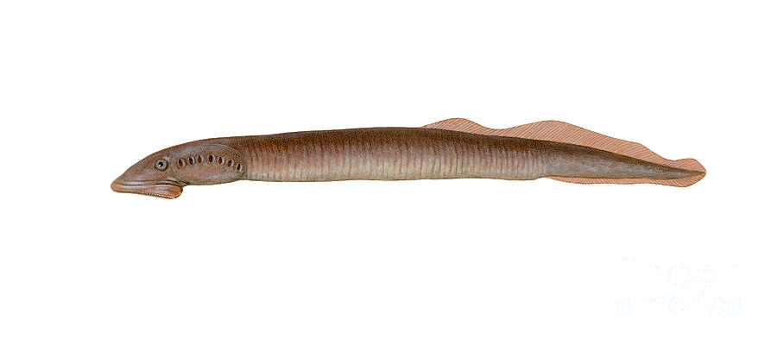
Kingdom: Animalia
Phylum: Chordata
Subphylum: Vertebrata
Super Class: Agnatha
Class: Cephalaspidomorphi
Order: Petromyzontiformes
Family: Petromyzontidae
Genus: Petromyzon
Species: marinus

2- Chondrichthyes class:
The general characteristics of cartilaginous fish are;
- Cartilage makes up the skeleton
- Body is covered with triangular placoid scales
- Possess ventral subterminal mouth
- Fins are stiff and non-flexible
- Absence of swim bladder
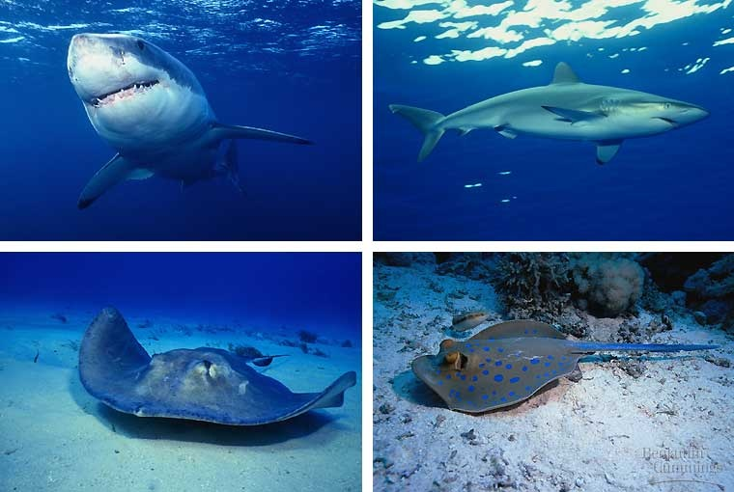
- Found in marine brackish and fresh water.

