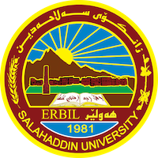
Academic Curriculum Vitae
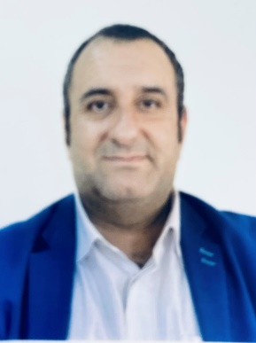
Personal Information:
Full Name:سيف الدين ابراهيم شريف
Academic Title: مامۆستاى ياريده‌ده‌ر
Email: saifddin.shareef@su.edu.krd
Mobile: 07518078786

Education:
- ماسته‌ر له‌ زمانه‌وانى و زمانه‌وانى كاره‌كى سالى 2013 مامۆستا له‌به‌شى شێوه‌كارى

Employment:
- له‌ سالى 2014 مامۆستاى ياريده‌ده‌ر

Qualifications
- خولى رِيَكاكانى وانةوتنةوة، 6 هةفتة، 2013، سةنتةرى فيركردنى بةردةوام-زانكؤى سةلاحةدين، هةوليَر .

Teaching experience:
* مامؤستا، لة قوتابخانةى كؤظانى ئيواران، لةسالى 2005 تاوةكو 2008 .

مامؤستا، لة قوتابخانةى زةردةشتى ئيواران، لةسالى 2010 تاوةكو 2012 .

* مامؤستا لةكؤليَذ ثةروةردةى بنةرِةتى لةسالَى 2014 تا 2019 .

* مامؤستا لةكؤليذى هونةرةجوانةكان لة سالى 2018 .............

Research and publications
- The Status Profile of the Individual Bilinguals in the Domain Language of KRG
- Applying Techniques in Creative Writing by EFL Students

- Conferences and courses attended
- 2019; Second Educational Conference of Colleges of Basic Education In Kurdistan Region, University of Sallahaddin - Erbil – Iraq.
- 2019; The Ninth scientific conference of the research and poster for students of the fourth and first stages in the College of Education, Salah al-Din University, Erbil.
- 2020 ; The First joint International Conference for Educational and Psychological Sciences (ICEPS) , University of Sallahaddin - Erbil – Iraq.
- 2022; 2nd Student Research Project & Idea Grant Conference SUE. University of Sallahaddin - Erbil – Iraq.

Funding and academic awards
- List any bursaries, scholarships, travel grants or other sources of funding that you were awarded for research projects or to attend meetings or conferences.

Professional memberships
- ئةندامى ليذنةى تاقيكردنةوةكان لة سالى 2015 .
- ئةندامى يةكيتى مامؤستايان .

