Environmental health Examination of Practical forest ecology Time:-1hr.
and science department
College of science- salahaddin university 3th stage

Q1/fill in the following blanks by correct words?
- Type of moisture are ------------- and----------- .
- Non resistant trees for freezing ------------,-----------and------- .
- The leaves which grow in light are ------,---------than the leaves that grow in shad.
- The --------- of wind in the upland areas measure by equipment called----------- .
- Trees affect storms which are pulling from the root and affect on the economic is -------- .
- Lyme disease causes ---------,-----,------,----------and-----------

Q2/ Define the following?
1-Wind
2- Physiological drought.
3- Stem flow
4- Heat
5-Rain
Q3/what is the measurement that taken for comparison between the seedling and talk about one of them.
Q4/ what is beaufort scale , what is meaning if the beaufort number are 3,7 and 12.
Q5/ Snow has many damages which are different according to ?
Q6/Effect of high soil tempareture on root, mention five point only?

Q7/mention name and use of the following instrument?

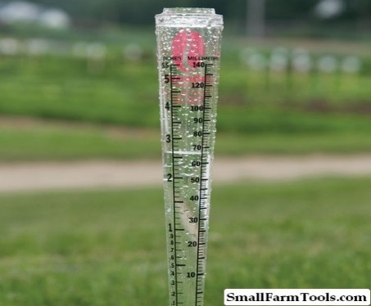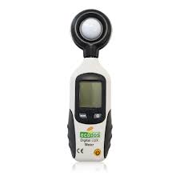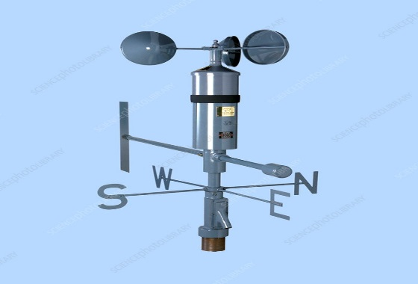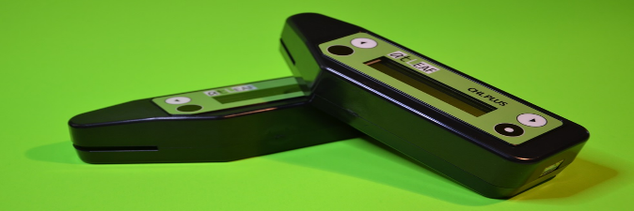
E
D
C
B
A
Q8/ WriteThe needs for production tree seedling? .
Q9/Write the effect of respiration and photosynthesis ratio on the plant growth?
Q10/ If someone in forest was bitten by snakes what’s the first aid you must do it for him?
Q11/ write the factors that affected the runoff that get through stem?
Q12/what is the nursery and write the properties of lath house?
Q13/If we have plant the dry weight of root is 1gm the stem dry weight is 3gm and leaf dry weight is 1.5 gm calculate root shoot ratio for this plant?
Q14/ write the effect of high soil temperature on root?
Q15/ write the precipitation resource in the forest as a source of moisture?
Q16/ Damages that caused by insect and explain one of this damage?
Q17/ write the physiological damage of wind on trees in forest?
Q18/ write the effect of forest on wind?
Q19/ How much light needs plant?
Q20/whates the scale for assessing plant condition and mortality?
Q21/ What you do when you can’t avoid poisonous plants?
Q22/ Write the types of pit viper snakes and write the symptoms of hemotoxins that caused by this type of bitten?
Q23/ write the difference between hemotoins and neurotoxine that causes by bitten snakes?
Q24/ whats the general rules you taken to be safe from bitten snakes in forest?
Q25/ write the types of venomous snakes that’s present in forest?
Q26/ What’s the types of nursery?
Q27/ mention the purpose of constructing nurseries?
Q28/ write the main types of plastics used in the coverage of plastic houses?
Q29/ what’s you must do when you caught the storm in forest ?
Q30/ write the personal equipment if you wanted to went to the forest?
Q31/ Write disease the caused by tick bitten in forest?
Q32/ write the apparatus that used for measuring the following?
- Wind speed
- Light intensity
- Chlorophyll in plant

Q33/ Differences in the amount of reflected solar radation and the penetration in to the forest and exploited by trees depending by many factors including?
Q34/write one species of each trees and shrubs of forest according to their tolerant to light and shad?
Q35/ what’s the composition of the light?
Q36/ write the division of forest trees according to their requirement to moisture?
Q37/ define the hail and write the harmful of hail which causes the trees in forest?
Q38/ whate the deference between heat and tempareture?
Q39/ What’s the effect of low temperature on root growth?
Q40/define the wind ?write the positive effect of wind on trees?
Q41/ what’s the physiological drought?
Q42/ what’s the stem flow in forest?
Q44/ write the scientific name of trees that affected by storm alittle bit?
Q45/ write the important of temperature?
Q46/ how change the temperature according to atmospheric layer?
Q47/ write the mechanical damage that occurs by low temperature on trees?
Q48/define photosynthesis process with equation?
Q49/ write the specification of light?
Q50/ what’s the chlorophyll meter ? for what purpose used ?

