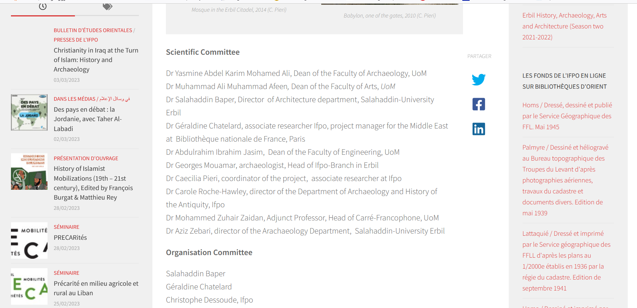

« AGIR-HIFAZ in Iraq », A New Cooperation Project in the Field of Higher Eduction (The Conservation of Built Heritage)

par Ifpo · Publié 20/05/2022 · Mis à jour 07/12/2022

AGIR-HIFAZ is an interdisciplinary training program which aims to strengthen the educational capacity of Iraqi teaching staff in the field of heritage conservation. It is a transfer of knowledge and skills between teachers / researchers / professionals and two groups of young Iraqi teachers. or confirmed students registered in archaeology, architecture or history, from the University of Mosul and the University of Salahaddin-Erbil.

The seminars focus on the concepts and fundamental historical knowledge which are compulsory for a correct diagnosis prior to any intervention of restoration or preventive conservation. They also discuss research methodologies on specific types of building materials, case studies and assessment methods for archaeology, architecture and history. Finally, they aim to improve the method and practices of the conservation of the built heritage thanks to a new academic and professional specialization : in archeology for the management of heritage sites, in architecture for the restoration of buildings, or in history for the expertise.
Mosul. Al-Nuri Mosque before restoration; photo Caecilia Pieri, 2018
Partnerships
French Ministry of Europe and Foreign Affairs, Institut national du Patrimoine, University of Mosul, Salahaddin University- Erbil
Contents and context
As part of the AGIR-HIFAZ program and with the help of the National Heritage Institute, Ifpo, Salahaddin-Erbil University and the University of Mosul are currently launching an academic cooperation project in Iraq in the field of the conservation of built heritage, hence its name (“Hifaz” means “conservation” in Arabic).

After several years of joint reflections and preparatory seminars between the partners, this new project is supported by the Ministry for Europe and Foreign Affairs within the framework of the FSPI (Solidarity Fund for Innovative Projects) n° 2020-89 with the aim of “training in the service of the preservation and enhancement of heritage in the Middle East – AGIR”.
Iraq’s built heritage has been brutalised by decades of conflict, political crises and neglect culminating in the recent destructions wrought on archaeological and religious sites by the Islamic State Organisation, especially the North of Iraq. Now in a post-crisis recovery stage, Iraq sees the multiplication of projects – many supported by international donors,– to address the rehabilitation and conservation of historic monuments and sites. This developing sector is expected to create job opportunities in the years to come.
Yet, despite the growing labour market demand, there is a dire shortage of highly specialised Iraqi expertise in built heritage conservation. This stems from decades of authoritarian rule, conflict and international sanctions which have caused the mass emigration of built heritage professionals and academics, in their majority trained in Europe before the 1990s. All this has entailed the isolation of the higher education and cultural heritage sectors from international advances in the field of conservation. Therefore, Iraq until today remains dependent on international expertise.
Erbil, Iraqi Kurdistan. Painted decor of a mansion inside the Citadel; photo Caecilia Pieri, 2014
Scientific Comittee :
Géraldine Chatelard, historian and anthropologist, Ifpo research associate
Barbara Couturaud, archaeologist, Head of Ifpo branch in Erbil
Caecilia Pieri, urban and heritage historian, Ifpo research associate, pedagogical coordinator of the project
Dominique Pieri, director of the Department of Archaeology, Ifpo
Yasmine Abdulkarim, Dean of the Faculty of Archeology, University of Mosul
Omar Muwafaq Mahmood, Dean of the Faculty of Engineering, University of Mosul
Aziz Zebari, director of the Department of Archaeology, University Salahaddin-Erbil
Salahaddin Baper, director of the Department of Engineering, University Salahaddin-Erbil

