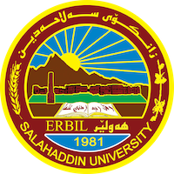
Academic Curriculum Vitae
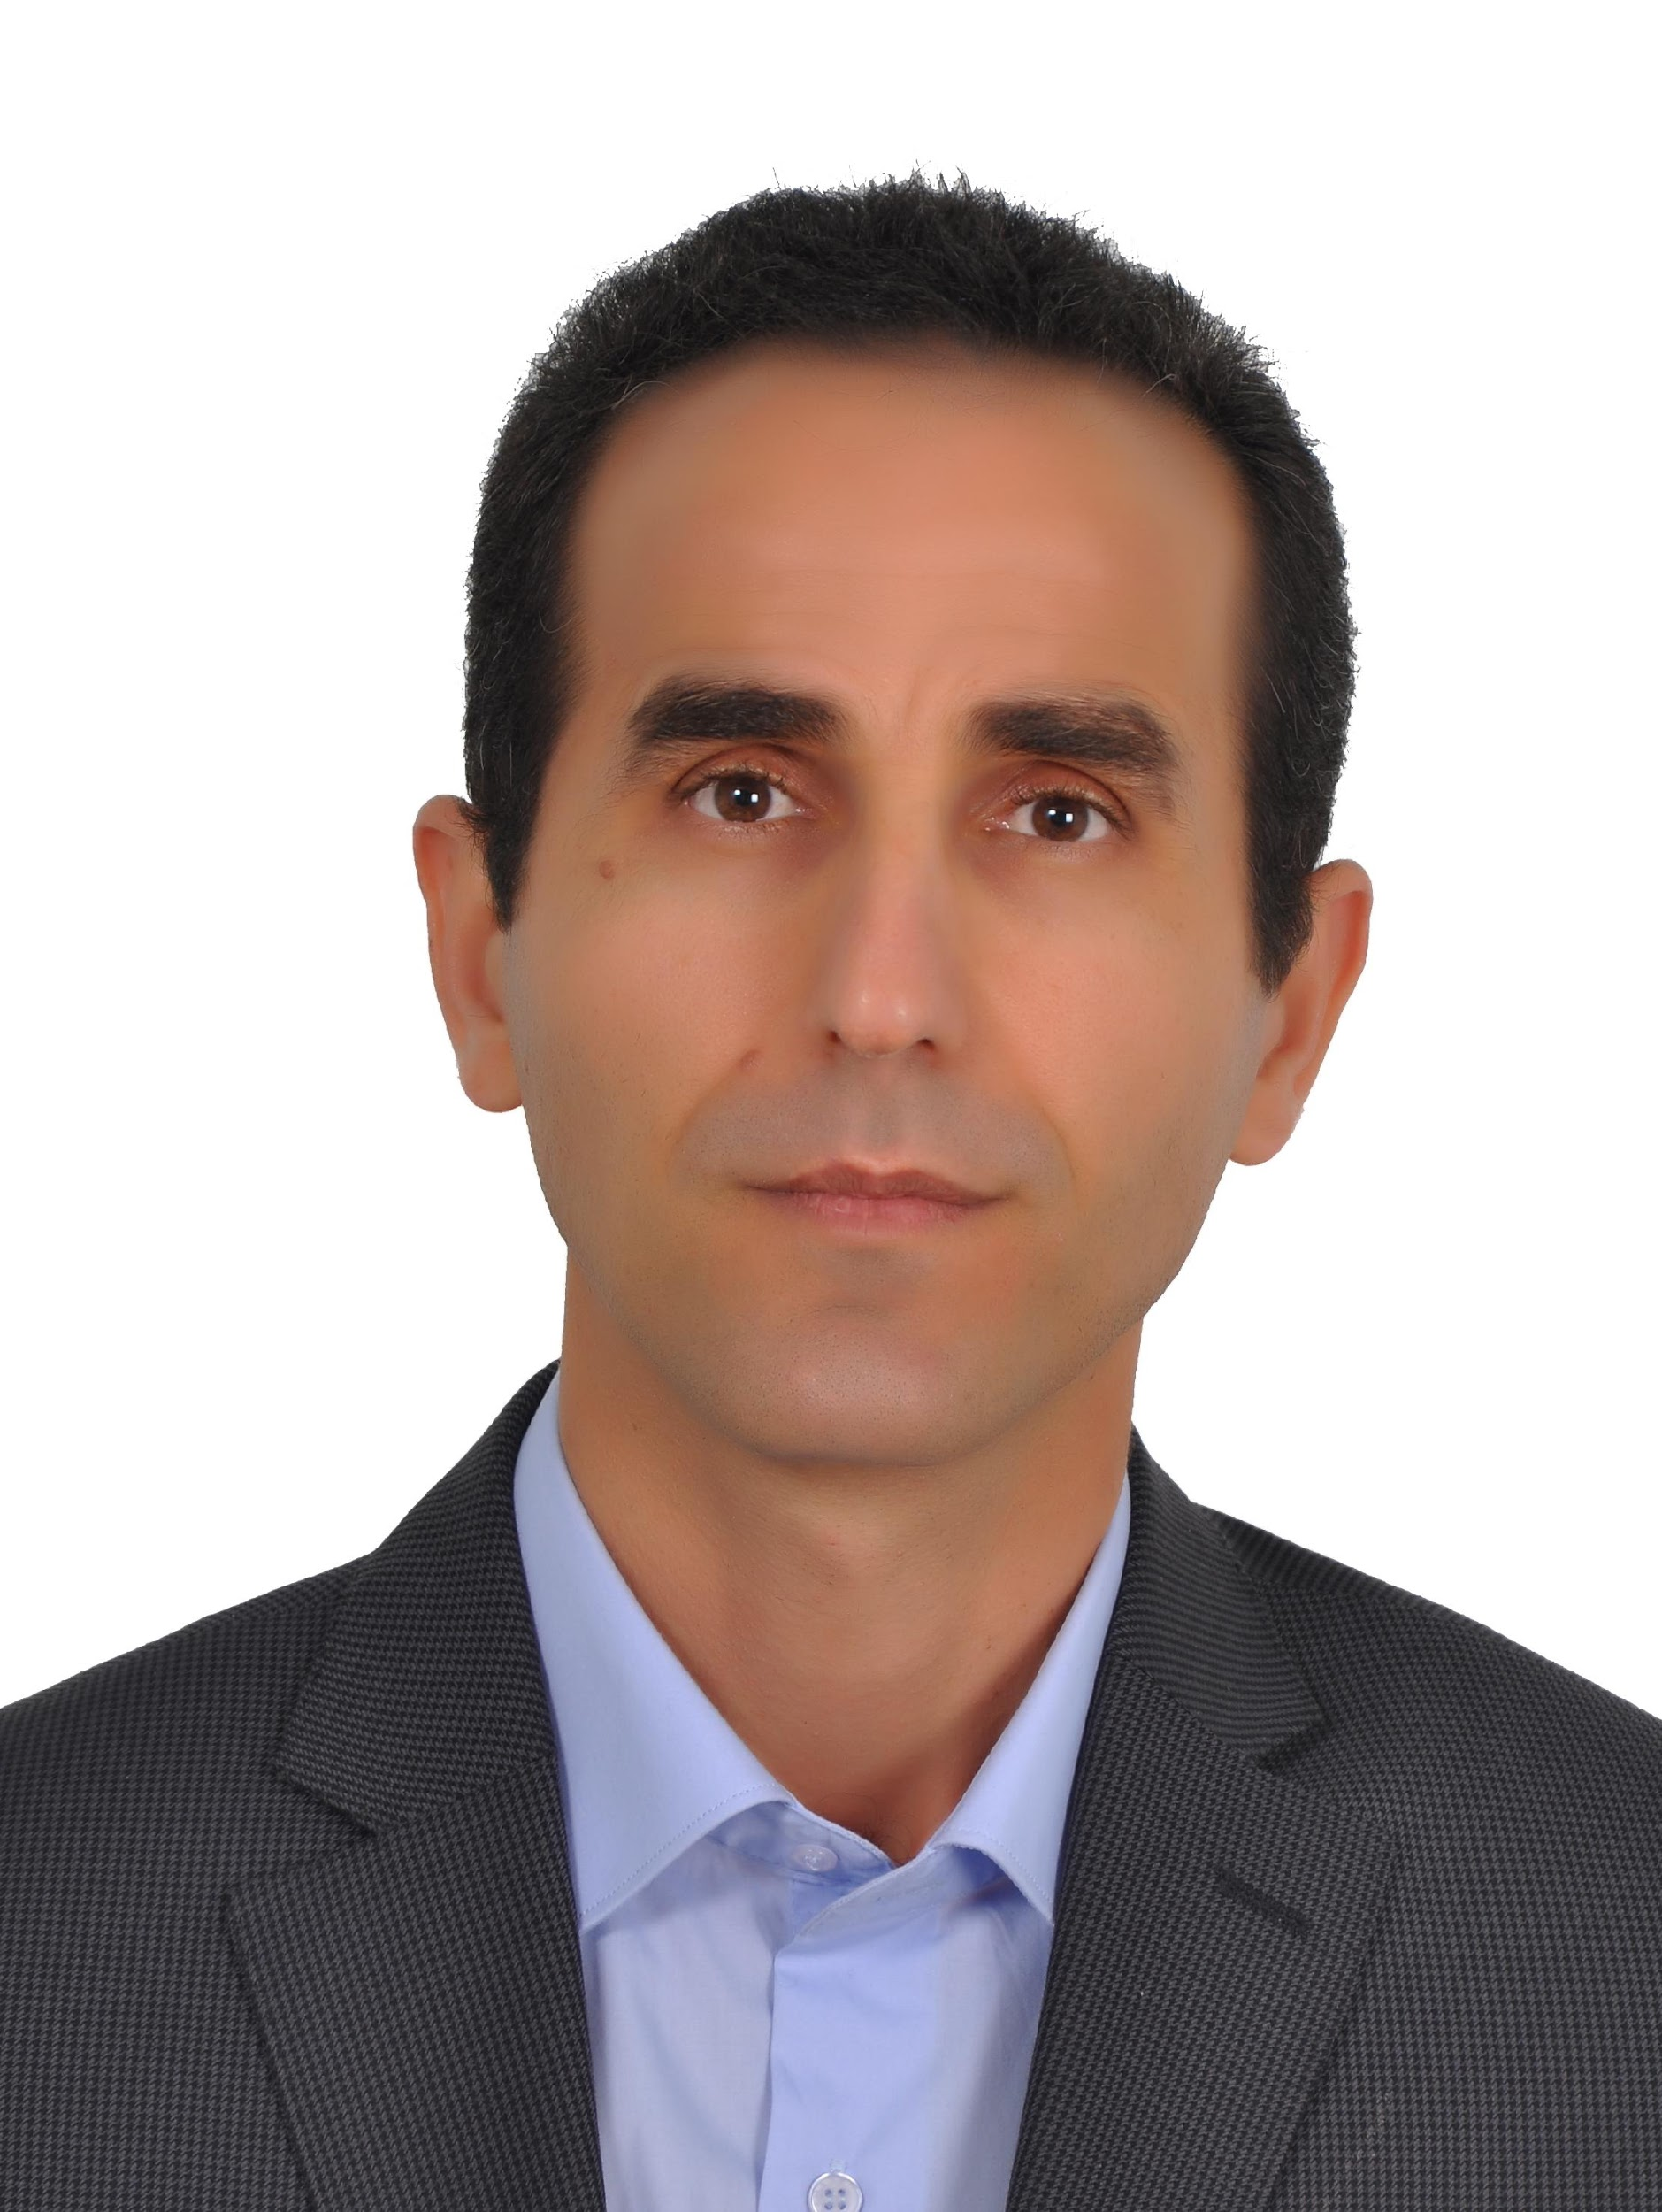
Personal Information:
Full Name: Salam Neamah Hirmiz Hakeem
Academic Title: Assistant Professor
Email: salam.hakeem@su.edu.krd
Mobile: +964 750 449 7838

Education:
- BA in English Language and Literature (Salahaddin University 1996)
- MA in English Language and Linguistics ((Salahaddin University 2002 )
- PhD in English Language and Linguistics ( Salahaddin University 2010 )

Employment:
- 1999-2001: Teacher at Ainkawa Secondary School for Girls..
- 2002-2007: Assistant Lecturer at Salahaddin University, College of Arts.
- 2010-2021: Lecturer at Salahaddin University, College of Education.
- 2021- present: Assistant Professor at Salahaddin University, College of Education

Qualifications
- A Training Course on the Methods of Teaching at Salahaddin University (3-29/7/2004).
- A Training Course on Ms PowerPoint 2007+Camtasia (1-12/8/2010) at the Center for Technology- Salahaddin University.
- A Workshop (in Cincinnati, 3-17/7/2011) about the most recent methods of teaching as part of the Linkage program between University of Cincinnati and Salahaddin University.
- Teachers' Refresher course sponsored by Wimbledon School of English-London,
- 9th -13th September 2012.
- Teaching Knowledge Test Workshop by the British Council, 31 Aug.-4 Sept. 2013.
- Effective Teaching in Higher Education, a workshop organized by Cihan University, 22nd June 2016.

Teaching experience:
- Teaching various courses to different levels of students at the English section of the French Institute for Languages.
- Teaching various courses to different levels of students at Salahaddin University-College of Languages
- Teaching various courses to different levels of students at Salahaddin University- Language Center.
- Teaching general English courses to ICRC (International Committee of the Red Cross) employees divided into three levels.
- Teaching general English courses to UNDP employees divided into two levels.
- Teaching ESP (English for Special Purposes) to Salahaddin University instructors.

Research and publications
My main area of interest has been sociolinguistics, stylistics and the use of technology to facilitate and enhance learning. My writings include:
- Female Humiliation vs. Male Glorification in the Discourse of Kurdish Proverbs
- A Linguistic Analysis of Errors in Undergraduate Students’ Translated Texts
- Conversational Implicatures in Shaw’s ‘How He Lied to Her Husband’
- Technology Integration in Higher Education in Kurdistan, Iraq: A Wiki Case Study
- Pedagogical Technology for M.Ed. Students in Kurdistan, Iraq: A Case Study

Conferences and courses attended
- the Future of Education conference in Italy, Florence (7-8 June 2012)
- Teaching English as Foreign Language Conference sponsored by Salahaddin University-Language Center (6 December 2012)
- 1st Quality Assurance Conference of English Language Provision for Higher Education at UKH 19-20 February 2013 Kurdistan.
- The 4th International Visible Conference on Educational Sciences at Ishik University in Erbil, Iraq (13-14th of April, 2013).
- the SUH-UC linkage conference on student-centered pedagogy and research (27-30 April, 2013).
- The 5th International Visible Conference on Educational Sciences and Applied Linguistics at Ishik University in Erbil, Iraq (26-27th of April, 2015).
- he 7th International Visible Conference on Educational Sciences and Applied Linguistics at Ishik University in Erbil, Iraq (24th of April, 2016).

Funding and academic awards
- None.

Professional memberships
- None.

Professional Social Network Accounts:
https://academics.su.edu.krd/salam.hakeem/
https://www.linkedin.com/in/dr-salam-hakeem-213b041a6/
https://www.researchgate.net/profile/Salam-Hakeem
https://scholar.google.com/citations?user=pevqcKkAAAAJ&hl=en
https://orcid.org/0009-0004-4041-343X

