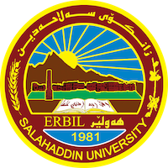
Academic Curriculum Vitae
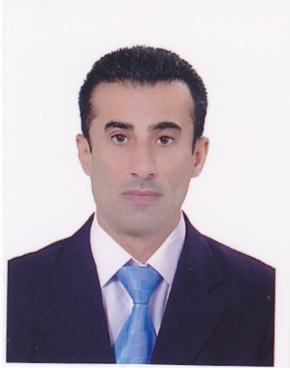
Personal Information:
Full Name: salman Muhammad khudhur
Academic Title: Assistant professor
Email: (salman.khudhur@su.edu.krd)
Mobile: 07504542833

Education:
Bachelor's degree - Salahaddin University - 1989-1990 - Faculty of Arts - Department of History
Master's degree - Salahaddin University - Faculty of Arts - Department of History - 2008 - Hijaz in the Ayyubid era
- PhD - Department of History - University of Mosul - College of Arts
2015 - Azerbaijan during the Mongol era.

Employment:
- Date of first appointment / (5/1/1992).
- Teacher at the Ministry of Education and Higher Education
- Currently, an assistant professor at Salah al-Din University / College of Education / Shaqlawa.

Qualifications
- Teaching qualifications
- IT qualifications
- Language qualifications such as TOEFL, IELTS or any equivalent
- Any professional qualification
- You could put any professional courses you have attended

Teaching experience:
- State all teaching courses you delivered, stating undergraduate or post graduate
- Courses, trainings, lab supervision, etc.,

Research and publications
- (The Crusade against the Hijaz / 578 AH / 1182 AD) by Tofari, the Academy of the Kurds of Nember (28) Sally (2014)
2- (Agriculture and Livestock in the Region of Azerbaijan (617-736 AH / 1219-1335 AD)) / Eleventh International Conference on Social Sciences and Current Research, Volume (5) in cooperation with Hitet University and the SAYBILDER Association, Antalya - Turkey.
3- (The Abbasid Caliph Al-Mu’tasim Billah and a course in Islamic conquests and the elimination of rebellious movements (218-227 AH / 833-841 AD) 1335 AD)) / The Tenth International Conference of Social Sciences and Current Research Volume (7) in cooperation with the University of HITET AND SAYBILDER ASSOCIATION ANTALYA - TURKEY.
4- (The Relationship of the Mughal Sultan Ahmed Tekudar with the Mamluk Sultan Qalawun Al-Alfi (681-683 AH / 1282-1284 AD) by University, the heritage of Rin Nember (8) Sally 2016.

5- (Sultan Jalal al-Din’s relations with the Abbasid caliphate (617-628 AH / 1219-1230 AD) by uneversty (Bah Naha) by Kumari Misr, by Sali 2016 in Nember (47) , Tofari Faculty of Arts .
6- (claims of the ethnic interpretation of history between scientific reality and philosophical imagination, claims by Gustave Le Bon as a model , Issue 76 in 2019, University of Mosul / Journal of Literature Al-Rafidain.
7- (Qutb al-Din al-Shirazi, his life and scientific works (634-710 AH / 1236-1311 AD), Volume (15), Issue (3), year 2019, University of Mosul / Research Journal of the College of Basic Education.
8- (Nasir al-Din al-Tusi, his life, homeland, and scientific achievements (597-672 AH / 1201-1274 AD), Issue (78) in 2019, University of Mosul / Journal of Arts Al-Rafidain.
- .

Conferences and courses attended
1- (Agriculture and Livestock in the Region of Azerbaijan (617-736 AH / 1219-1335 AD)) / Eleventh International Conference on Social Sciences and Current Research, Volume (5) in cooperation with Hitet University and the SAYBILDER Association, Antalya - Turkey.
2- (The Abbasid Caliph Al-Mu’tasim Billah and a course in Islamic conquests and the elimination of rebellious movements (218-227 AH / 833-841 AD) 1335 AD)) / The Tenth International Conference of Social Sciences and Current Research Volume (7) in cooperation with the University of HITET AND SAYBILDER ASSOCIATION ANTALYA - TURKEY.

Funding and academic awards
- List any bursaries, scholarships, travel grants or other sources of funding that you were awarded for research projects or to attend meetings or conferences.

Professional memberships
- List any membership you hold of any professional body or learned society relevant to your research or other life activities.

Professional Social Network Accounts:

- salman Muhammad khudhur
- salman.khudhur@su.edu.krd
- https://scholar.google.com/citations?user=JqpHo1YAAAAJ&hl=ar.
- https://orcid.org/my-orcid?orcid=0009-0007-2273-7918
- https://www.researchgate.net/profile/Salman-Khudhur

It is also recommended to create an academic cover letter for your CV, for further information about the cover letter, please visit below link:
https://career-advice.jobs.ac.uk/cv-and-cover-letter-advice/academic-cover-letter/

