**Exp.(1) The Non-Inverting DC Voltage Amplifier**

**Objective**

In this experiment, the performance of the non-inverting DC voltage amplifier will be examined. The investigation will include the effect of feedback resistors on setting voltage gain.

**Circuit diagram:**

We will use circuit wizard to built the following circuit.

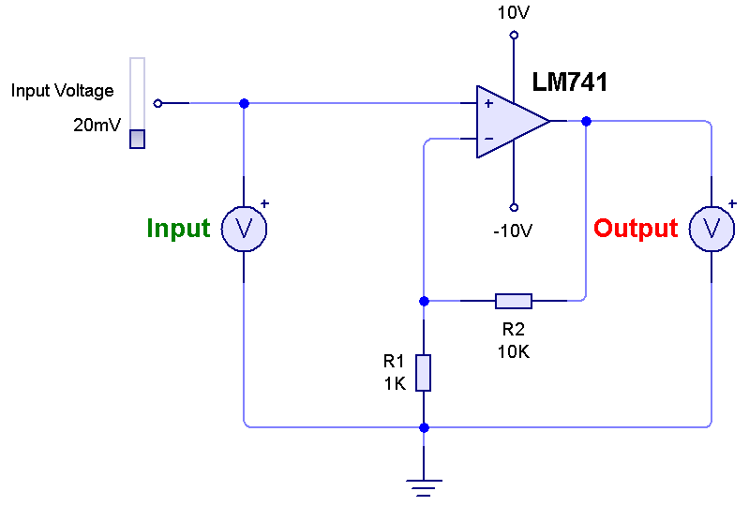

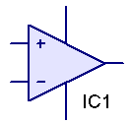**Procedure:**

1- From the [Gallery>Integrated Circuit], choose and drag to the stage an Operational Amplifire.

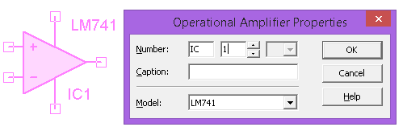2- Double click on the OP, set the Model LM741 and the other parameters as this:

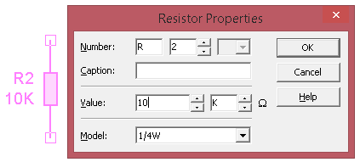

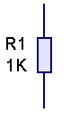3- Now pull two resistors to stage R1=1k and a second one R2. Double click on R2 and set its value to 10k.

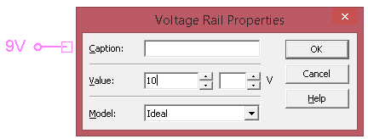4- Pull Two Voltage Rails to stag, Double Click on one of them set the Value to 10V, and the other to -10V.

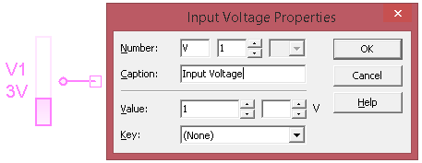

5- Pull One Input Voltage to stage Double click on it set its Value to 1V and its Caption to: “Input Voltage”.

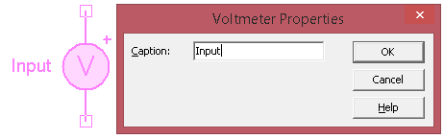6- Finally pull two Voltmeters to stage, set their Caption as:” Input” the other as “Output”.

Here are all the components, connect the as the circuit diagram and set the proper parameters. The component can be connected by clicking on one of its terminals and by moving the mouse curser a wire will be traced, when reaching another component terminal Click to join them.

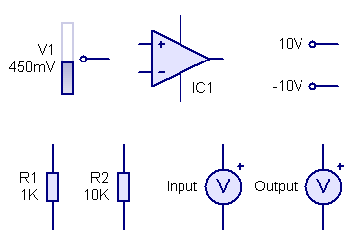

**Data Acquisition:**

**PART 1:**

1- Run the program, change the Input Voltage from 5mV, 10mV,15mV…, 90mV.

2- Record and tabulate the input and output readings of the Voltmeters, find the voltage gain for each step.

3- Draw a graph between Vin versus Vout.

Table 1: Recordings for PART 1.

|  |  |  |  |
| --- | --- | --- | --- |
| No. | Input Voltage (mv) | Output Voltage (mv) | Voltage Gain |
| 1 | 5 |  |  |
| 2 | 10 |  |  |
| 3 | 15 |  |  |
| 4 | 20 |  |  |

**PART 2:**

1- Now change the feedback resister to a variable resister we’ll need to change the value from (1k-10k).

2- Run the program, set the input voltage =10mV. Set R2 =1K,2K,3K…,10K.

3- Record the input and output readings of the Voltmeters, find the voltage gain for each step.

4- Draw a graph between R2 and the voltage gain.

Table 2: Recordings for PART 2.

[Keep Vin =10mv]

|  |  |  |  |
| --- | --- | --- | --- |
| No. | R2 (KΏ) | Output Voltage (mv) | Voltage Gain |
| 1 | 1 |  |  |
| 2 | 2 |  |  |
| 3 | 3 |  |  |
| 4 |  |  |  |

**Questions:**

1. What the equation of theoretical voltage gain?
2. Does your calculation differs from theoretical calculation? If Yes, why?
3. What happens to output voltage if we increased the input voltage to 1V and the voltage gain to 20?

**Exp.(2) The Non-Inverting AC Voltage Amplifier**

**Objective**

In this experiment, the performance of the non-inverting AC voltage amplifier will be examined. The investigation will include the effect of feedback resistors and the input frequency on voltage gain.

**Circuit diagram:**

We will use circuit wizard to built the following circuit.

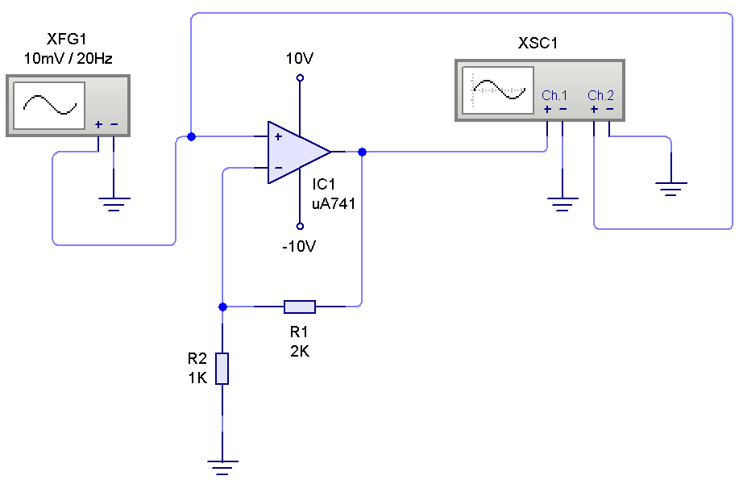

Build the circuit setting the parameters for components shown in the figure. For detailed instructions see previous experiment.

To add Graph to the stage Right-Click on the Oscilloscope and choose Add Graph, set its properties as shown below:

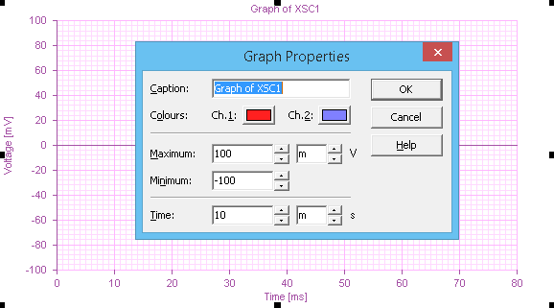

Now Right-Click on the graph and set the following properties:

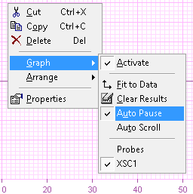

**Data Acquisition:**

**PART 1:**

1- Set the function generator frequency to 100Hz and its voltage to 10mV, run the program, Record the Peak-Peak value of the input and output wave form.

2- Repeat step1, for V=10, 20, 30…90mV. You might need to change the range of the Graph to a proper value.

3- Using the snipping tool in Windows copy at least one graph picture.

4- Tabulate the recordings, calculate the Voltage Gain, then draw a graph between Vin versus Vout (Peak to Peak value).

Table 1: Recordings for PART 1, Peak to Peak voltages.

|  |  |  |  |
| --- | --- | --- | --- |
| No. | Input Voltage (mv) | Output Voltage (mv) | Voltage Gain |
| 1 | 5 |  |  |
| 2 | 10 |  |  |
| 3 | 15 |  |  |
| 4 | 20 |  |  |

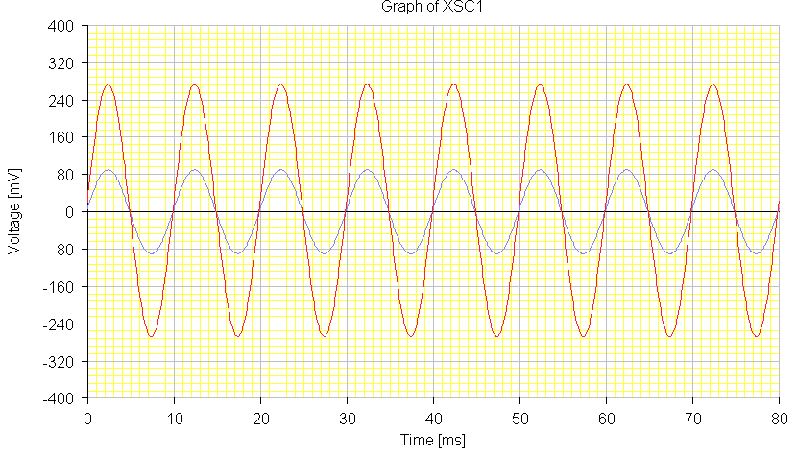

**PART 2:**

1- Set the function generator frequency to 100Hz and its voltage to 10mV, run the program, Record the Peak-Peak value of the input and output wave form.

2- Repeat step1, for f=100,200, 300,…900Hz. You might need to change the range of the Graph to a proper value. You’ll need to Stop the program between each step.

3- Tabulate the recordings, calculate the Voltage Gain, and then draw a graph between the frequencies versus voltage gain.

Table 2: Recordings for PART 2, Peak to Peak voltages.

[Keep Vin =10mv, read the input voltage VPP once]

|  |  |  |  |
| --- | --- | --- | --- |
| No. | F (Hz) | Output Voltage (mv) | Voltage Gain |
| 1 | 100 |  |  |
| 2 | 200 |  |  |
| 3 | 300 |  |  |
| 4 | 400 |  |  |

**PART 3:**

1- Now set the function generator frequency to 100Hz and its voltage to 10mV, change the feedback resister to a variable resister we’ll need to change the value from (1k-10k).

2- Run the program, record the output voltage (VPP) for R2 =1K,2K,3K…,10K.

3- Tabulate readings, find the voltage gain for each step.

4- Draw a graph between R2 and the voltage gain.

Table 3: Recordings for PART 3, Peak to Peak voltages.

[Keep Vin =10mv, read the input voltage VPP once]

|  |  |  |  |
| --- | --- | --- | --- |
| No. | R2 (KΏ) | Output Voltage (mv) | Voltage Gain |
| 1 | 1 |  |  |
| 2 | 2 |  |  |
| 3 | 3 |  |  |

**Questions:**

1. What the effect of the frequency change on voltage gain?
2. Is the shape of graph PART2 defer from theoretical principles? Why?
3. What happens to output voltage if we increased the input voltage to 1V and the voltage gain to 20?

**Exp.(3) The Inverting AC Voltage Amplifier**

**Objective**

In this experiment, the performance of the inverting AC voltage amplifier will be examined. The investigation will include the effect of feedback resistors on voltage gain.

**Circuit diagram:**

We will use circuit wizard to built the following circuit.

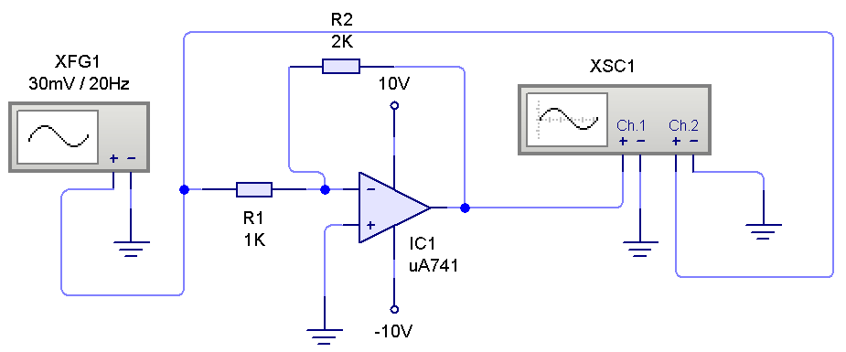

Build the circuit setting the parameters for components shown in the figure. To add Graph to the stage Right-Click on the Oscilloscope and choose Add Graph, set its properties as shown below:

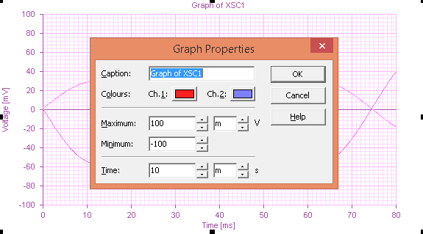

**Data Acquisition:**

**PART 1:**

1- Set the function generator frequency to 100Hz and its voltage to 10mV, run the program, Record the Peak-Peak value of the input and output wave form.

2- Repeat step1, for V=10,20, 30,…90mV. You might need to change the range of the Graph to a proper value.

3- Using the snipping tool in Windows copy at least one graph picture.

4- Tabulate the recordings, calculate the Voltage Gain, then draw a graph between Vin versus Vout (Peak to Peak value).

Table 1: Recordings for PART 1, Peak to Peak voltages.

|  |  |  |  |
| --- | --- | --- | --- |
| No. | Input Voltage (mv) | Output Voltage (mv) | Voltage Gain |
| 1 | 5 |  |  |
| 2 | 10 |  |  |
| 3 | 15 |  |  |
| 4 | 20 |  |  |

Sample figure of the Graph.

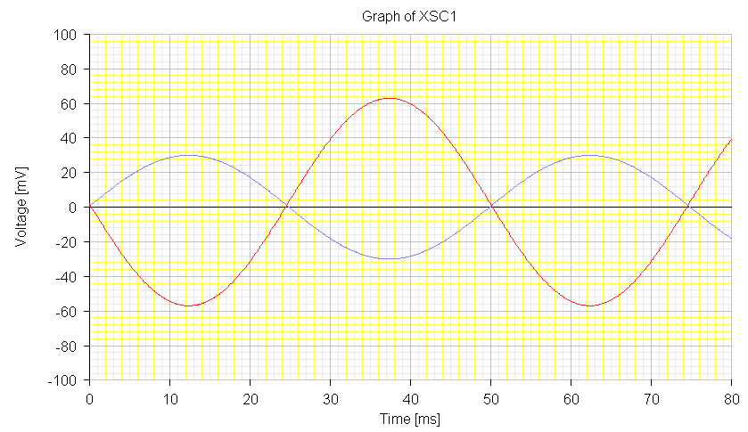

**PART 2:**

1- Set the function generator frequency to 100Hz and its voltage to 10mV, change the feedback resister to a variable resister we’ll need to change the value from (1k-10k).

2- Run the program, record the output voltage (VPP) for R2 =1K,2K,3K…,10K.

3- Tabulate readings, find the voltage gain for each step.

4- Draw a graph between R2 and the voltage gain.

Table 3: Recordings for PART 3, Peak to Peak voltages.

[Keep Vin =10mv, read the input voltage VPP once]

|  |  |  |  |
| --- | --- | --- | --- |
| No. | R2 (KΏ) | Output Voltage (mv) | Voltage Gain |
| 1 | 1 |  |  |
| 2 | 2 |  |  |
| 3 | 3 |  |  |

**Questions:**

1. Is there difference between the Previous non-inverting voltage Amplifire output and this one?
2. What the equation of theoretical voltage gain?

**Exp.(4) OP-Amp RC Relaxation Oscillator**

**Objective**

In this experiment, the performance of the OP-Amp RC Relaxation Oscillator will be examined. The investigation will include the cycle repeat of the Oscillator.

**Circuit diagram:**

We will use circuit wizard to built the following circuit.

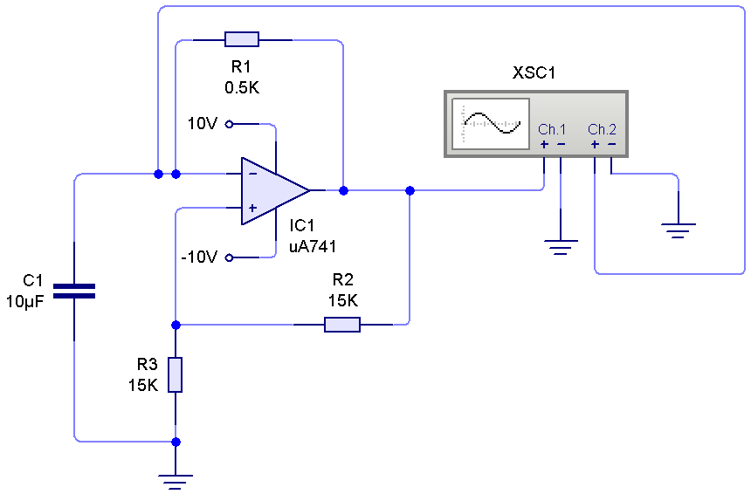

Build the circuit setting the parameters for components shown in the figure.

**Data Acquisition:**

1- Set the value of R1=0.5k, from the Oscilloscope Graph find the frequency practically. The theoretical value is: f=2.2R1C1.

2- Repeat step1, for R1=0.5,1,1.5,…8KΏ. You might need to change the range of the Graph to a proper value.

3- Using the snipping tool in Windows copy at least one graph picture.

4- Tabulate the recordings, then draw a graph between R1 versus f (Practical and theoretical).

Table 1: Recordings for Exp. 4.

|  |  |  |  |
| --- | --- | --- | --- |
| No. | R1 (KΏ) | f Practical (Hz) | f Theoretical (Hz) =2.2R1C1 |
| 1 | 0.5 |  |  |
| 2 | 1 |  |  |
| 3 | 1.5 |  |  |

Sample Graph of Exp.4.

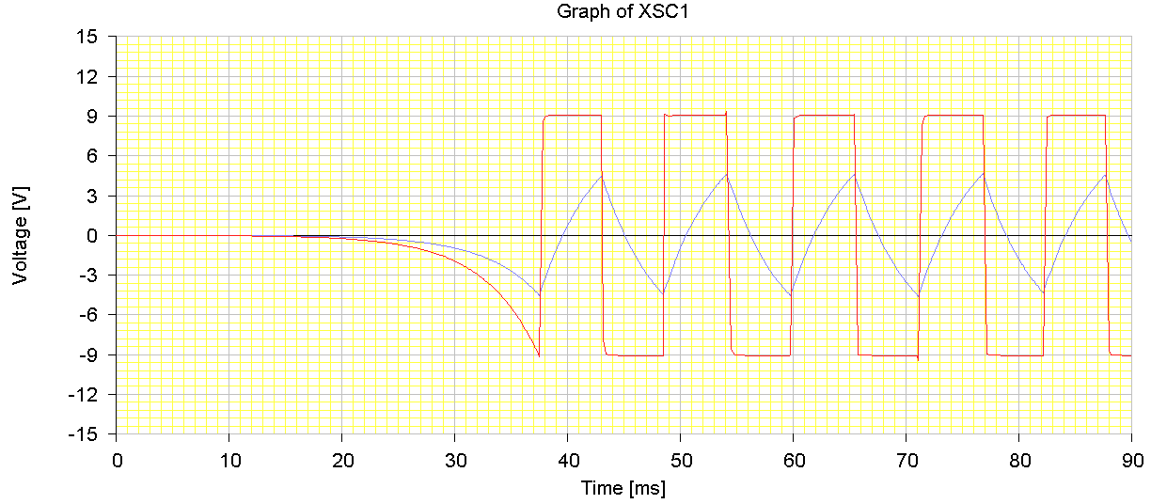

**Exp.(5) OP-Amp LC Oscillator**

**Objective**

In this experiment, the performance of the OP-Amp LC Relaxation Oscillator will be examined. The investigation will include the cycle repeat of the Oscillator.

**Circuit diagram:**

We will use circuit wizard to built the following circuit.

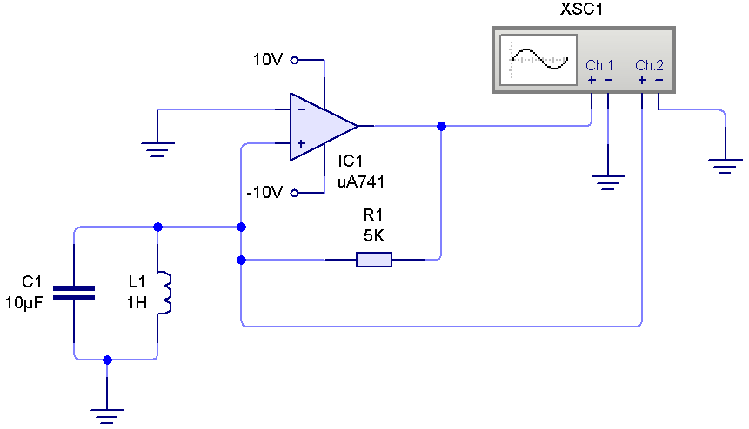

Build the circuit setting the parameters for components shown in the figure.

**Data Acquisition:**

1- Set the value of R1=10k, from the Oscilloscope Graph find the oscillation frequency practically. The theoretical value is:

$$f= \frac{1}{2π\sqrt{LC}}$$

2- Repeat step1, for C=10,20,30,…100 μF. You might need to change the range of the Graph to a proper value.

3- Using the snipping tool in Windows copy at least one graph picture.

4- Tabulate the recordings, then draw a graph between C versus *f* (Practical and theoretical).

Table 1: Recordings for Exp. 5.

|  |  |  |  |
| --- | --- | --- | --- |
| No. | C (μF) | f Practical (Hz) | f Theoretical (Hz) |
| 1 | 10 |  |  |
| 2 | 20 |  |  |
| 3 | 30 |  |  |

Sample Graph of Exp.5.

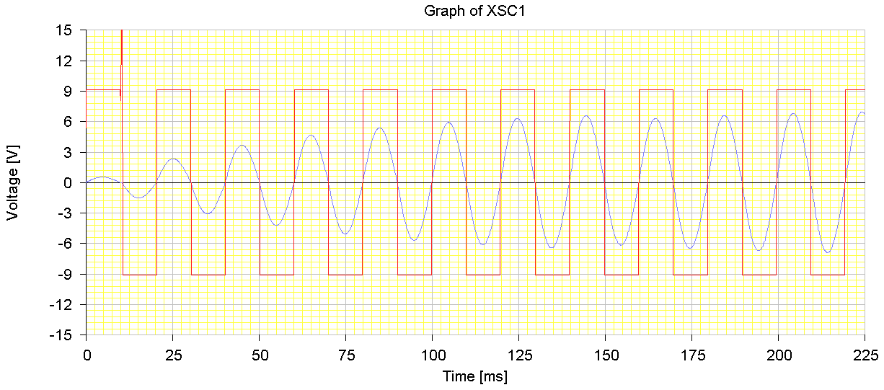

**Exp.(6) 555 Timer Astable Operation**

**Objective**

In this experiment, the performance of the 555 Timer Astable Operation will be examined. The investigation will include the duty cycle of the Oscillator.

**Circuit diagram:**

We will use circuit wizard to built the following circuit.

 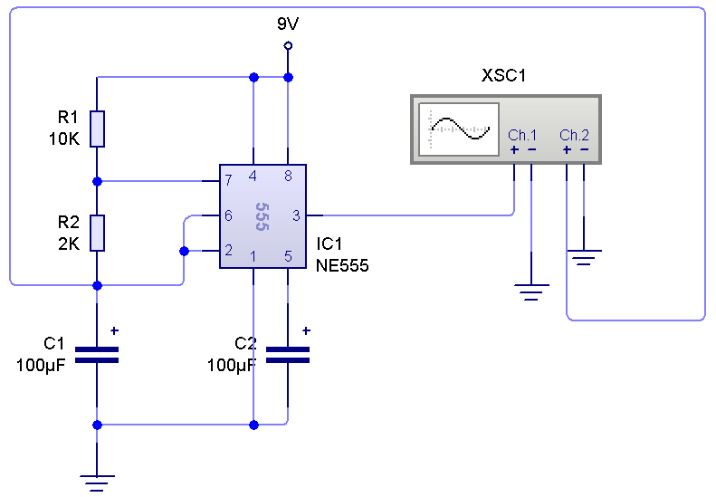

Build the circuit setting the parameters for components shown in the figure.



**Data Acquisition:**

1- Set the value of R2=2k, from the Oscilloscope Graph find (tlow and thigh) of the oscillation frequency practically. The theoretical value is mentioned earlier.

2- Repeat step1, for R2=2,4,6,…20KΏ. You might need to change the range of the Graph to a proper value.

3- Using the snipping tool in Windows copy at least one graph picture.

4- Tabulate the recordings, then draw a graph between R2 versus (tlow and thigh, Practical and theoretical).

Table 1: Recordings for Exp. 6.

|  |  |  |  |
| --- | --- | --- | --- |
| No. | R2 (KΏ) | tlow | thigh |
| 1 | 2 |  |  |
| 2 | 4 |  |  |
| 3 | 6 |  |  |

Sample Graph of Exp.6.

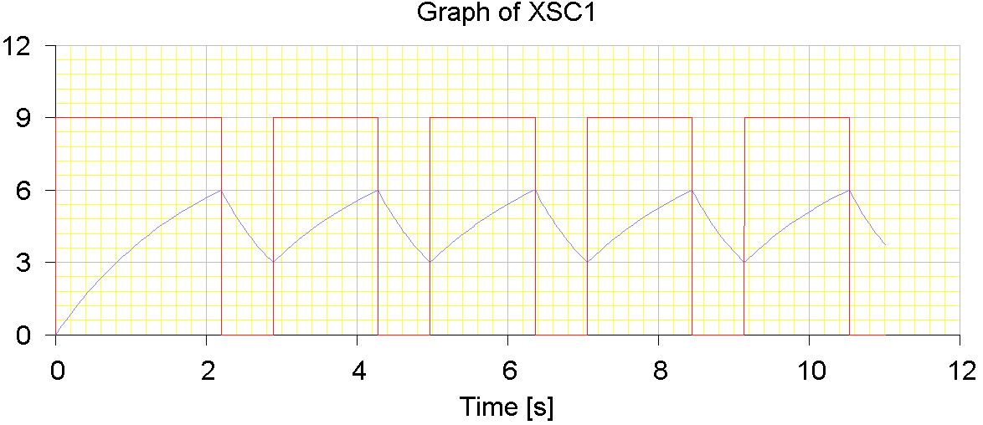

**Exp.(7) 555 Timer Monostable Operation**

**Objective**

In this experiment, the performance of the 555 Timer Monostable Operation will be examined. The investigation will include the duty cycle of the Oscillator.

**Circuit diagram:**

We will use circuit wizard to built the following circuit.

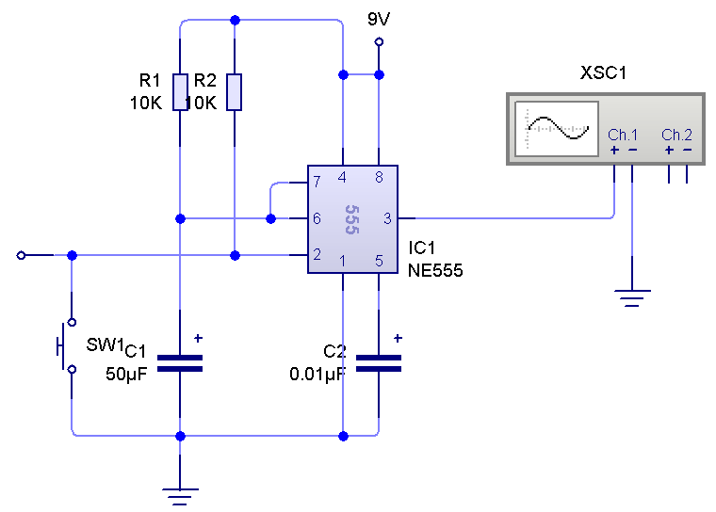

Build the circuit setting the parameters for components shown in the figure.

The width of the high output pulse is:



**Data Acquisition:**

1- Set the value of R1=10k, from the Oscilloscope Graph find(twidth) of the width of the high output pulse practically. The theoretical value is: (twidth =1.1R1C).

2- Repeat step1, for R1=10,20,40,…100KΏ. You might need to change the range of the Graph to a proper value.

3- Using the snipping tool in Windows copy at least one graph picture.

4- Tabulate the recordings, then draw a graph between R1 versus (twidth, Practical and theoretical).

Table 1: Recordings for Exp. 6.

|  |  |  |  |
| --- | --- | --- | --- |
| No. | R1 (KΏ) | twidth (Practical ms) | twidth (Theoretical ms) |
| 1 | 10 |  |  |
| 2 | 20 |  |  |
| 3 | 30 |  |  |

Sample Graph of Exp.7.

