**DNA as Genetic Material**

Established by several critical experiments:

* Fred Griffith (1928)
* Oswald T. Avery’s Transformation Experiment – 1944
* Alfred D. Hershey and Martha chase(1952)

**Fred Griffith (1928)**

Many scientists contributed to the identification of DNA as the genetic material. In the 1920s, Frederick Griffith made an important discovery. Griffith used two [strains](https://en.wikipedia.org/wiki/Strain_(biology)) of pneumococcus ([*Streptococcus pneumoniae*](https://en.wikipedia.org/wiki/Streptococcus_pneumoniae)*)* bacteria which infect [mice](https://en.wikipedia.org/wiki/Mouse) – a type III-S (smooth) which was virulent, and a type II-R (rough) strain which was nonvirulent. The S strain killed (virulent) the mice, but the R strain did not (non-virulent). Griffith also injected mice with S-strain bacteria that had been killed by [heat](http://www.ck12.org/physical-science/Heat-in-Physical-Science). As expected, the killed bacteria did not harm the mice. However, when the dead S-strain bacteria were mixed with live R-strain bacteria and injected, the mice died.

Griffith's experiment, reported in 1928 by [Frederick Griffith](https://en.wikipedia.org/wiki/Frederick_Griffith), was the first experiment suggesting that bacteria are capable of transferring genetic information through a process known transformation.

* Live S strain cells killed the mice
* Live R strain did not kill the mice
* Heat –killed S strain did not kill the mice
* Heat –killed S strain + live R strain cells killed the mice

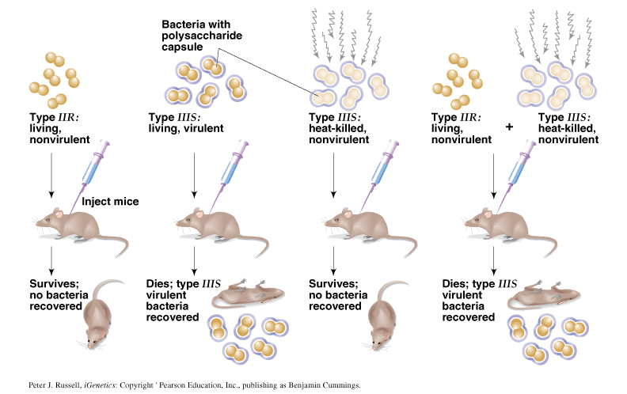

**Oswald T. Avery’s Transformation Experiment - 1944**

Determined that “IIIS” DNA was the genetic material responsible for Griffith’s results (not RNA).

Repeated Griffith’s experiment using purified cell extracts and discovered:

Removal of all protein from the transforming material did not destroy its ability to transform R strain cells, DNA –digesting enzymes destroyed all transforming ability, and the transforming material is DNA.

Peter J. Russell, *iGenetics*: Copyright © Pearson Education, Inc., publishing as Benjamin Cummings.

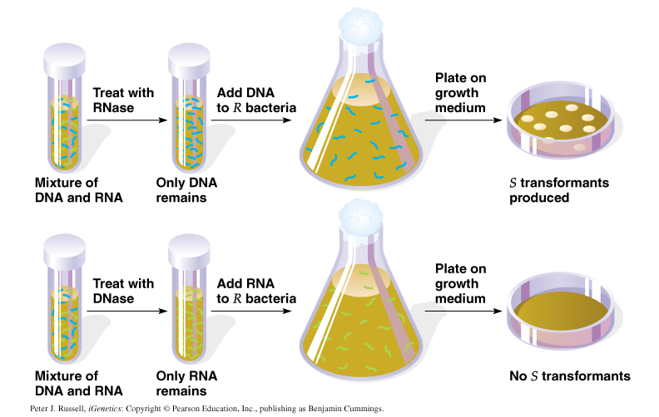

**Nuclic Acid**

Nucleic acids play an important role in the storage and expression of genetic information. They are divided into two major classes: **deoxyribonucleic acid (DNA)** functions solely information storage, while **ribonucleic acids (RNAs)** are involved in most steps of gene expression and protein biosynthesis. All nucleic acids are made up from **nucleotide** components, which consist of a nitrogenous base, a sugar and a phosphate residue. A sugar and a nitrogenous base without the phosphate group is called as a **nucleoside**. The nitrogenous bases are classified into two types:-

* + **Purines:**
    - **Two ring structure**
    - **Adenine (A) and Guanine (G)**
  + **Pyrimidines:**
    - **Single ring structure**
    - **Cytosine (C) and Thymine (T) or Uracil (U).**

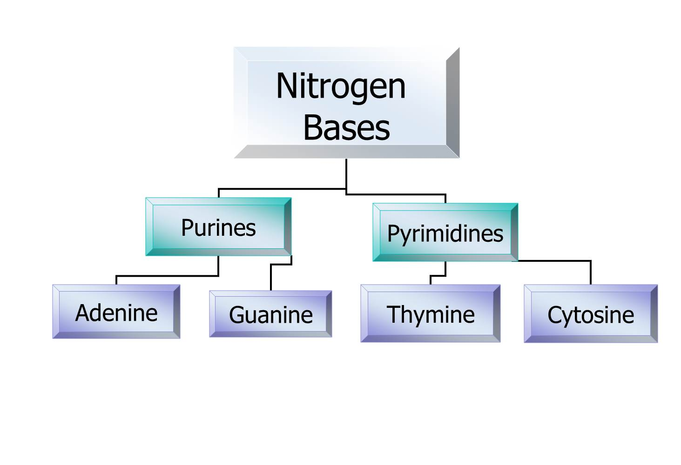

**DNA Structure (Deoxyribose Nucleic Acid)**

DNA is the chemical name for the molecule that carries genetic instructions in all living things. The DNA molecule consists of two strands that wind around one another to form a shape known as a double helix. Each strand has a backbone made of alternating sugar (deoxyribose) and phosphate groups. Attached to each sugar is one of four bases--adenine (A), cytosine (C), guanine (G), and thymine (T). The two strands are held together by bonds between the bases; adenine bonds with thymine, and cytosine bonds with guanine. The sequence of the bases along the backbones serves as instructions for assembling protein and RNA molecules.

DNA, or deoxyribonucleic acid, is the central information storage system of most animals and plants, and even some viruses. The name comes from its structure, which is a sugar and phosphate backbone which have bases sticking out from it--so-called bases. So that "deoxyribo" refers to the sugar and the nucleic acid refers to the phosphate and the bases. The bases go by the names of adenine, cytosine, thymine, and guanine, otherwise known as A, C, T, and G. DNA is a remarkably simple structure. It's a polymer of four bases--A, C, T, and G--but it allows enormous complexity to be encoded by the pattern of those bases, one after another. DNA is organized structurally into chromosomes and then wound around nucleosomes as part of those chromosomes. Functionally, it's organized into genes, of which are pieces of DNA, which lead to observable traits. And those traits come not from the DNA itself, but actually from the RNA that is made from the DNA, or most commonly of proteins that are made from the RNA which is made from the DNA.

A nucleotide is a mono-, di-, or triphosphate deoxyribonucleoside; that is, a deoxyribose sugar is attached to one, two, or three phosphates.

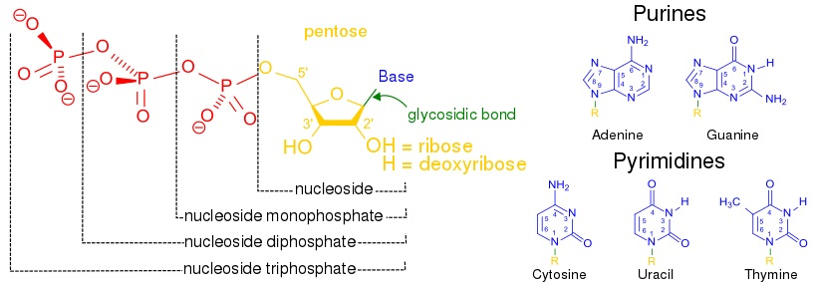

Chemical interaction of these nucleotides forms phosphodiester linkages, creating the phosphate-deoxyribose backbone of the DNA double helix with the bases pointing inward.

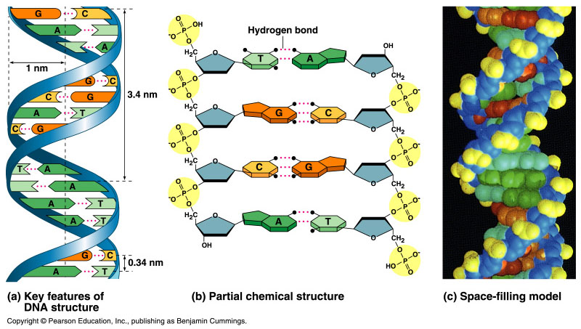

Nucleotides (bases) are matched between strands through hydrogen bonds to form base pairs. Adenine pairs with thymine and cytosine pairs with guanine.



**General features of DNA**

* DNA is a double stranded molecule consists of 2 polynucleotide chains running in opposite directions.
* Both strands are complementary to each other.
* The bases are on the inside of the molecules and the 2 chains are joined together by double H-bond between A and T and triple H-bond between C and G.
* The base pairing is very specific which make the 2 strands complementary to each other.
* So each strand contains all the required information for synthesis (replication) of a new copy to its complementary.

**Directionality of DNA strands**

DNA strands have a directionality, and the different ends of a single strand are called the "3' (three-prime) end" and the "5' (five-prime) end" with the direction of the naming going 5 prime to the 3 prime region.

The strands of the helix are anti-parallel with one being 5 prime to 3 then the opposite strand 3 prime to 5.

These terms refer to the carbon atom in deoxyribose to which the next phosphate in the chain attaches. Directionality has consequences in DNA synthesis, because DNA polymerase can synthesize DNA in only one direction by adding nucleotides to the 3' end of a DNA strand.