**From DNA to protein**

**Introduction**

* DNA contains genes, sequences of nucleotide bases
* These Genes code for polypeptides (proteins)
* Proteins are used to build cells and do much of the work inside cells
* DNA info is in the form of specific sequences of bases along the DNA strands.
* The DNA leads to specific traits by dictating the synthesis of proteins.
* Proteins are the links between genotype and phenotype.
* For example, Mendel’s dwarf pea plants lack a functioning copy of the gene that specifies the synthesis of a key protein, gibberellins.
* Gibberellins stimulate the normal elongation of stems.

**Genes & Proteins**

* Proteins are made of amino acids linked together by peptide bonds
* 20 different amino acids exist

**Amino Acid Structure**

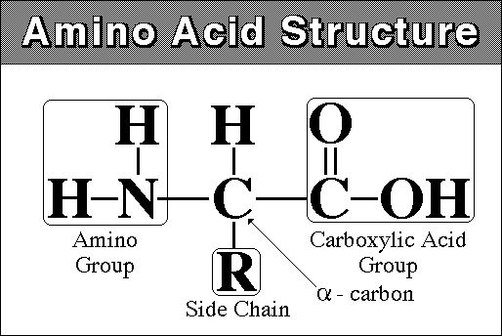

**Polypeptides:**

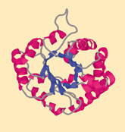

**Amino acid chains are called polypeptide**

**DNA Begins the Process**

* DNA is found inside the nucleus
* Proteins, however, are made in the cytoplasm of cells by organelles called ribosomes
* Ribosomes may be free in the cytosol or attached to the surface of rough ER

**Starting with DNA**

* DNA ‘s code must be copied and taken to the cytosol
* In the cytoplasm, this code must be read so amino acids can be assembled to make polypeptides (proteins)
* This process is called PROTEIN SYNTHESIS
* DNA acts as a “manager” in the process of making proteins
* DNA is the template or starting sequence that is copied into RNA that is then used to make the protein

**Central Dogma**

The **central dogma of molecular biology** is an explanation of the flow of genetic information within a biological system. It was first stated by [Francis Crick](https://en.wikipedia.org/wiki/Francis_Crick) in 1958.The Central Dogma, This states that once ‘information’ has passed into protein it cannot get out again. In more detail, the transfer of information from nucleic acid to nucleic acid, or from nucleic acid to protein may be possible, but transfer from protein to protein, or from protein to nucleic acid is impossible.

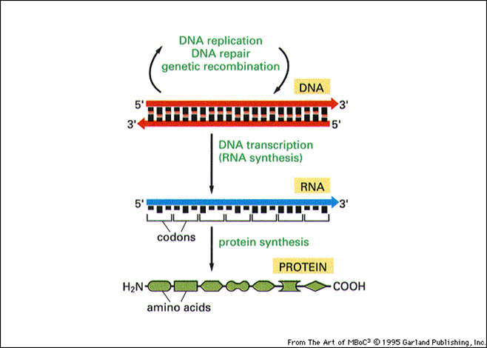 One gene – one protein

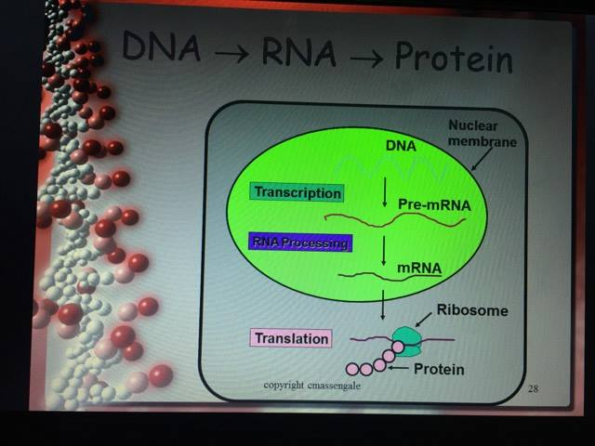

**General property of Central Dogma**

* This is the same for bacteria to humans
* DNA is the genetic instruction or gene
* DNA → RNA is called Transcription
* RNA chain is called a transcript
* RNA → Protein is called Translation

**The role of RNA**

* Three Types of RNA
* Messenger RNA (mRNA) copies DNA’s code & carries the genetic information to the ribosomes
* Ribosomal RNA (rRNA), along with protein, makes up the ribosomes
* Transfer RNA (tRNA) transfers amino acids to the ribosomes where proteins are synthesized

**amino acid**

**attachment site**

**The Genetic Code**

* A codon designates an amino acid
* An amino acid may have more than one codon
* There are 20 amino acids, but 64 possible codons
* Some codons tell the ribosome to *stop* translating
* **Use the code by reading from the center to the outside**
* **Example: AUG codes for Methionine**

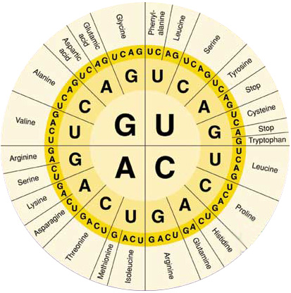

**Codons and Anticodons**

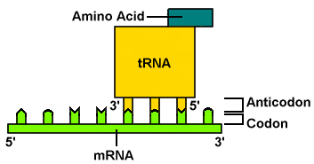

* **The 3 bases of an anticodon are complementary to the 3 bases of a codon**
* **Example: Codon ACU**

**Anticodon UGA**

**Protein synthesis pathway**

1.Tanscription

* The process of copying the sequence of one strand of DNA, the template strand
* mRNA copies the template strand
* Requires the enzyme RNA Polymerase

**Template Strand**

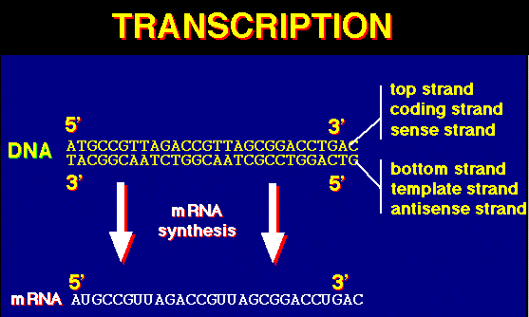

* During transcription, RNA polymerase binds to DNA and separates the DNA strands
* RNA Polymerase then uses one strand of DNA as a template to assemble nucleotides into RNA
* Promoters are regions on DNA that show where RNA Polymerase must bind to begin the Transcription of RNA
* Called the TATA box
* Specific base sequences act as signals to stop Called the termination signal

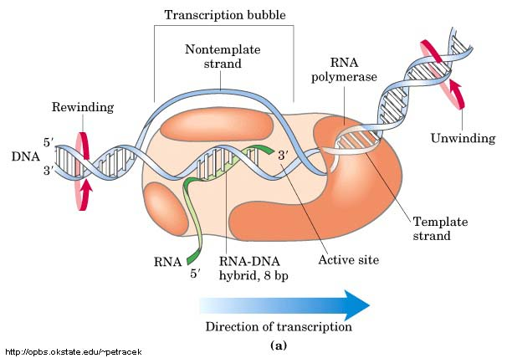

**2.mRNA Processing**

* After the DNA is transcribed into RNA, editing must be done to the nucleotide chain to make the RNA functional
* Introns, non-functional segments of DNA are snipped out of the chain
* mRNA Editing
* Exons, segments of DNA that code for proteins, are then rejoined by the enzyme ligase
* A guanine triphosphate cap is added to the 5” end of the newly copied mRNA
* A poly A tail is added to the 3’ end of the RNA
* The newly processed mRNA can then leave the nucleus
* Result of Transcription

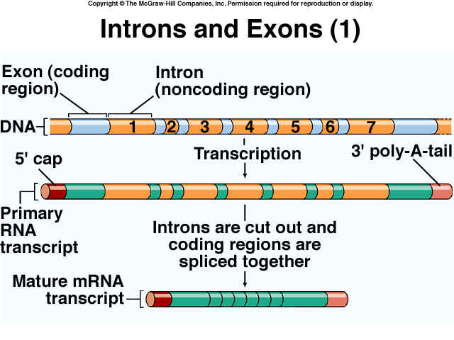

**CAP**

**New Transcript**



* mRNA Transcript
* mRNA leaves the nucleus through its pores and goes to the ribosomes

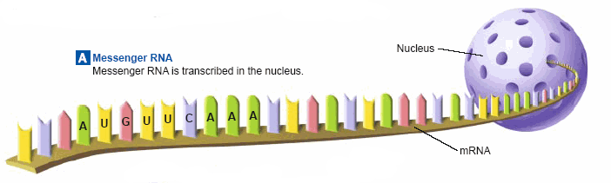

**3.Translation**

* **Translation is the process of decoding the mRNA into a polypeptide chain**
* **Ribosomes read mRNA three bases or 1 codon at a time and construct the proteins**

