**DNA cloning (Recombinant DNA technology)**

To work directly with specific genes, scientists prepare well-defined segments of DNA in identical copies, a process called *DNA cloning*.

Cloning technology - generation of many copies of DNA template (e.g., recombinant DNA molecule) that is replicated in a host.

**Principles of Recombinant DNA Technology**

* + Recombinant DNA - DNA that has been artificially manipulated to combine genes from two different sources.
  + Genes transferred - among unrelated species via laboratory manipulation.
  + Genetic engineering - human manipulation of an organism's genetic material in a way that does not occur under natural conditions

**The general features of Recombinant DNA Technologies**

1. Gene of interest (DNA) is isolated (DNA fragment)

2. A desired gene is inserted into a DNA molecule - vector

(plasmid, bacteriophage or a viral genome)

3. The vector inserts the DNA into a new cell, which is grown to form a clone.

(bacteria, yeast, plant or animal cell)

4. Large quantities of the gene product can be harvested from the clone.

5. Most methods for cloning pieces of DNA in the laboratory share general features, such as the use of bacteria and their plasmids

6. Plasmids are small circular DNA molecules that replicate separately from the bacterial chromosome

7. Cloned genes are useful for making copies of a particular gene and producing a protein product

8. Gene cloning involves using bacteria to make multiple copies of a gene

1. Foreign DNA is inserted into a plasmid, and the recombinant plasmid is inserted into a bacterial cell
2. This results in the production of multiple copies of a single gene

**Tools for Genetic engineering (Recombinant DNA technology)**

**1. Restriction Enzymes**

Substrate –DNA -recognizes one particular nucleotide sequence in DNA and cuts the DNA molecule (breaks down the bond between two nucleotides)

**blunt ends**

**sticky ends**

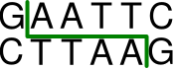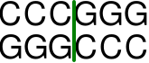

**Using Restriction Enzymes to Make Recombinant DNA**

* Bacterial **restriction enzymes** cut DNA molecules at specific DNA sequences called **restriction sites**
* A restriction enzyme usually makes many cuts, yielding **restriction fragments**
* The most useful restriction enzymes cut DNA in a staggered way, producing fragments with “**sticky ends**.”

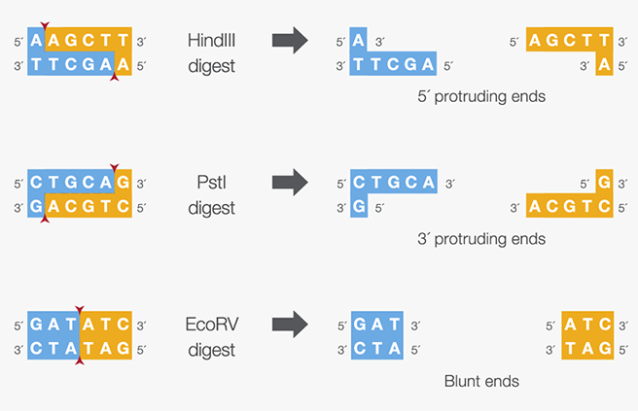

* Sticky ends can bond with complementary sticky ends of other fragments
* **DNA ligase** is an enzyme that seals the bonds between restriction fragments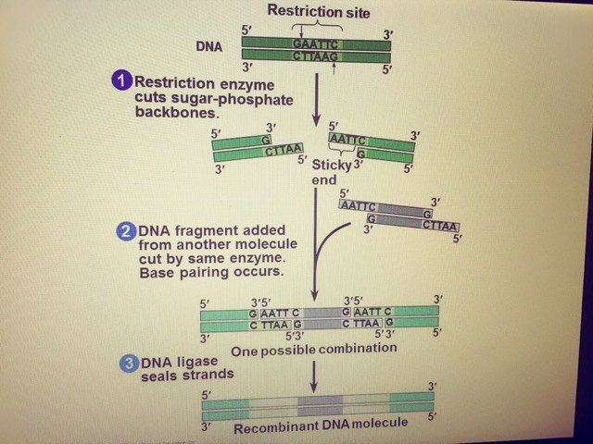

**2. Ligase**

* **DNA ligase** is an enzyme that can link together DNA strands that have double-strand breaks (a break in both complementary strands of DNA).
  + Naturally DNA ligase has applications in both **DNA replication** and **DNA repair**.
  + Needs ATP
* DNA ligase has extensive use in molecular biology laboratories for **genetic recombination experiments**

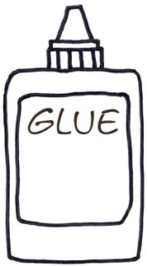

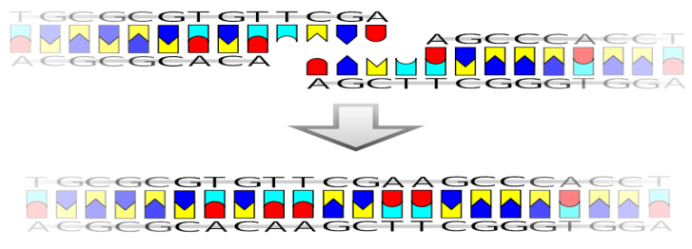



**3. Vectors**

Vectors - small pieces of DNA used for cloning (the gene to be inserted into the genetically modified organism must be combined with other genetic elements in order for it to work properly)

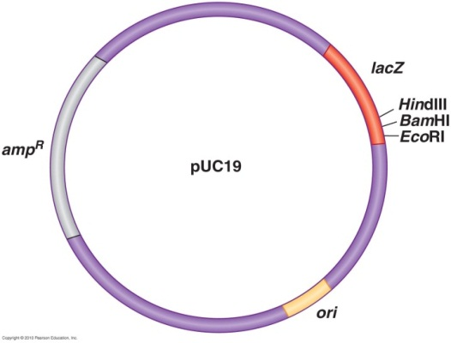

**Requirements of the Vector**

1. Self-replication - able to replicate in the host (origin of

repliction)

2. Cloning site (site for recognition of restriction nucleases)

3. Promoter (and operator) - to support the gene (new DNA) expression in the host

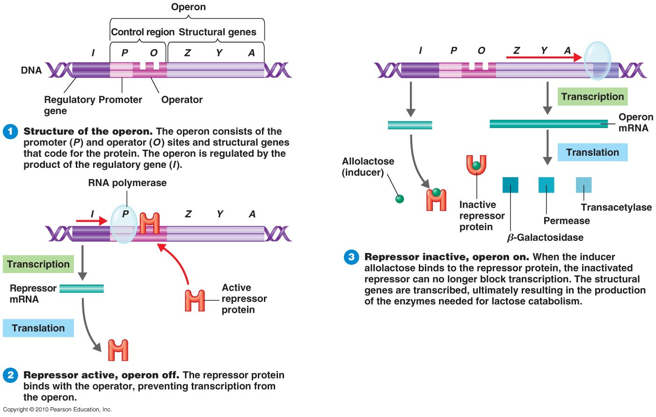

4. Selectable marker – antibiotic resistance

5. Proper size

**Vectors**

**1. Plasmid vectors**

* Naturally occurring extra chromosomal DNA found in bacteria.
* Plasmids dsDNA
* Plasmid can be cleaved by restriction enzymes, leaving sticky ends.
* Can hold 0-10 Mb of DNA.

2. Viral vectors - retroviruses, adenoviruses and herpes viruses

* + - * Accept much larger pieces of DNA
      * Mammalian hosts

3. Cosmid

The cosmid it’s artificial vector composed from the Cos sequence from lambda phage and plasmid and can hold 30-44 kb of the DNA.

4.Yeast Artificial Chromosome(YAC)

The YAC is also artificial vector composed from the origin of replication (from plasmid ) with another artificial parts and can hold 0.2-2 , Mb of DNA.

**Hosts for DNA recombinant technology**

1. Bacteria
   * *E. coli* - used because is easily grown and its genomics are well understood.
   * Gene product is purified from host cells

2. Yeasts - *Saccharomyces cerevisiae*

* + Used because it is easily grown and its genomics are known
  + May express eukaryotic genes easily
  + Continuously secrete the gene product.
  + Easily collected and purified

3. Plant cells and whole plants

* + May express eukaryotic genes easily
  + Plants are easily grown - produce plants with new properties.

**Insert the naked DNA into a host cell**

1.Transformation

* treatment make cells competent to accept foreign DNA (CaCl2 make pores in cell membrane)

2. Electroporation

*use electrical current to form microscopic pores in the membranes of cell

3. Protoplast fusion

– yeast, plants and algal cells

4. Microinjection

5. Gene gun

**The steps of recombinant DNA technology - Cloning**

1.Isolating and copying the genetic material of interest (DNA fragment ).

2. Building a construct (recombinant DNA - vector and desired gene) containing all the genetic elements for correct expression.

3. Inserting the vector into the host organism, directly through injection or transformation.

4. Selecting the cells expressing that gene by growing under positive selection (of an antibiotic or chemical) – clone.

5. Growing successfully the clone (transformed organisms).

