Polymerase Chain Reaction

Introduction

PCR is an exponentially progressing synthesis of the defined target DNA sequences *in vitro*. It was invented in 1983 by Dr. Kary Mullis, for which he received the Nobel Prize in Chemistry in 1993.

PCR is a process in which a DNA sequence is artificially amplified by repeated cycles of replication and strand separation, generating thousands to millions of copies of a particular DNA sequence

Definition of PCR

It is a genetic technique that occurs in vitro which allows the enzymatic synthesis of large quantities (amplification) of a targeted region of DNA.

The DNA is synthesized in the same manner as that seen in vivo (in the cells) using a DNA polymerase (the enzymes that cells use to replicate their DNA).

The principle of PCR

The PCR technique copies the target DNA by performing repeated cycles each containing the following three main steps:

**Steps:**

1- A denaturation or melting step to separate the two strands of DNA, this step requires very high temperature 95 ºC for 10-20 seconds.

2-The Annealing step, allowing the primers to bind to the complementary sequences on the template DNA, this step requires the temperature to be dropped to 50-60 ºC.

3- The Elongation step, once the primers are bound to the template the synthesis of DNA can start, the temperature should be increased to 70 ºC which is the optimum temperature for the polymerase enzyme.

A basic PCR components and reagents

1) DNA template

2) Two primers

3) Taq polymerase

4) Deoxynucleoside Triphosphates

5) Buffer solution

6) Divalent cations

7) Monovalent cation

A basic components and reagents of PCR

* **DNA template**: is the DNA molecules that contains the DNA region (segment) to be amplified, the segment that we are concerned with is the target sequence.
* Two primers: a short segment of DNA that are complementary to the 3' ends of each of the sense and anti-sense strand of the DNA target, they are needed to get DNA synthesis started.



* **Taq polymerase:** Is the enzyme to manufacture the DNA copies. The PCR involves a couple of high temperature steps so we use a heat resistant DNA polymerase, this is extracted from heat resistant bacteria living in a hot springs at temperature up to 80 ºC, or another DNA polymerase with a temperature optimum at around 70 ºC.
* **PCR Primers**

_ All DNA polymerases require short segment of double--stranded

nucleic acid to initiate DNA synthesis.

_ During DNA replication cells use short stretches of complementary

RNA—synthesized by enzymes called ‘primases’—to initiate

polymerization.

_ In the laboratory, short, complementary segments of DNA called “primers” are used in PCR to initiate DNA synthesis and to designate the specific target region to be amplified.

_ The primers (also called oligonucleotides— meaning small number of

nucleotides) are easily synthesized in the laboratory and can be designed to be complementary to any known DNA sequence. They can range in size from 10 to 100 nucleotides in length, but typically they range from 15 to 30 bases for PCR.

* **Deoxynucleoside triphosphates:**

The building blocks from which the DNA polymerases synthesizes a new DNA strand.

* **Buffer solution,** providing a suitable chemical environment for optimum activity and stability of the DNA polymerase.
* **Divalent cations**: magnesium or manganese ions; generally Mg2+ is used, but Mn2+ can be utilized for PCR-mediated DNA mutagenesis, as higher Mn2+ concentration increases the error rate during DNA synthesis
* **Monovalent cation** potassium ions.
* **PCR machine:** Also called thermal cyclers, modern PCR machines rapidly changes temperatures for PCR reactions, allowing PCR to cycle between primer annealing, DNA amplification, and strand melting cycles.

**PCR Procedure**

_ The DNA to be amplified is mixes with Deoxynucleoside triphosphates, a thermal stable DNA polymerase and DNA primers.



**PCR Procedure**

_ Each synthesis cycle is composed of Three steps

_Denaturation

_Primer Annealing

_Extension

**Denaturation:**

During the denaturation step, the reaction cocktail (reaction mixture) is exposed to high temperature, usually 94-95°C. This high temperature will denature the DNA—meaning the hydrogen bond between the two complementary strands melt, unraveling the DNA

molecule and exposing the nucleotide bases.

_ The high temperature of the denaturing step has the added advantage of denaturing proteins (inactivating them) and disrupting cells so that you don’t have to always start with purified DNA as your amplification template. You can often amplify directly from cell lysates—or even whole cells.



**Primer Annealing**

_ During the second step of each cycle, the temperature is lowered to an annealing temperature, allowing binding (annealing) of the primers to their complementary targets on the DNA template (one for each DNA strand). These are designed to flank the desired target region of your DNA template and serve as the starting points for DNA synthesis by the Taq polymerase.

**Extension:**

The reaction cocktail is now brought to the optimum reaction temperature for Taq polymerase (68 to 72°C).

During this step, the Taq will bind to each DNA strand and “extend” from the priming sites (add nucleotides to synthesize a complementary strand of the targeted DNA).



**PCR Procedure (new cycle)**

_ The temperature is raised again to separate the DNA strands and the lowered sufficiently to allow the primers to attach. Tag polymerase now synthesizes another set of new complementary strands. This process is repeated until enough DNA has been produced to be identified or used for further research. After twenty-one cycles, one molecule of DNA can be amplified to over a million copies. This amount of amplification can be achieved by running the reaction overnight in a thermal cycler, an instrument that automatically raises and lowers the temperature at appropriate time intervals

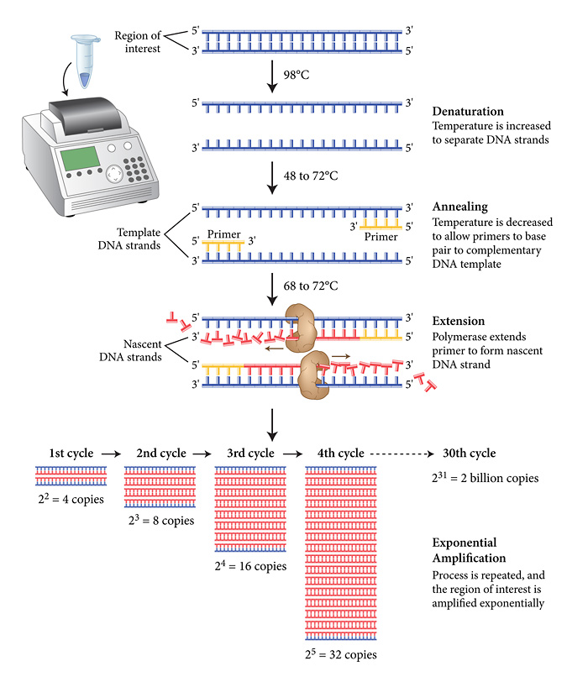

**Applications of PCR**

PCR is useful when small initial amounts of DNA are available (e.g., forensics or diagnostic samples) or anytime large quantities of a particular region of the genome are needed (e.g., for DNA sequencing or finger printing).

1- Selective DNA isolation; PCR allows selective amplification of a specific region of the DNA which can be used later for many other investigations such as DNA sequencing ,genetic finger printing, investing evolutionary relationships among organisms It is used in forensic medicine where amplification of the DNA is very useful especially when only trace amounts of DNA is available as evidence, may also be used in paternity testing, can also be used in the analysis of ancient DNA like the DNA analysis of the remains of Egyptian mummies.

2- For quantification of DNA : this allows to estimate the amount of DNA present in a sample which is used to quantitatively determine the level of gene expression . Real -Time PCR is used then which measures the accumulation of the DNA product after each PCR round.

3-PCR In diagnosis of disease; It permits early diagnosis of malignant diseases or can establish whether the person is at risk or not (by investigated the presence of a certain gene that is associated with a certain type of cancer)

**PCR Optimization:**

In practice, PCR can fail for many reasons that is why it is important to ensure successful PCR conditions of the reactions and technique should be optimized:

- Contamination can cause the amplification of unwanted DNAs, thus there should be spatial separation of PCR set up areas from areas of purification and analysis of the PCR product. Add to that all precautions should be taken to minimize contamination as much as possible.

_ The primer designing is very important in improving the product yield and avoiding formation of spurious products.

_ The choice of buffer or polymerase enzyme can help in the amplification of long or otherwise problematic regions of the DNA.

**General Precautions:**

* There should be a spatial separation of PCR set up areas

from areas of purification and analysis of PCR.

* Use of pipette tips with filters (to minimize contamination).
* storage of materials used in PCR should be separated

from all other reagents and should be added to the

reaction mixes in a sterile spatially separated facility.

* Use of PCR grade distilled water which has been heat and

UV

sterilized.

* The use of non powdered gloves