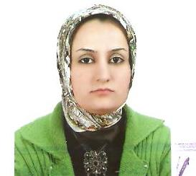
Personal Info:
Name: Samar Sabah Mamand Rasheed
Age: 20-jun-1983
Nationality: Iraqi - Kurdish
Sex: Female
Marital Status: Married
Address: Erbil – tayrawa
Phone Number: +964 (0) 7504523808
Emil address: samarsabah_389@yahoo.com

Degree & License:
BSc degree - Salahaddin University - College of Science – computer science department on 2005
Master degree – Salahaddin University - College of Science – computer science department on 2011.

Work Experience:
Lecturer at Salahaddin University-Erbil -College of Science- Department of Computer Science and Information Technology .M.Sc. degree in Computer Science

Language:

English
Arabic
kurdish

Other Skills:
I am an enthusiastic person who can achieve more goals at work and I can work under pressure, and endure long hours of working. Also I can handle many tasks in the field of work. I have good ability to guide people in Kurdistan and Iraq.

