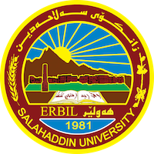
Academic Curriculum Vitae
Personal Information:
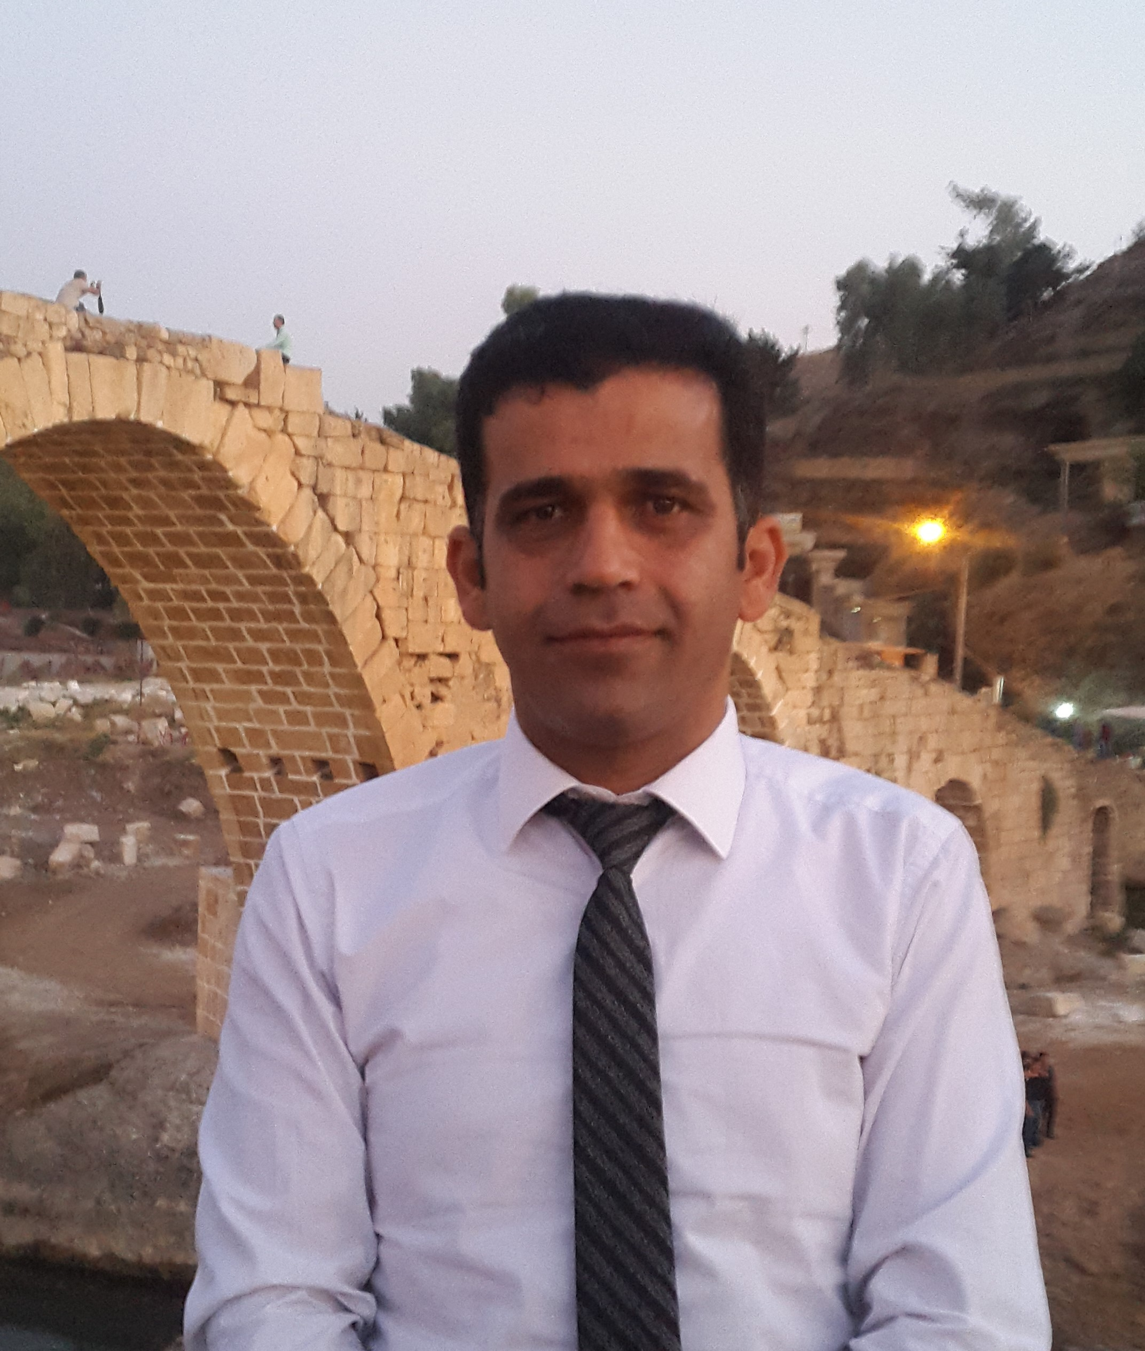
Full Name: Sami Ali Hussein
Academic Title: Assistant Professor
Email: sami.hussein@su.edu.krd
Mobile:07504538162

Education:
1) Ph. D. in Mathematics. Mathematics Department - College of Computer Sciences and Mathematics – University of Mosul in 2012.
2) M. Sc. in Mathematics. Mathematics Department - College of Education - Salahaddin University –Erbil in 2003.
3) B. Sc. in Mathematics, Mathematics Department - College of Education - Salahaddin University -Erbil in 1999.
Employment:
- Research Assistant, Dept. of Mathematics, College of Education, University of Salahaddin-Erbil, 1999-2001.
- Assistant Lecturer, Dept. of Mathematics College of Basic Education, University of Salahaddin-Erbil, 2003-2009.
- Lecturer, Dept. of Mathematics College of Basic Education, University of Salahaddin-Erbil, 2009-till 2018.
- Assistant Professor, Dept. of Mathematics College of Basic Education, University of Salahaddin-Erbil, 2018.
- Director of Computer unit in College of Basic Education University of Salahaddin-Erbil, 2004-2008.
- Vice head of Mathematics Dept. 2006-2009.
- Member of Examination Committee in College from 2004-till now
- Vice head of Examination Committee in College of Basic Education 2016
- Member of Scientific Committee in Mathematics dept.
(2004 till now)
- Head of Quality Assurance committee in Math. Dept. from 2013-2016.
- Head of Quality Assurance in College of Basic Education from 2016-2017.
- Head of Examination Committee in College of Basic Education 2017-2021
13. Head of Mathematics department 2017 till now

Qualifications
- Training course in English Language, Salahaddin University-Erbil, 2001, ( One month) .
- Training course in Teaching methods, Salahaddin University-Erbil, 2006, ( two weeks) .
- Training course in Special Education, Salahaddin University-College of Basic Education Erbil, 2013,( two weeks) .
- Training course about Capacity building of teachers in university, Leipzig University, Germany from 18-10-2014 to 24-10-2014.
- Training course about Diversity and Entrepreneurship in Education , FA University in Nuremberg and Erlangen , Germany from 22-09-2016 to 6-10-2016.
- Training course about Diversity and Entrepreneurship in Education , FA University in Nuremberg and Erlangen , Germany from 15-07-2016 to 29-7-2017.

Teaching experience:
III. Subjects which have been taught to undergraduate
(B. Sc.) students
- Abstract Algebra. (3rd Math. )
- Linear Algebra. (2nd Math.)
- Mathematical Analysis. (3rd Math.)
- Advanced Calculus (2nd Math.)
- Programming Pascal(3rd Math.)
- General Topology. (4th Math.)
- Foundations of Mathematics. (1st Math.)
- Finite Mathematics. (1st Math.)
- Calculus (1st Math.)
- Linear Mathematics (Optional) (4th Math.)
- Matlab( 2nd Math.)
- Information Technology ( 1st Math.)

IV. Subjects which have been taught to postgraduate (M. Sc.& PhD.) students
- Advanced Algebra (M.Sc. in Math. Dept.) (2014)
- Advanced Mathematical Analysis (M.Sc. in Math. Dept.) (2014)
- Advanced Mathematics (MSc. In Statistics) (2015)
- Advanced Information Technology (M.A in English Department) (2017)
- Advanced Information Technology (M.A in English and General Science Department) (2018)
- Advanced Mathematical Analysis (Ph.D. in Mathematics Departement)(2021)

Research and publications
VIII. Published Papers
[1] Ahmed N.K. , Hussein S.A.(2004), P$δ$-open sets in topological spaces, J. of Zanco. 2(3 ),
[2] Ahmed N.K. , Hussein S.A.(2007), On Pθ-open sets in topological spaces, J. of Kirkuk Univ. 2(3 ), (125-132).
[3] Hussein S.A.(2009), Function with P*-Closed Graph, J. of Koya Univ.
[4] Tahir, H. I & Ibrahim, O. H. & Sami, A. H.; (2012), βθ- Monads in General Topology, Int. J. Contemp. Math. Sciences, 7( 5), 241 – 249.
[5] Tahir, H. I & Ibrahim, O. H. & Sami, A. H.(2012), On New Type Of Monads in Topology, J.of Theoretical Math.&Applications 2(3),139-150.
[6] Tahir, H. I & Ibrahim, O. H. & Sami, A. H., Pθ-Topological groups in Nonstandard Analysis, Rafidain. J.Comp.SC.and Maths.9(1) 191-199.
[7]Hussein, S. A., $ψ_{c}-$open sets in topological spaces, accepted in J.of Zanco 2016.
[8] Ibrahim, O. H. & Sami, A. H., Nonstandard Version of Intermediate value property , Zakho J.2017 .
[9] Hussein, S.A,& Rashid N.O.(2022), Maximal and Minimal Regular β -Open Sets in Topological Spaces, Iraqi J. of Science, 63(4),pp.1720-1728.
[10] Hussein, S.A,& Rzgar O.A.(2023), Nano βθ-Open Sets in Nano Topological Spaces, Accepted in Tikrit J. of Pure and Applied Sciences.

Conferences and courses attended
1) Participated at, the first Iraq-French mathematics conference in cooperation with College of Science/Salahaddin University-Erbil/Iraq.(2009).
2) Participated at the first (Kudish-Swiden) mathematics workshop in cooperation with College of Science/University of Zakho-Iraq.(2015).
3) Participated at, the West Asia School of Mathematics in Erbil , College of Science/Salahaddin University-Erbil/Iraq.(2017).
4) Organizer of First International Conference between Salahaddin Univ. and FAU in Germany
5) Organizer of Second International Conference of Mathematics , Salahaddin University-Erbil(2019)
6) Organizer of Third International Conference of Mathematics , Salahaddin University-Erbil(2022)
7) Organizer of 6th Conference of Educational Science , Salahaddin University-Erbil(2023).
Funding and academic awards

Professional memberships
Teachers Union of Kurdistan
Professional Social Network Accounts:
e-mail: sami.hussein@su.edu.krd or samimath4@gmail.com
Google Site: https://sites.google.com/a/su.edu.krd/sami-ali-hussein/
Researchgate: https://www.researchgate.net/profile/Sami_Hussein
LinkedIn: https://www.linkedin.com/in/sami-a-hussein
https://orcid.org/0000-0002-3930-0241

