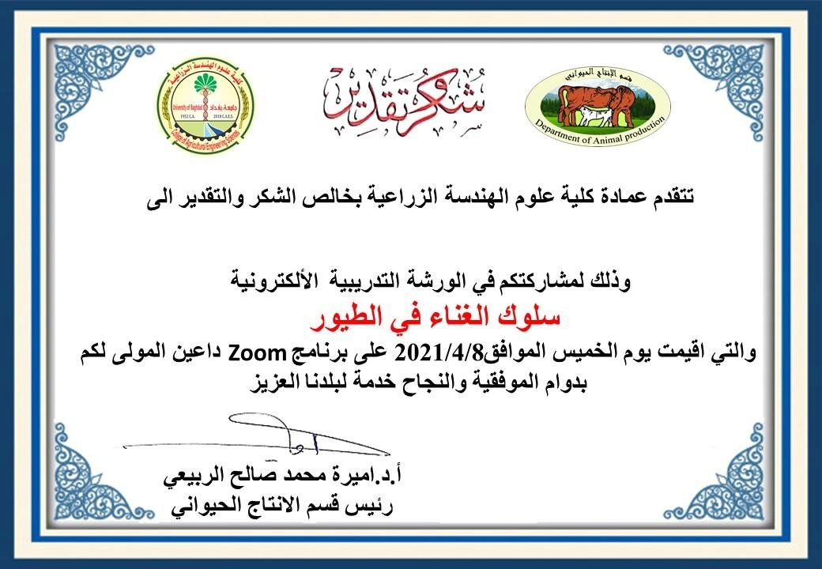

Asst. Prof. Sami Muhammad Amin

Made for free with Certify'em

