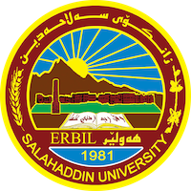
Academic Curriculum Vitae
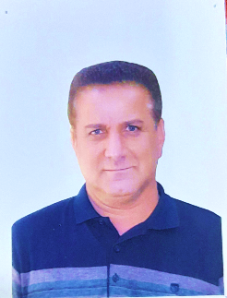
Personal Information:
Full Name: Samih Mustafa Hassan
Academic Title: Asst. Lecturer
Email: (samih.hassan@su.edu.krd)
Mobile: 0750 344 5588

Education:
- Bachelor Degree in Sociology Department-1998
- Master’s Degree in Sociology Department-Beirut Arab University-2015

Employment:
- As a social worker- Ministry of Labour and Social Affairs-2000
- University Teacher-Salahaddin University-2009-Present

Qualifications
- Bachelor Degree in Sociology
- Master’s Degree in Sociology
- Language Qualification-Salahaddin University-Language Center
- Diploma in Teaching-2015
- Academic Debate Qualification-Salahaddin University

Teaching experience:
- I have taught many different subjects at Salahaddin University-College of Arts including; Ecstatic, Philosophy of Religion, Academic Debate, Ethic
- Foster Family Supervision, etc.,

Research and publications
- Social Movements against Globalism-Halabja University Journal
- Handling Students’ Disruptive Behaviour in Language Study Classroom: A Descriptive Analytical Study
- The Economical Outcomes of the Political Party in The Kurdistan Region of Iraq
- Social Value and Its Impact on Women’s Work in Erbil Governorate
- Third Stage Students’ Difficulties in Translating Idiomatic Expressions: An Analytical Study

Conferences and courses attended
- College of Arts Conference

Funding and academic awards
- No

Professional memberships
- Member in Kurdistan Sociologists Association

Professional Social Network Accounts:

- I don’t have them.

It is also recommended to create an academic cover letter for your CV, for further information about the cover letter, please visit below link:
https://career-advice.jobs.ac.uk/cv-and-cover-letter-advice/academic-cover-letter/

