Detector question bank
- Why the S/N ratio improvement offered by a good photodetector design should be so important ? Wouldn’t be just sufficient to increase the source power to get the same result?

- A photodetector received 3x10 ¹⁰ photons with wavelength 0.85 μm , at the terminal on device 1.2x10¹⁰ electrons are collected , what is the quantum efficiency and responsivity of detector at this wavelength ?

- A photodiode has quantum efficiency of 60%
A}Calculate the wavelength of operating Detector when photons of energy 1.55 × 10⁻¹⁹ J are incident upon it. (b) Calculate the incident optical power required to obtain a photocurrent of 2.2µA when the detector is operating as described in (A)
- GaAs has a 1.42 eV bandgap energy at room temperature, what is the wavelength that the photodetector fabricated from this material will operate?
- What are the difference between extrinsic and extrinsic photodetector .
- What are the basic ways to detect photon.
- A Si photodetector with responsivity (0.65) has an active area of A=5mm2, a bandwidth of 100MHz and dark, find the total noise
- Consider an intrinsic silicon photoconductor operating at 1 μm and constructed as shown in Figure 2.6. Let it be 1 mm2, and operate it at 300 K. Assume the detector breaks down when its bias voltage, Vb, exceeds 60 mV. Determine: (a) a reasonable detector thickness for good quantum efficiency; (b) the responsivity; (c) the dark resistance; (d) the time response; and (e) the Johnson noise.
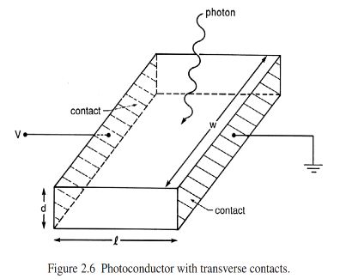
- A Si photodetector has an intrinsic region with a widith of 20 μm and a diameter of 500μm in which the drift velocity of elctrons is 10⁵m s-1 ,when the permitivity of the device is 10.5x10 ⁻¹³ Fcm⁻¹ , calculate a the drift time of the carriors across the depleation region, the junction capacitance of the photodiode
- What is the maximum value of the energy gab that a semiconductor used as a photoconductor, can have if it is to be sensitive to red light (630nm)
- Define thr quantum efficiency ,resposivity of a photodetector
- Calculate the responsivity of a detector with quantum efficiency of 15% at 850 nm

- A photodiode has a quantu efficincy of 65% when photon of energy 1.5x10⁻¹⁹j are incident upon it

At what wavelength is the photodiode oparating? Calculate the incident optical power required to obtaine a photpcurrent of 2.5μA when the photodiode is oparating as described above .
- What are the difference between intrinsic and extrinsic of photodetector ?
- What is detector mean, write about detector characteristic .
- Derive the formula of total noise of a photodetector.

- What is the photocurrent if the quantum efficiency is 75% at 830nm,and the incident optical power is 100μW
- Define the following parameters of a photodetectors: (a) responsivity, (b) quantum efficiency, (c) photo-carrier generation rate
.
- In a photodiode for high speed operation the depilation region must be ….
- `What is the constitute of PIN diode?
- What is the difference between intrinsic and extrinsic photodetector
- What are photodetectors?

