The soil (pedon)
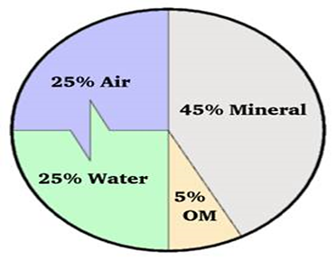
Pedology is a branch of soil science focusing on the formation, morphology, and classification of soils as bodies within the natural landscape.
Soil is a natural body consisting of layer constituent of variable thickness which differs from the parent materials in there morphological, physical, chemical and mineralogical characteristic.
Soil component:
Soil is comprised of minerals, soil organic matter, water, and air. The composition and proportion of these components greatly influence soil physical properties, including texture, structure, and porosity, the fraction of pore space in a soil. In turn, these properties affect air and water movement in the soil, and thus the soil’s ability to function.
Soil forming factors:
(Parent materials, climate, time, organisms…)
Soil Physical Properties
- Soil horizon (profile):
is a layer parallel to the soil surface, whose physical characteristics differ from the layers above and beneath; each soil type has at least three or four horizons.
- O horizon: The "O" stands for organic. It is a surface layer, dominated by the presence of large amounts of organic material in varying stages of decomposition system.
- A horizon: this layer has a layer of dark decomposed organic materials, which is called "humus".
- E horizon: is a subsurface horizon that has been heavily leached. Leaching is the process in which soluble nutrients are lost from the soil due to precipitation or irrigation. The horizon is typically light in color.
- The B horizon: is a subsurface horizon that has accumulated from the layer above. It is a site of deposition of certain minerals that have leached from the layer above.
- C horizon: is composed of weathered parental material, Plant roots do not penetrate into this layer.
- R horizon: the final layer of a typical soil profile this layer consisted of un weathered rock. (Bedrock) layer that is beneath all the other layers.

2-Soil Moisture
Water contained in soil is called soil moisture. The water is held within the soil pores. Soil water is the major component of the soil in relation to plant growth. If the moisture content of a soil is optimum for plant growth, plants can readily absorb soil water.
Forms of soil water:
Water percent in the soil can exist in three Forms:
1. Capillary water: Is held in the small pore or capillaries in continuous water film.
2. Hygroscopic water: Is the water that adsorbed on soil particle surface by surface tension or force.
3. Gravitational water: Is water that occupies aeration pore space but will drain down to lower depth under gravity force.
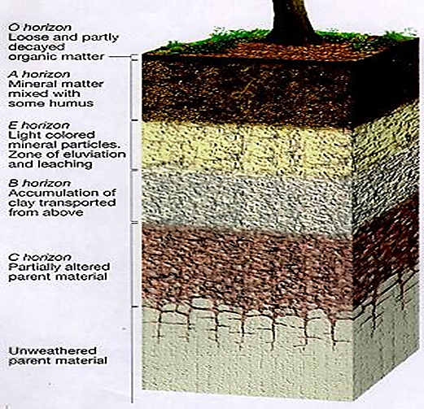

Water holding capacity (W.H.C.):
Is the maximum amount of water that soil retains it or (the ability of soil micro pore to hold water for the plant use)
Procedure for estimating W.H.C:
1-put funnel on cylinder
2-put 50 gm of soil in funnel after adding filter paper
3- Add 50 ml of water to the soil surface & let the water driven down to the measuring cylinder.
W.H.C. = Volume of retained water / weight of soil
Volume of retained water = volume of water used - volume of water in cylinder

