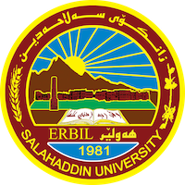
Academic Curriculum Vitae
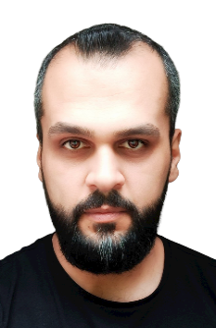
Personal Information:
Full Name: Sangar Sarbast Qasim Alawezi
Academic Title: Lecturer
Email: sangar.aqasim@su.edu.krd
Mobile: +964 750 486 32 19

Education:
- Master Degree in Economic Science- Salahaddin University- 2016.

Employment:
Work experience in Public Directorate of Art and Culture form March 2007 till 10 August 2009 in Accounting, Computer and Human Resources departments.
Work experience in Ministry of Communications in IT department from 11 August 2009 to 1 January 2010.
Work experience in Public Directorate of Culture and Art in Computer department from 3 January 2010 till 27 October 2010.
Work experience in Public Directorate of Sport and Youth in Human resources and computer department from 28 October 2010 till 16 October 2011.
Work experience in Salahaddin University/College of Administration and Economy in IT and planning units from 16 October 2011 till September 2013.
Work experience in Life Support Team “LST” in Management and Secretary Departments from 27 of March 2012 till 8 September 2012.
Work experience in Dara Group Company as accountant and Human resources from 11 May 2015 and till 8 October 2016.

Qualifications
- All Microsoft office versions, Internet, Formatting computer, some other programs.
Certificate of computer training course “ICDL” at Salahaddin University, at 13 March 2013.
English language proficiency certificate at Language Center of Salahaddin University, at 9 September 2013, rank 3.
Appreciation certificate from Danish refugee council, United Nations Development Program “UNDP” and Japan government council for presenting seminars about Kurdistan economy and its labor market for Syrian refugees in Kurdistan region at 9th and 11 September 2014.
Participated in summer training course of Salahaddin University/ Administration and Economy College from 10th of July 2010 till 10th of August 2010.

Teaching experience:
- Academic Skills and critical thinking, Grade 1.
- Corporate Governance, Grade 3.
- Financial Service Marketing, Grade 3.
- Microsoft Excel, Grade 2

Research and publications
Analysing Credit Risk Management in Commercial Banks: An Exploratory Research about the Opinions of a Sample of Managers and heads of departments in selected commercial banks in Erbil City (2021)
Analyzing the role of Commercial Banks’ policies in promoting savings: An applied study of a sample of commercial banks operating in Erbil 2021.

Conferences and courses attended
- Public sector banking situation in Kurdistan Region, challenges, problems and treatments workshop. Participated as presenter and presented in 30/11/2022 in College of administration and economy.
- The outcome of Russia-Ukraine war on political and economic issues of Kurdistan region symposium, as a participant presented in 12/04/2022 in Kocher Byrkar Hall.

Professional memberships
- Member in Kurdistan Economists Syndicate since 2012

Professional Social Network Accounts:
- Research Gate account: https://www.researchgate.net/profile/Sangar-Alhawezi
- Google scholar account: https://scholar.google.com/citations?hl=en&user=mqUjeJEAAAAJ

