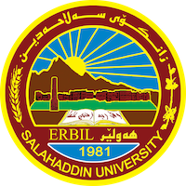
Academic Curriculum Vitae
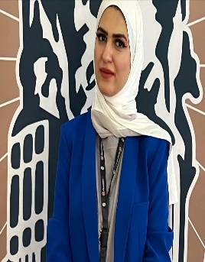
Personal Information:
Full Name: Sara Zaid Mahmood
Academic Title: Assistant Lecturer
Email: Sara.mahmood@su.edu.krd
Mobile:0750 4495309
Date of birth: September, 8th, 1990

Education:
- Bachelor Degree in Arabic language at Arabic Department / college of languages / Salahaddin University – Erbil in 2009.
- Master Degree in Arabic Language at College of Languages / Salahaddin University – Erbil in 2017.
- PhD student in Arabic Language at College of Languages / Salahaddin University – Erbil since 2020.

Employment:
- Assistant researcher at Arabic Department / college of languages / Salahaddin University – Erbil in 2012.
- Assistant lecturer at Arabic Department / college of Education - Shaqlawa / Salahaddin university – Erbil since 2018.

Teaching experience:
- I have taught the following modules:
- Pre-Islamic Literature
- Abbassid Literature
- Andalusian Literature

Research and publications:
(Discourse of Narrative Character in Maha Hassan Novels - Qalay Zanst journal - Lebanese French University / 2023).

The style of poetic dialogue in Amal Dunqul poetry (Al Adab Journal - university of Baghdad / 2017).

The discourse its references in Maha Hasaan s novels selected models (Raparin journal- university of Raparin).

https://orcid.org/0009-0004-7100-6968.

https://scholar.google.com/citations?view_op=new_profile&hl=en

Professional Social Network Accounts:
Sara.mahmood@su.edu.krd

