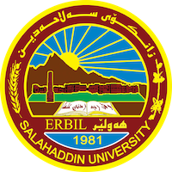
Academic Curriculum Vitae

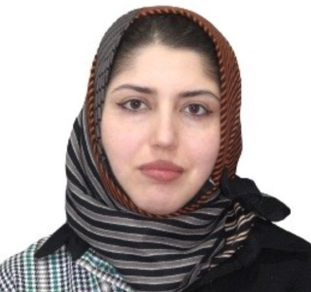
Personal Information:
Full Name: Sara Falah Mohammed
Academic Title: Assistant Lecturer
Email: sara.mohammed@su.edu.krd
Mobile: 07506393538

Education:
- Bachelor in Arabic language (Salahaddin University 2012-2013)
- Master's degree in Arabic Literature (Salahaddin University 2017 )

Employment:
- 2012-2013: Lecturer at Shahid Khader Swara primary School for Girls.
- 2013 Assistant Researcher, College of Education.
- 2019 Assistant Lecturer, College of Education.

Qualifications
- Teaching qualifications.
- IT qualifications MS Word and PowerPoint and Exel .
- Kurdish language proficiency : very good
- Arabic language proficiency : very good
- English language proficiency : very good.
- 2017 - 2018- Course teaching methods to prepare teachers Salahaddin University - Erbil –as a lecturer and evaluator. University of Sallahaddin - Erbil - Iraq...

Teaching experience:
- in undergraduate students;
- Linguistic and Literary Researches for Undergraduate.
- Teaching various courses to different levels of students at the Arabic Language.

Research and publications
- Dimension of Place in Imru Al-Qays’s Poetry.
- Critical Judgments on the Pattern of Preference.
- The Phenomenon of Revision in Arabic Poetry, Selected Models.
- The Image of the Woman in The Poetry of Amr Bin Kulthum Al-Taghlibi.

Conferences and courses attended
I participated in the First Arba’elo International Conference and Workshop on Syriac and Sureth language Studies, a joint conference between Salahaddin University, University of Heidelberg, and University of Cambridge (9-11 September 2017)

Professional memberships
- 2018-2022: Department Assistant of Syriac Language Department, Salahaddin University-College of Education
- 2017-2022: Instructor at Salahaddin University-College of Education –Syriac Language Department.

Professional Social Network Accounts:
https://academics.su.edu.krd/sara.mohammed
https://www.researchgate.net/profile/sara .mohammed
https://scholar.google.com/ citations?hl=ar&user=Q5rc- -

