C.V of sara omar swar
Full name ; lecture Dr sara omar swar
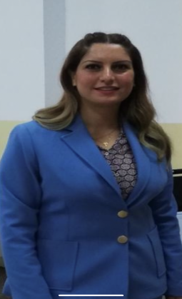 Place and date of Birth / Iraq/ Erbil 1987
E-mail sara_swar@yahoo.com
General specialty / Food science technology
Sub- specialty / Food microbiology
- 2007 Bachelor degree in food science , collage of agriculture engineering science , food technology departments , Salahaddin university
- 2014 M.Sc. degree in food microbiology ,collage of agriculture engineering science , food technology departments , Salahaddin university
Isolation and identification of Helicobacter pylori from water and food and patients , molecular characterization of H. pylori gene by using conventional methods PCR in Erbil , Iraq .

- 2021 PhD degree in food microbiology , collage of Science , Biology department , Soran university
Ultrastructural and Molecular Characterization (PCR ) of Sarcocystis species (Lankester, 1882) Isolated from Domestic Sheep and Goats in Soran City, Erbil-Iraq

Academic record
2007- 2021/ assist lecture and lecture in food science department

In Addition , I had taught
- General microbiology
- Dairy microbiology
- Food safety
- Food poisoning
- Genetic modified food

Publication
1/Detection of Helicobacter pylori in leafy vegetables by PCR and determination of the antibacterial activity of green tea and garlic extracts against isolated bacteria

2/Recent advanced in molecular characterization of Sarcocystis species in some meat producing animals

3/Prevalence and microscopic studies of mixed sarcocystis infection in naturally infected sheep and goats in soran city

4/ Ultrastructure and molecular characterization of Sarcocystis species in domestic sheep and goats

Book chapter (Agrobiologicalrecord.com)

- Sarcocystosis in meat-producing animals An updating on the molecular characterization

2-Viral Diseases of fish

3-Parasitic diseases of fish

4- Possible Role of Pets , Wilds and Domestic Animals in the Transmission of COVID 19 to Humans

