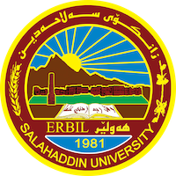
Academic Curriculum Vitae
Personal Information:
Full Name: Sara Abdulkhaleq Yaseen
Academic Title: Assistant lecturer
Email: sara.yaseen@su.edu.krd
Mobile: 009647503152383

Education:
- Bachelors degree from environmental science and health department and masters degree in Phycolimnology

Employment:
Assistant lecturer in Environmental science and health department
Qualifications
- ( Limnology, Phycology, Waste management, Ecology, Hematology, Microbiology)
- Microsoft, SPSS, Graph Pad
- Language qualifications such as IELTS, Language center
- Comprehensive Course of molecular Techniques for three week
Teaching experience:
- ( Limnology, Phycology, Waste management, Ecology, Hematology, Microbiology)
- Supervisor at biotechnological lab.

Research and publications
- I have four papers in different subject in my speciation

Conferences and courses attended
- I attended in seven conferences and twenty five courses
Funding and academic awards
- List any bursaries, scholarships, travel grants or other sources of funding that you were awarded for research projects or to attend meetings or conferences.

Professional memberships
- Membership in health commute, section council commute and supervisor at biotechnology lab.

