What are landfills?

Landfill Processes
The landfill is the most economical form of solid waste disposal that reduces adverse environmental effects. Landfills cannot be built in environmentally-sensitive areas, and they are placed using on-site environmental monitoring systems. These monitoring systems check for any sign of groundwater contamination and for landfill gas, as well as provide additional safeguards.

What Are the Four Types of Landfills?
- Municipal Solid Waste Landfills.
- Industrial Waste Landfills.
- Hazardous Waste Landfills.
- Green Waste Landfills.

Technical protection system:
- Isolation of the landfill with protective and closing layers
- keeping off the rain and underground water from the waste.
- Collection and treatment of leachates.
- Construction and operation of monitoring system.
- Covering, closing of the dump.

The following wastes may not be accepted in a landfill:
- Liquid waste.
- Flammable waste.
- Explosive or oxidizing waste.
- Hospital and other clinical waste which is infectious.

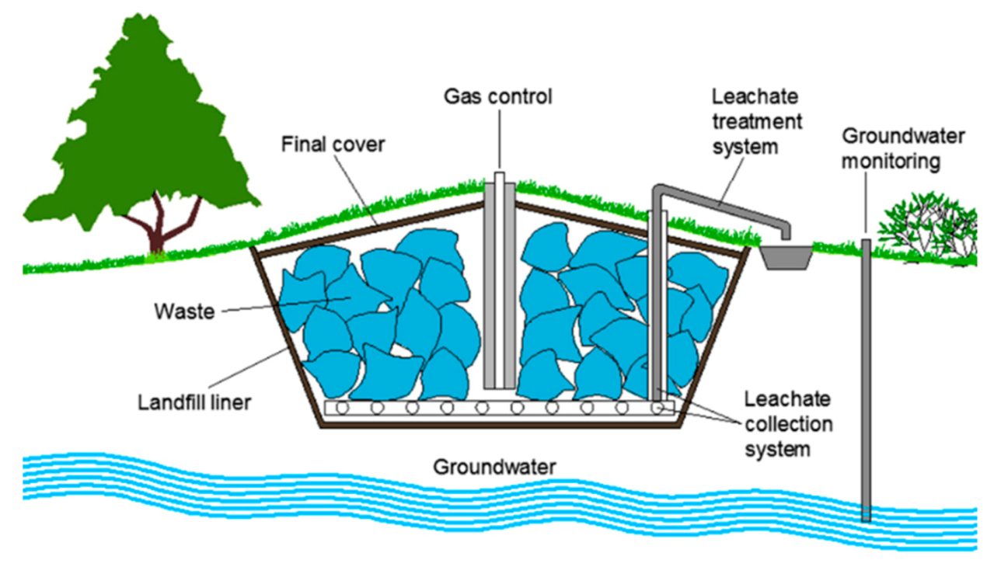
Land filling system

