LIMNOLOGY QUESTION BANK
Q1- Choose the correct answer:
1- When nitrate is increase in water cause a syndrome in children called
- Methemoglobinemia, b- nitrosamine, c- Ethemoglobinemia, d- Nethemoglobinemia)
2- We take two different absorbance in nitrate determination was.
- 220-265nm, b- 220-260,c- 226-271nm, d- 220-275nm)
3-…………………. mean the morphological information of the site include (location of the source, historitical background of the source).
- Morphometry, b- Morphotetry, c- Morphology, d- Morphotemry)
4- High algae and nutrient cause to decrease.
- Viscosity, b- Transparency ,c- Temperature , d- Water current)
5- The acid base indicator depends on.
- Temperature, b- pH, c- O₂ , d- EC)
6-The concentration of Na in water depend on
- Geological formation, b- waste water contaminant, c- Geological formation &waste water contaminant)
7-pottasiumin ground water occurs as a result.
{a-mineral dissolution, b- Decomposition of plant material, c- Agricultural run-off, d- all of them(a,b,c)}
8- The second layer of lake is
- Epelimnion, b- hypolimnion , c- Thermoclin, d- hyperlimnion)
9- The high nutrient and low quality water lake was
- Ephemeral, b- Eutrophic , c- Oligotrophic, d- Mesotrophic)

Q2/ Prepare the 50 ml of concentration (1, 10, 20, 30) mg/l for NO₃ in (KNO₃ stock solution). Note: the concentration of stock solution is 100 mg/l.
Q3/Why high algal concentrations reduce transparency?
Q4/ How decline the NO₃ concentration in water by ion exchange.
Q5/ Write the name of instrument and for which purpose use (to determine which ions or parameters).
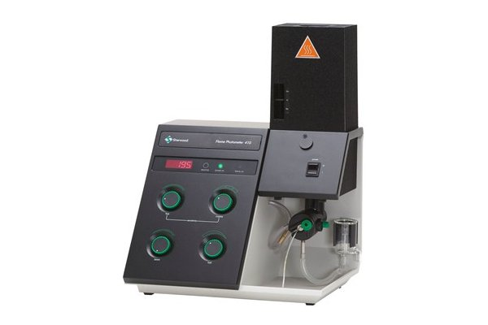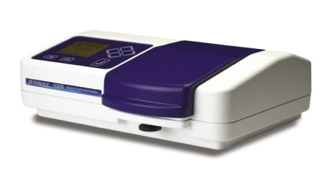
3
1
2
Q6/ Choose write answer
1- At 24 hours after the addition of sodium hypochlorite to containers that are used by families to store water there should be a minimum of ---------of free chlorine residual present.
- 0.2 mg/L, b- 0.3 mg/L, c- 0.4 mg/L, d- 0.5 mg/L)
2- When water current increase Electrical conductivity also increase, because
- Nutrient decrease and mix nutrient, b- O₂ increase and not mix nutrient, c- mix nutrient, d- increase temperature)
3-…………………. have water current and vertical parallel to the water depth.
- River, b- Stream, c- Lake, d-Spring).
4- The factors effect on CO2 in water was
(a-Phytoplankton, b- Atmosphere ,c- Microorganism, d- Phytoplankton, Microorganism and Atmosphere)
5-The gas that used in atomic absorption to metals that need above 1000 ℃
(a-Acetylene b- athelin c-argon d- arsenic)
6-Chlorine demand was composed of reaction chlorine with
- organic material & metals, b- nitrogen, c-bacteria and virus, d- heavy metals)
10- When the Ph of sample is 8.0 the total hardness is equal to
(a-Total alkalinity= M.O alkalinity +Ph.ph alkalinity b- Total alkalinity= M.O alkalinity c- Total alkalinity= Ph.ph alkalinity) .
Q7/Write the difference between polluted water and fresh water according to source of CO2.
Q8/ Write the flow chart of chlorine addition.
Q9/ Label the following table and the write the name of instrument.
b
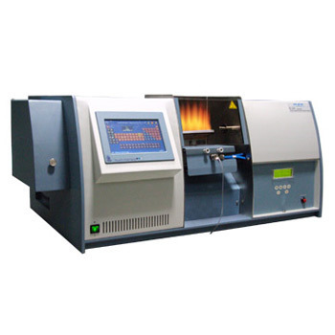
d- name of instrument
c
a

Q10/ If the pH of sample is 8.4 The sample need 2 ml of H2SO4 to change ph.ph in pink to colorless while 12 ml to change M.O From orange to dark orang find total alkalinity.

Q11/ Write the source of dissolved oxygen in water.

Q12/ Write the name of titrant reagent that used in O₂ determenation?
Q13/ what’s mean of modified Alkaline Iodide Azide method?
Q14/ what is the source of sodium in water?
Q15/ Write types of solid matters in water?
Q16/ Chemical structure of solid matters depends on what?
Q17/ What is water transparency?
Q18/ Why the transparency one of the physical properties?
Q19/ Write the factors affect the transparency?
Q20/ what is the difference between transparency and turbidity?

