بةشى سامانى ماسى

قؤناغى دووةم ليمنؤلؤجى عملى م. عبدالقادر

**(Water current)**

***Water current:*** mean flow of water influenced by gravity.

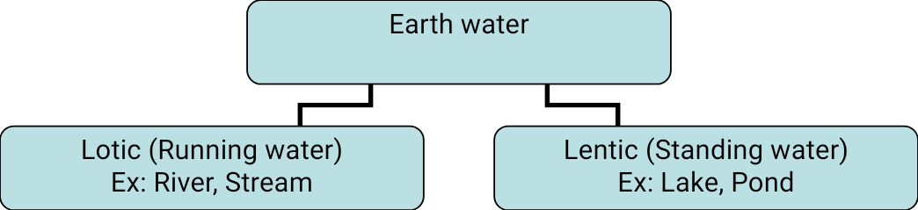



Running water has water current Standing water has water current 

Unidirectional Multidirectional

Faster than standing water current slower than running water current

***The factors that affect the water current***

1. Wind (directly proportional to increase the surface area of water).
2. Shape of stream or river.
3. Volume of water.
4. Gravity (movement of earth planet, position).

***Advantage of water current:***

1. Increase the surface area of water surface.
2. increase of dissolved oxygen contents.(why)
3. Mixed nutrient.
4. Electrical conductivity ∞ water current.
5. Change in water diversity.
6. Water current ∞ self purification.

* Any change in terrestrial environment effect on aquatic environment.

\****How can relate between water current and water profile.***

In standing water, water current vertical parallel to the water depth.

In running water, water current horizontal, perpendicular to the water depth.

***\*Water current in running water affected by water depth, is it true or false.***

Move by all volumes and does not affected by depth that is false.

*The movement of the water current in stream and waves in an open water determine the natural of many aquatic environments, the velocity of the current hold the character and structure of stream.

Rivers are unidirectional current and with velocity (0.1-1) m/sec. while lakes are multidirectional with average current (o.oo1- 0.01) m/sec.