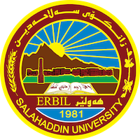
Academic Curriculum Vitae
Personal Information:
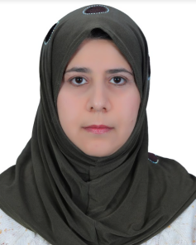
Full Name: Sarah Ahmed Hassan Chawsheen
Academic Title: Lecturer
Email (university email): sarah.chawsheen@su.edu.krd
Mobile: 07503010428

Education:
- Highschool, scientific branch 1991-1992, Azadi Highschool for girls.
- Bachelor science in statistics 1995-1996, Salahaddin University.
- Master science in economic and finance 2010, University of Kurdistan- Hawler.
- Ph.D. in Economics, 2024.

Employment:
- Started my career as employee since March 1998 till the time being.

Qualifications
- Faculty staff in the dep. Of Economic, Salahaddin University.
- I can use the following softwares: Word, Excell, SPSS, EViews, Stata.
- Language qualifications: TOEFL, and IELTS.
- Apply Econometrics.
- Professional courses taken: Teaching methods, training methods, Moodle, Bolognia teaching system, statistical surveys, and office administration.

Teaching experience:
- Mathematics, Economic Statistics, SPSS, Macroeconomic Theories in English, principles of Microeconomic, principles of Macroeconomic, Macroeconomic Studies in English, Microeconomic Studies in English, and Econometrics.
- Research supervision of stage four students, supervision of a statistical survey in Erbil technical institute, supervision of summer training of third stage students, data entry of our collage employees, …etc.
- Working on my PhD. Dissertation at the time being.

Research and publications

- A Statistical Study on Stomach and Esophagus Ulcer Patients in Rizgari Hospital of Erbil Governorate.
- The Agriculture Sector in Kurdistan Region with emphasis on the Supply of Wheat: Econometric Models.
- The Demand for Tourism in the Province of Erbil, especially during the Winter Season of 2015-2016.
- Using Factor Analysis for Expenditure Patterns of Peshmerga Households in Erbil Governorate, with Focus on Food Items.
- The Impact of Economic Determinants on Terrorism in Iraq During the Period 2000-2020.
- Analyzing the Relationship Between Some Economic Indicators and Iraq Terrorism Index, and Forecasting it Using the ARMA Model.
- The Influence of Some Economic and Non-Economic Factors on Terrorism in the Seven Most Affected Countries During the Years 2000-2021.

Professional memberships
- Kurdistan Teachers Syndicate membership.

Professional Social Network Accounts:
- https://scholar.google.com/citations?hl=en&user=yzD9O8MAAAAJ
- https://academics.su.edu.krd/profile-admin/index.php?p=dashboa rd
- https://www.researchgate.net/profile/Sarah-Chawsheen-2
- https://www.linkedin.com/in/sarah-chawsheen-b12406129/
- https://www.facebook.com/sarah.chawsheen/
- https://orcid.org/0009-0000-8264-5512

