Bank of questions – microeconomic studies – 4th stage economics – 2021-2022

- How people make decisions? Mention your answer in points.
- How people make interact? Mention your answer in points.
- How the economy as a whole works?

- Translate point 10 of the ten principles of economic below:
Society faces a short-run trade-off between inflation and unemployment. While an increase in the quantity of money primarily has the effect of raising prices in the long run, in the short run the story is more complex. Most economists describe the short-run effects of money growth as follows:
• Increasing the amount of money in the economy stimulates the overall level of spending and thus the demand for goods and services.
• Higher demand may over time cause firms to raise their prices, but in the meantime, it also encourages them to hire more workers and produce a larger quantity of goods and services.
• More hiring means lower unemployment. This line of reasoning leads to one final economy-wide trade-off: a short-run trade-off between inflation and unemployment.

- Define scarcity. And, why do we face Scarcity?
- Mention the types of scarcity in points.
- Define Price elasticity of demand, and how it is calculated.
- When a demand curve is inelastic a price increase --------- total revenue and a price decrease ------------ total revenue.
- When a demand curve is elastic a price increase ---------- total revenue and a price decrease ------------ total revenue.
- Define price elasticity of demand. Explain the relationship between total revenue and the price elasticity of demand.
- In the special case of unit elastic demand a change in the price ------------ total revenue.
- With an elastic demand curve, how an increase in the price affect the quantity demanded, and the total revenue? Clarify your answer with figure.
- How is the slope and elasticity of a linear demand curve?
- Along the linear demand curve, at points with a low price and high quantity, the demand curve is -----------. At points with a high price and low quantity, the demand curve is ----------.
- Define income elasticity of demand, and how would you calculate it?
- Why economists use the cross-price elasticity of demand?
- Define cross-price elasticity of demand, and how it is calculated it?
- the positive and negative cross-price elasticity indicate to what, clarify your answer with examples.
- What is the purpose of calculating price elasticity of supply? And how would you calculate it?
- Draw the types of price elasticities of supply.
- Considering an elastic supply curve, what would be the response of the quantity supplied if its price changes. Explain and support your answer with figure.
- How the price elasticity of supply can vary in which firms have factories with a limited capacity for production, explain with figure.
- Who introduced the methods of price elasticity of demand? And mention them in points.
- If the demand curve slope is near to Y-axis, then value of elasticity is --------------
- If the demand curve slope is parallel to Y-axis, then value of elasticity is -------------
- According to outlay method, if E >1 what would be the effect on total expenditure if price increases?
- If the length of line AB=4 cm, calculate the elasticity of demand at point C from the following figure. And clarify what type is this elasticity.

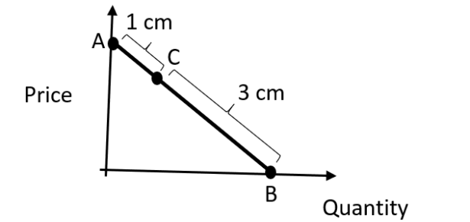

- If total expenditure increases with fall in price and decrease with rise in the price then price elasticity is -------------------
- Consider the price-quantity combinations P and M as given in Table.

Point | Price | Quantity
P | 5 | 25
M | 8 | 20

Find the Elasticity through ARC?

- The Advertising Elasticity of Demand (AED) measures what? And why the AED ‘s value is always positive?
- AED ratio of smaller than 1 mean that the ----------------------
- AED ratio of greater than 1 mean that the ----------------------
- Mention the factors of Advertising Elasticity of Demand AED in
brief.
- What are the factors that might affect price elasticity of demand PED? Mention them in brief points, with few examples.
- What is the Importance of Elasticity of Demand? Or why economists pay more attention to study elasticities? Mention them briefly.

