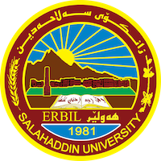
Academic Curriculum Vitae

Personal Information:
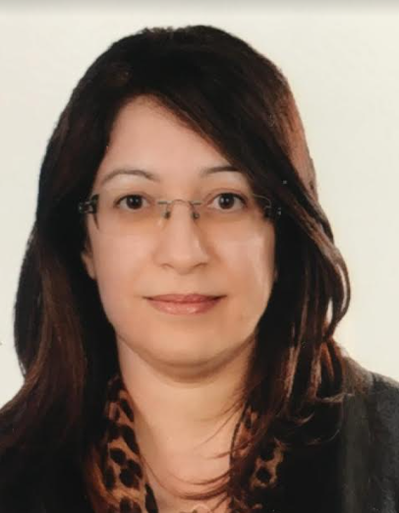
Full Name: Sara Khalid Khall
Academic Title: Assistant professor
Email: Sarah muhammad@su.edu.krd
Mobile: 07504616934

Education:
- 1990-1994, B.Sc., Salaheddin university, college of Administration and Economics, Business management department. (Erbil – Iraq).
- 2000, M.Sc., Salaheddin university, college of Administration and Economics, Business management department. (Erbil-Iraq).

Employment:
- 24/12/1994 assistant researcher
- 13/4/2003 assistant lecturer
- 16/6/2012 lecturer
- 16/6/2019 assistant professor

Qualifications
- IELTE exam (5.5) in Erbil

Teaching experience:
- Subject deliveries in business management department (Time management-Insurance management-Managerial seminars-Principles of management).
- Supervision post graduate student (M.Sc.) degree.
- Working as a lecturer in university of Lebanon-France (LFU) in 2016.
- Working as a lecturer in Catholic university in Erbil (CUE) on 2017-2018.
- conduct a training course on “Time Management” for International Relief and Development (IRD) staff in Erbil 2006.

Research and publications
- Published: research under titled (the role of expectation theory on the innovation of Salaheddin university lecturers). the scientific journal of Salaheddin University, No. (38) 2008, page 309.
- Published: research under title (the role of organizational trust on the organizational commitment). Journal of Koya University, No (25) 2012, Page 441.
- Published research under title (the relationship between social capital and knowledge sharing and their impact on improving the educational service quality). Journal Of Economic & Administrative Science, p – ISSN 2518 – 5764, E – ISSN 2227 – 703X
- Publish research under title (The relationship between strategic agility and banking governance and their impact on achieving strategic goals). Qalaai Zanist Journal, Vol. 4 no, 3 (2019).
- Publish research under title (Create shared value as a new competitive advantage, and its impact on sustainable strategy). ICABEP, 2019 ISBN: 978-9922-9036-3-7
- Publish research under title (360-degree performance appraisal and its impact on positive psychological capital). Eurasin Journal Of Management & Social Sciences, ISSN 2708 – 177X (print) ISSN 2708 – 034X (online)
- Spiritual leadership and its role in promoting proactive behavior.
- The role of reengineering human resource in supporting organizational immunity.

Conferences and Courses
- 4th ICABEP, International Conference of Accounting, Business, Economics, and Politics. Tishik University, Erbil 2022.
- 2nd ICABEP, International Conference of Accounting, Business, Economics, and Politics. Tishik University, Erbil 2019.
- “Corporate Governance”, ToT course by Kurdistan Institution of Directors (KIOD) Erbil 2018.
- “Corporate Governance”, training course by Kurdistan Institution of Directors (KIOD) Erbil 2017.
- “English Language Course” by (British council), March 2014.
- “Reconstruction and Development in Iraq” conference held by Dortmund University (winter school) Dortmund, Germany 2004.

Professional Social Network Accounts:
https://www.researchgate.net/profile/Sara_Khall/research
https://scholar.google.com/citations?hl=en&user=1zMjgYcAAAAJ&view_op=list_works&gmla=ABEO0YrDbrqR6vGdbAi9Ahkdg6UKfzGMebwVijMUKKtd34edJLfpZe4hByxneICpBc5yOwYTQAPHIG4GaCTljjMK

